Section 1.1 Functions

Topic 1: Cartesian Coordinate System

Recall that to form a Cartesian or rectangular coordinate system, we select two real number lines - one horizontal and one vertical - and let them cross through their origins as indicated in the figure below. Up and to the right are the usual choices for the positive directions. The two number lines are called the horizontal axis and the vertical axis, or, together, the coordinate axes. The horizontal axis is usually referred to as the x-axis and the vertical axis as the y-axis. The coordinate axes divide the plane into four parts called quadrants which are numbered counterclockwise from I to IV (see the figure below).
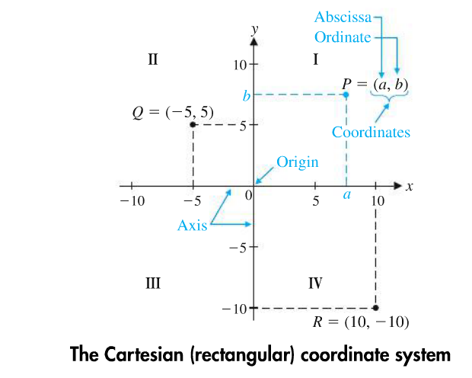

Topic 2: Definition of a Function

A function is a correspondence between two sets of elements such that to each element in the first set, there corresponds one and only one element in the second set. The first set is called the domain, and the set of corresponding elements in the second set is called the range.

If in an equation in two variables we get exactly one output (value for the dependent variable) for each input (value for the independent variable), then the equation specifies a function. If we get more than one output for a given input, the equation does not specify a function.

The Vertical Line Test: An equation specifies a function if each vertical line in the coordinate system passes through, at most, one point on the graph of the equation. If any vertical line passes through two or more points on the graph of the equation, then the equation does not specify a function.

Topic 3: Function Notation

If an equation in two variables $x$and $y$ yields precisely one value of $y$for each value of​ $x$, then $y$is a function of $x$. The notation $y$equals​ $f(x)$indicates that the variable $y$ is a function of$x$. The notation​ ​$f(x)$is read as​ "the value of the function $f$at​ $x$" or simply​ "$f$of $x$."
​

In addition to evaluating functions at specific numbers, it is important to be able to evaluate functions at expressions that involve one or more variables. For example, the expression is called the difference quotient and is studied extensively in calculus.

Topic 4: Functions Specified by Equations

The domain of a function is the set of all values of x for which the function is defined. When only the equation of a function is given, we agree that the domain of $f$is the largest set of real numbers for which​ $f(x)$ is a real number. In this section, we will look at three different types of functions:

Functions | Restrictions | Domain
Rational functions | Division by zero is undefined, so exclude values of the variable that cause division by zero. | For example: Find the domain of $f\left(x\right)=\frac{x-1}{x+8}$  In order for $f(x)$to be real the denominator cannot be equal to 0.  $x+8≠0$  $$x≠-8$$  The domain of ​ $f:$  (-∞, -8)$∪$(-8, ∞)
Square root functions | The expression under the square root must but be greater than or equal to 0. | For example: Find the domain of $f\left(x\right)=\sqrt{16+x}$ .  In order for $f(x)$to be real the expression under the square root must but be greater than or equal to 0.  $$16+x≥0$$  $$x≥-16$$  The domain of ​ $f$: [-16, ∞)
Polynomial functions | None | (-∞, ∞)

Topic 5: Applications

A manufacturing company has costs, C, and revenue, R. The company will have a loss if R < C, will break even if R = C, and will have a profit if R > C. Costs include fixed costs (such as plant overhead, product design, setup, and promotion) and variable costs which are dependent on the number of items produced at a certain cost per item. In addition, price- demand functions, usually established by financial departments using historical data or sampling techniques, play an important part in profit-loss analysis.

Function | Let x represent the number of units manufactured and sold; x is an independent variable.
Cost function | $C =$ fixed costs + variable costs  $C = a + b x$ where a and b are constants
Price- Demand Function | $p = m – n x$ where x is the number of items that can be sold at $p per item; m and n are constants determined from the context of the particular problem
Revenue Function | $R =$number of items sold multiplied by the price per item  $$R = x p = x (m – n x)$$
Profit Function | $$P = R – C$$  $$P = x (m – n x) – (a + b x)$$

