Section 1.6 Logarithmic Functions

# Topic 1: Inverse Functions

A function *f* is said to be **one-to-one** if each range value corresponds to exactly one domain value.

If *f* is a one-to-one function, then the **inverse** of *f* is the function formed by interchanging the independent and dependent variable for $f$. Thus, if  is a point on the graph of *f***,** then  is a point on the graph of the inverse of $f.$

Note: If *f* is not one-to-one, then *f* does not have an inverse that is a function.

# Topic 2: Logarithmic Functions

The inverse of an exponential function is called a **logarithmic function**.

For , the **logarithmic function with base *b*** is defined by  if and only if ****.

The **log base *b* of *x*** is the exponent to which *b* must be raised to obtain *x*. A logarithmic function has domain  and range . The graph of  and its inverse, , are shown below. Note that the graph of  is a reflection of the graph of  about the line , and that the y-axis is a vertical asymptote for the graph of .

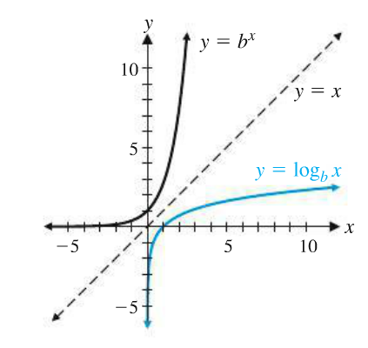

# Topic 3: Properties of Logarithmic Functions

If *b*, *M*, and *N* are all positive real numbers, , and *p* and *x* are real numbers, then the following **properties of logarithmic functions** are true.















if and only if 

**Common logarithms** are logarithms with base 10.

**Natural logarithms** are logarithms with base *e $.$*

# Topic 4: Calculator Evaluation of Logarithms

For *a*, *b*, and *c* all positive real numbers and , the **change-of-base formula** is

**.**

This holds true for any variable *c,* . We choose to use base *e* or base 10 if using a calculator.

# Topic 5: Applications