12.4 The Normal Distribution

# Objective 1: Recognize characteristics of normal distributions

The **normal distribution** is a theoretical distribution for an entire population. A histogram of a normal distribution will look more and more like a smooth curve as the sample size increases and the class width decreases. The distribution is bell-shaped and symmetric about a vertical line through the mean. For a normal distribution, the median and mode are equal to the mean.

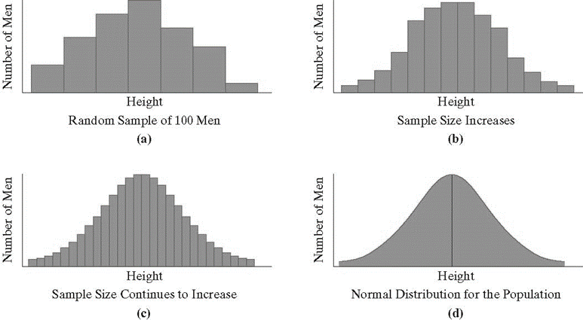

The normal distribution is sometimes called a **bell curve** or a **Gaussian distribution.** The shape of the curve is determined by the mean and standard deviation of the population. As the standard deviation increases, the distribution becomes more dispersed, or spread out, but retains a symmetric bell shape.

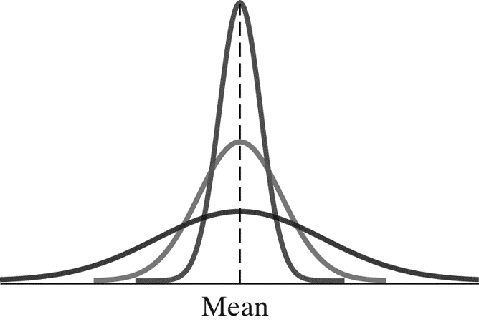

 Not all statistical situations are represented by a normal distribution. Some may be weighted to one side or may appear more random.

# Objective 2: Understand the 68-95-99.7 Rule

The **68-95-99.7 Rule** is a way to describe the distribution of data items relative to the mean of a normal distribution. The symmetry of the curve means that an equal number of items fall above and below the mean in each region.

**THE 68-95-99.7 RULE FOR THE NORMAL DISTRIBUTION**

1. Approximately 68% of the data items fall within 1 standard deviation of the mean.
2. Approximately 95% of the data items fall within 2 standard deviations of the mean.
3. Approximately 99.7% of the data items fall within 3 standard deviations of the mean.

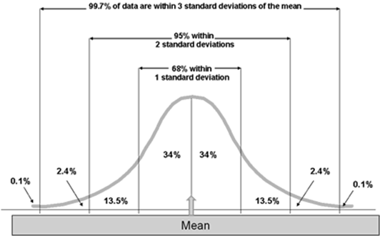

# Objective 3: Find scores at a specified number of standard deviations from the mean

**FINDING SCORES *n* STANDARD DEVIATIONS FROM THE MEAN**

1. Multiply *n* by the standard deviation, *s.*
2. Add or subtract the result from the mean,  , to get a value *n* standard deviations greater than or less than the mean.



This method can also be used to determine the ranges of data for applying the 68-95-99.7 Rule.

# Objective 4: Use the 68-95-99.7 Rule

# Objective 5: Convert a data item to a *z*-score

A *z-score* describes how many standard deviations a data item in a normal distribution lies above or below the mean. Data items greater than the mean have positive *z-scores*. Data items less than the mean have negative *z-scores*. The *z-score* for the mean is 0.

**COMPUTING *Z-SCORES***

The z-score can be obtained using

.

# Objective 6: Understand percentiles and quartiles.

A *z-score* measures a data item’s position in a normal distribution. Another measure of a data item’s position is its **percentile**. A data item is in the ***nth* percentile** of a distribution if it is greater than *n* percent of the items in the distribution. Percentiles are often associated with scores on standardized tests. If a score is in the 45th percentile, then 45% of the scores are less than this score.

**Quartiles** refer specifically to the 25th, 50th, and 75th percentiles. These are called the first, second, and third quartiles, respectively. Since the median is greater than 50% of the items in a distribution, it is equal to the second quartile.

The graph of a normal distribution is divided into four sections. The first section contains the bottom 25% of the data and is the first quartile or 25th percentile. The next two sections left and right of the median each contain 25% of the data each and are combined to form the  middle fifty percent. The median is the second quartile or 50th percentile since 50% of the data is below the median.  The third quartile is at the right end of the third section and is the 75th percentile because 75% of the data is below this value. The last section contains the top 25% of the data.
