14.1 Graphs, Paths, and Circuits

Objective 1: Understand relationships in a graph

A graph consists of a finite set of points called vertices and line segments or curves called edges that start and end at vertices. The singular of vertices is vertex. An edge that starts and ends at the same vertex is called a loop.

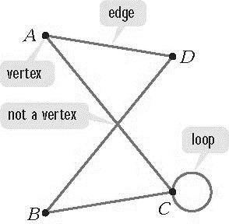

Two graphs are equivalent if they have the same number of vertices connected to each other in the same way. The placement of the vertices and the shapes of the edges are unimportant.

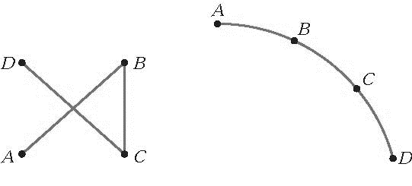

Objective 2: Model Relationships Using Graphs

In the early 1700’s, the city of Königsberg, Germany, was located on both banks and two islands of the Pregel River. The figure below shows that the town’s sections were connected by seven bridges.

The city map can be modeled by a graph using vertices to represent the land masses and edges to represent the bridges.

A graph can be created to model the borders between New England states by using vertices to represent the states and edges to represent common borders.

Objective 3: Understand and use the vocabulary of graph theory

The degree of a vertex is the number of edges at that vertex. Since a loop connects a vertex to itself, that loop contributes 2 to the degree of the vertex. On a graph, the degree of each vertex is found by counting the number of line segments or curves attached to the vertex.

A vertex with an even number of edges attached to it is an even vertex. A vertex with an odd number of edges attached to it is an odd vertex.

Two vertices in a graph are said to be adjacent vertices if there is at least one edge connecting them. It is helpful to think of adjacent vertices as connected vertices.

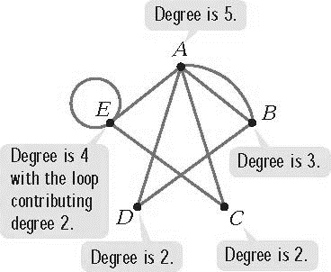

A path in a graph is a sequence of adjacent vertices and the edges connecting them. Movement along a path can be described by naming adjacent vertices. Although a vertex can appear on the path more than once, an edge can be part of a path only once. A path does not have to include every vertex and every edge of a graph.

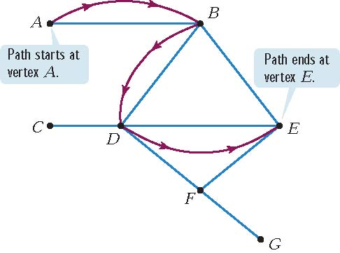

A circuit is a path that begins and ends at the same vertex. Every circuit is a path, but not every path is a circuit, because not every path ends at the same vertex where it starts.

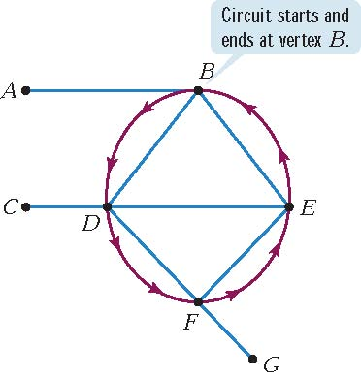

A graph is connected if there is at least one path that connects any two vertices. Visually this means that a graph is connected if it consists of one piece. If a graph is not connected, it is said to be disconnected. A disconnected graph is made up of connected pieces that are called the components of the graph. A bridge is an edge that, if removed from a connected graph, would leave behind a disconnected graph.

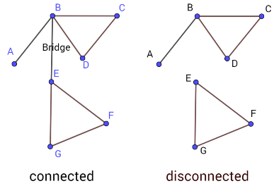

Note that the city bridges in the Konigsberg bridge map are simply edges of the graph where the land masses are vertices. None of these edges are bridges that would make the difference between a connected and a disconnected graph.

