14.2 Euler Paths and Euler Circuits

Objective 1: Understand the definition of an Euler path

In graph theory, a path is a sequence of adjacent vertices and the edges connecting them. Each edge in the graph can be a part of the path at most one time but not every edge must be used. An Euler path is a path that travels through every edge of a graph once and only once. Each edge must be traveled, and no edge can be retraced.
Note: The German pronunciation of Euler is “oi’-ler.”

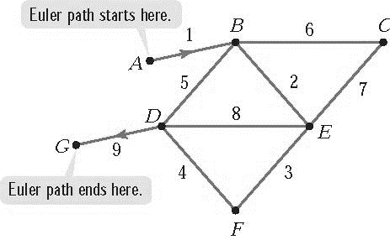

Objective 2: Understand the definition of an Euler circuit.

An Euler circuit is a circuit that travels through every edge of a graph once and only once. Like all circuits, an Euler circuit must begin and end at the same vertex. Note that every Euler circuit is an Euler path, but not every Euler path is an Euler circuit.

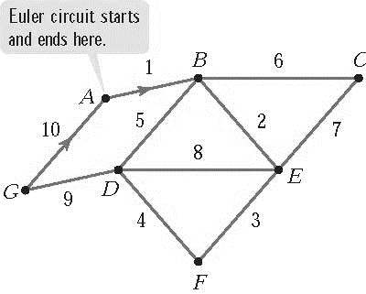

Objective 3: Use Euler’s Theorem

Some graphs have no Euler paths. Other graphs have several Euler paths. Some graphs with Euler paths have no Euler circuits. Euler’s Theorem is used to determine if a graph contains Euler paths or Euler circuits.

EULER’S THEOREM
The following statements are true for connected graphs:
- If a graph has exactly two odd vertices, then it has at least one Euler path, but no Euler circuit. Each Euler path must start at one of the odd vertices and end at the other one.
- If a graph has no odd vertices (all even vertices), it has at least one Euler circuit (which, by definition, is also an Euler path). An Euler circuit can start and end at any vertex.
- If a graph has more than two odd vertices, then it has no Euler paths and no Euler circuits.
Number of Odd Vertices | Euler Paths | Euler Circuits
None (all even) | At least one | At least one
Exactly two | At least one | None
More than two | None | None

Objective 4: Solve problems using Euler’s Theorem

Objective 5: Use Fleury’s Algorithm to find possible Euler paths and Euler circuits
Euler’s Theorem uses the number of odd vertices in a graph to determine whether or not the graph has an Euler path or an Euler circuit. The theorem does not provide a method for finding an actual Euler path or circuit. Fleury’s Algorithm provides a method for finding these paths and circuits.

FLEURY’S ALGORITHM
If Euler’s Theorem indicates the existence of an Euler path or Euler circuit, one can be found using the following procedure:
- If the graph has exactly two odd vertices choose one of these odd vertices as the starting point of an Euler path. If the graph has no odd vertices it has an Euler circuit. In this case, choose any vertex as the starting point.
- Number edges as you trace through the graph according to the following rules:
- Each edge must be used exactly once. It may help to erase or mark an edge to indicate that it has already been used and is no longer a part of the decision process.
- When faced with a choice of edges to trace, choose an edge that is not a bridge. Travel over an edge that is a bridge only if there is no alternative.

When using Fleury’s Algorithm, don’t cross a bridge unless you have no choice. When looking for bridges, use the remaining graph after previous edges have been removed.

