14.3 Hamilton Paths and Hamilton Circuits

Objective 1: Understand the definitions of Hamilton paths and Hamilton circuits

A path that passes through each vertex of a graph exactly once is called a Hamilton path. If a Hamilton path begins and ends at the same vertex and passes through all vertices exactly once, it is called a Hamilton circuit.

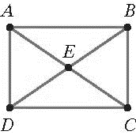

A complete graph is a graph that has an edge between each pair of vertices. The figure above is a complete graph. The figure below is not a complete graph because there are no edges connecting A and D or B and C.

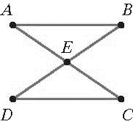

Objective 2: Find the number of Hamilton circuits in a complete graph

Any two circuits that pass through the same vertices in the same order will be considered to be the same. To avoid duplication when listing circuits, use the convention that all circuits will start and at point A. Then the number of Hamilton circuits will be equal to the number of possible arrangements, or orders, of the remaining points. This can be calculated by using the fundamental counting principle.

THE NUMBER OF HAMILTON CIRCUITS IN A COMPLETE GRAPH
The number of Hamilton circuits in a complete graph with n vertices is .

Objective 3: Understand and use weighted graphs

A weighted graph is a graph whose edges have numbers attached to them. The numbers shown along the edges of a weighted graph are called the weights of the edges and may represent things such as the cost of a plane flight between two cities or the distance between two points.
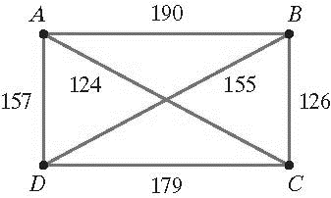

Weighted graphs are not generally drawn to scale. The length of the edges is chosen to create a clearly readable graph, not to represent the weights.

Objective 4: Use the Brute Force Method to solve traveling salesperson problems

The traveling salesperson problem is the problem of finding a Hamilton circuit in a complete weighted graph for which the sum of the weights of the edges is a minimum. This Hamilton circuit is called the optimal Hamilton circuit or the optimal solution.

One method for finding an optimal Hamilton circuit for the traveling salesperson or similar problems is the Brute Force Method. As the name suggests, this method involves finding the weights of all possible circuits and then selecting the smallest. It is effective, but it quickly becomes cumbersome.

THE BRUTE FORCE METHOD
The optimal solution can be found using the following steps:
- Model the problem with a complete weighted graph.
- Make a list of all possible Hamilton circuits.
- Determine the sum of the weights of the edges for each of these Hamilton circuits.
- The Hamilton circuit with the minimum sum of weights is the optimal solution.

Objective 5: Use the Nearest Neighbor Method to approximate solutions to traveling salesperson problems

As the number of vertices increases, the rapidly increasing number of possible Hamilton circuits makes the Brute Force Method impractical. There is not another method for solving the traveling salesperson problem, but there are several ways to find approximate solutions. One of these is the Nearest Neighbor Method which involves continually choosing edges with the smallest weight to approximate the optimal solution.

THE NEAREST NEIGHBOR METHOD
The optimal solution can be approximated using the following steps:
- Model the problem with a complete weighted graph.
- Identify the vertex that serves as a starting point.
- From the starting point, choose the edge with the smallest weight. Move along this edge to the second vertex. If there is more than one edge with the smallest weight, choose either one.
- From the second vertex, choose the edge with the smallest weight that does not lead to a vertex already visited. Move along this edge to the third vertex.
- Continue building the circuit, one vertex at a time, by moving along the edge with the smallest weight until all vertices are visited.
- From the last vertex, return to the starting point.

