Section 2.1 The Idea of Limits

# Topic 1: Average Velocity

The **average velocity** of a moving object is its change in position divided by the elapsed time. For an object traveling over a time interval  whose position at time *t* is given by ,  .

# Topic 2: Instantaneous Velocity

The **instantaneous velocity** at a single point in time,  is determined by computing average velocities over intervals  that decrease in length. As approaches , the average velocities typically approach a unique number, which is the instantaneous velocity. This single number is called a **limit**.

# Topic 3: Slope of the Tangent Line

Average velocities correspond to the slope of a secant line on the graph of the position function.

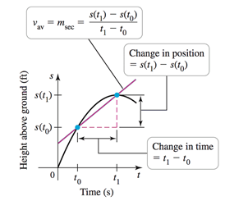

Instantaneous velocities correspond to the slope of a tangent line on the graph of the position function.