Section 2.2 Infinite Limits and Limits at Infinity

# Topic 1: Infinite limits

The graph of  indicates that  does not exist, since there is no real number *L* that the values of  approach as *x* approaches 1 from the right. Instead, as *x* approaches 1 from the right, the values of  are positive and become larger and larger. The function  increases without bound. We write  or .

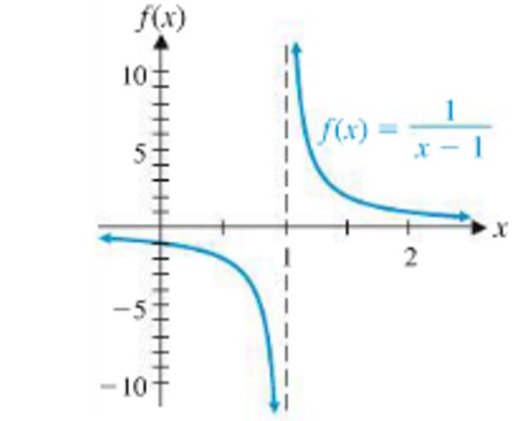

Since  is not a real number, the limit above does not exist. We are using the symbol  to describe the manner in which the limit fails to exist, and we call this situation an **infinite limit.**

# Topic 2: Locating Vertical Asymptotes

The vertical line  is a **vertical asymptote** for the graph  if

 or  as  or **.**

That is, if either increases or decreases without bound as *x* approaches *a* from the right or from the left.

**Theorem: Locating Vertical Asymptotes of Rational Functions**

If  is a rational function,  and , then the line  is a vertical asymptote of the graph of *f*.

When is is correct to say that the limit does not exist and when is it correct to use ? It depends on the situation. The table below lists examples of infinite limits:

| **Function** | **Right- Hand Limit** | **Left- Hand Limit** | **Two- Sided Limit** |
| --- | --- | --- | --- |
|  |  |  | does not exist |
|  |  |  |  |

We use infinite limits to describe behavior at vertical asymptotes. If we had been asked to evaluate the limits, with no mention of  or asymptotes, then the correct answer would be that all of these limits do not exist.The  is a symbol used to describe the behavior of functions at vertical asymptotes.

# Topic 3: Limits at Infinity

**Theorem: Limits of Power Functions at Infinity**

If *p* is a positive real number and *k* is any real number except 0, then









provided that  is a real number for negative values of *x.* The limits in 3 and 4 will be either  or  depending on the values *k* and *p.*

**Theorem: Limits of Polynomial Functions at Infinity**

If  with  and  , then



and

.

Each limit will be either  or  depending on the values  and *m.*

# Topic 4: Finding Horizontal Asymptotes

**Theorem: Limits of Rational Functions at Infinity and Horizontal Asymptotes of Rational Functions**

If  with  and , then



and

.

There are three possible cases for these limits:

1. If , then , and the line  (the *x*-axis) is a horizontal asymptote of the graph of *f.*
2. If , then , and the line  is a horizontal asymptote of the graph of *f.*
3. If , then each limit will be either  or  depending on the values of , , *m*, and *n*, and the graph of *f* does not have a horizontal asymptote.