Section 2.5 Limits at Infinity

# Topic 1: Limits at Infinity and Horizontal Asymptotes

If  becomes arbitrarily close to a finite number *L* for all sufficiently large and positive *x*, we write . In this case, the line  is a horizontal asymptote of the graph of *f*.

The limit at negative infinity, , is defined analogously. When the limit exists,  is a horizontal asymptote of the graph of *f*.

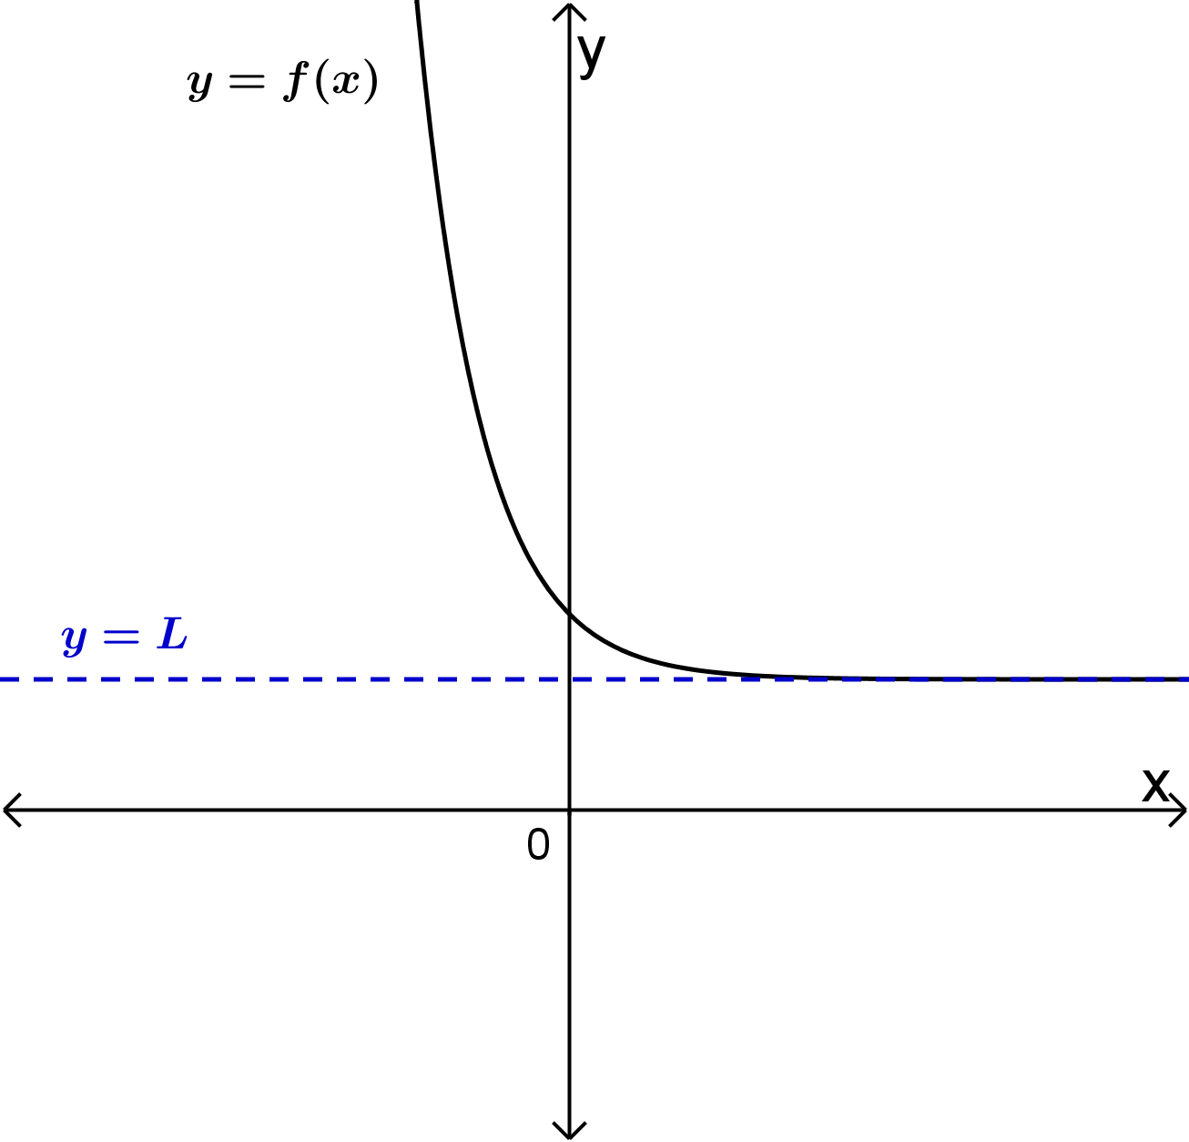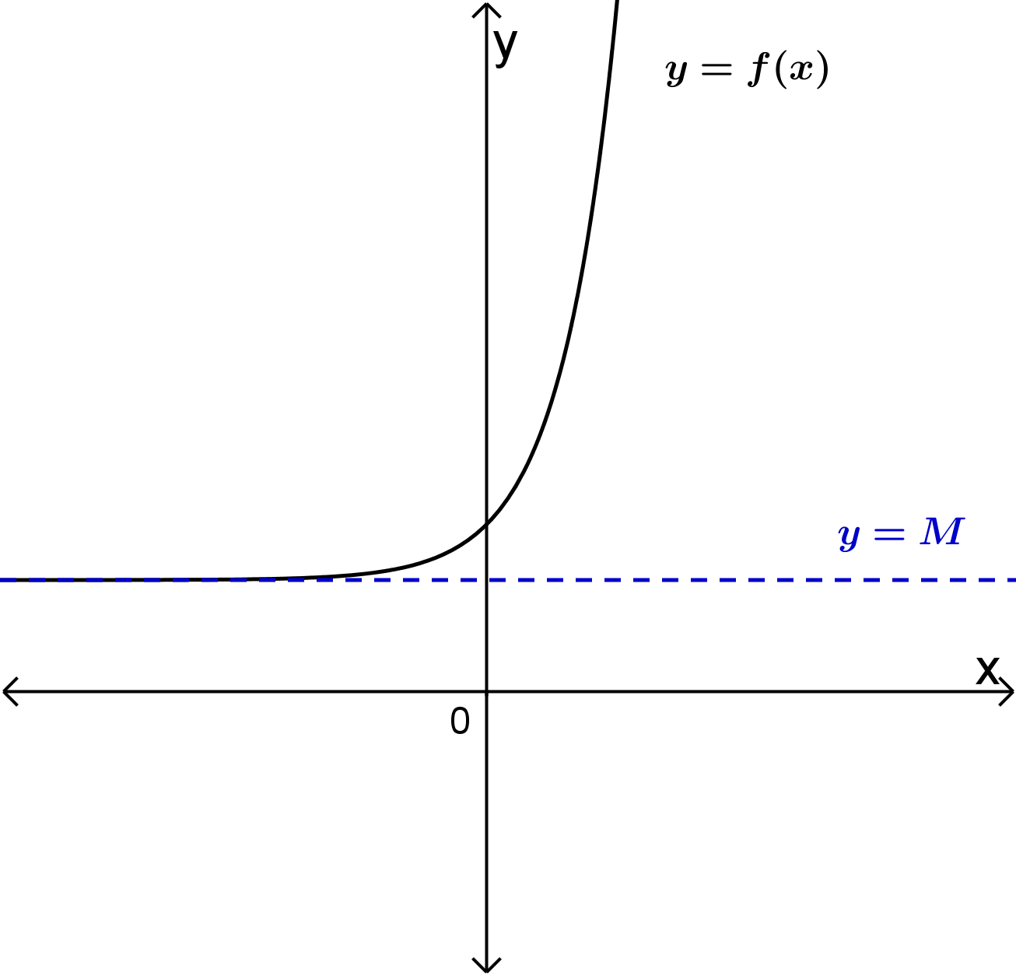

# Topic 2: Limits at Infinity of Powers and Polynomials

**Theorem:** Let *n* be a positive integer and let *p* be the polynomial where .

1.  and when *n* is even.
2.  and when *n* is odd.
3. 
4. , depending on the degree of the polynomial (*n*) and the sign of the leading coefficient (). Two examples are shown in the following figures.

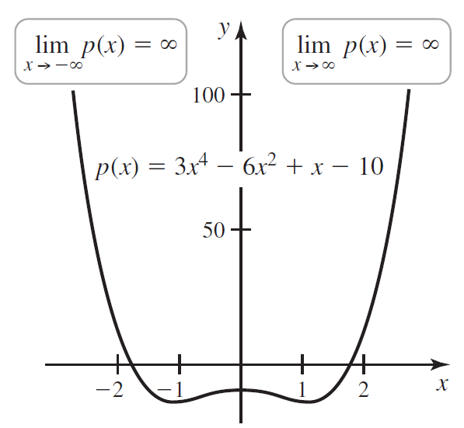 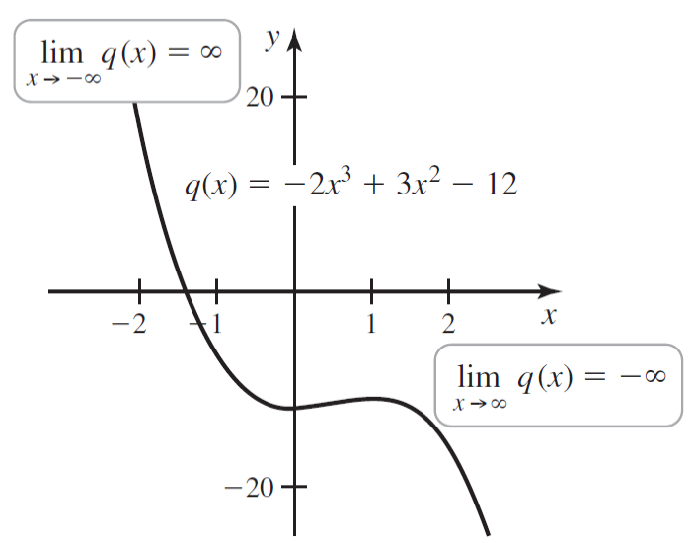

# Topic 3: End Behavior of Rational Functions

Limits at infinity for rational functions may be finite or infinite and depend on many factors. Some examples are shown in the figures below.

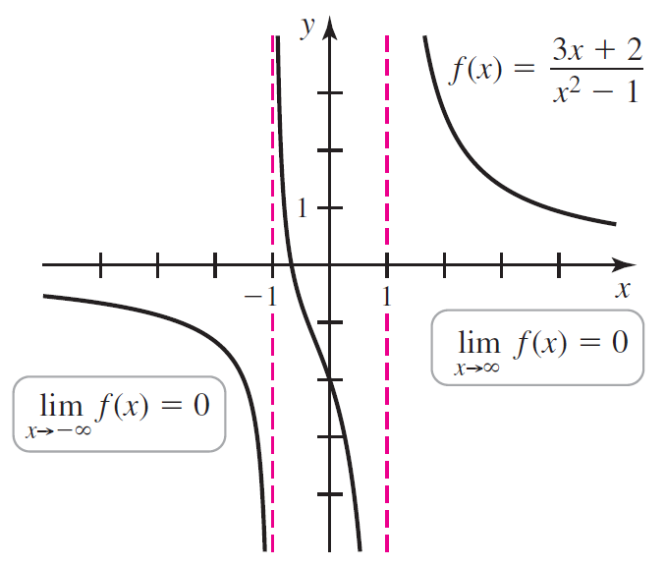

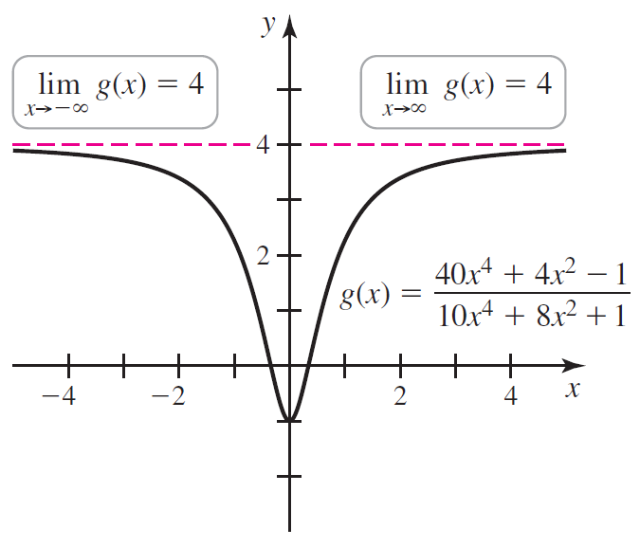

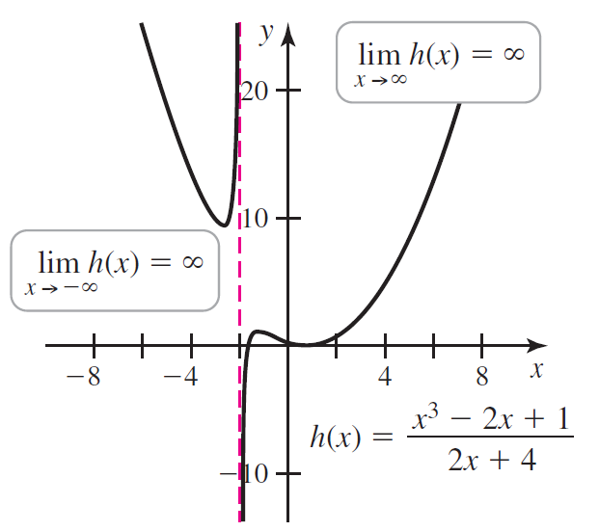

# Topic 4: End Behavior of Transcendental Functions

The graphs of the functions , , and  below show the limits at infinity of these transcendental functions.

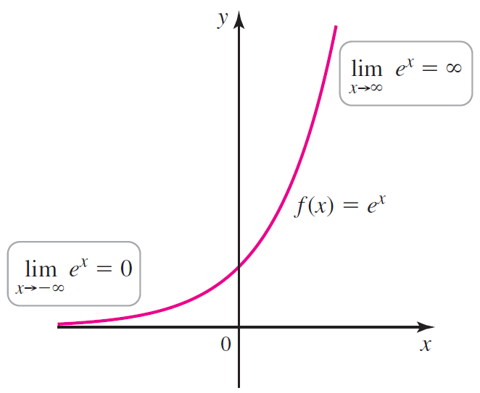 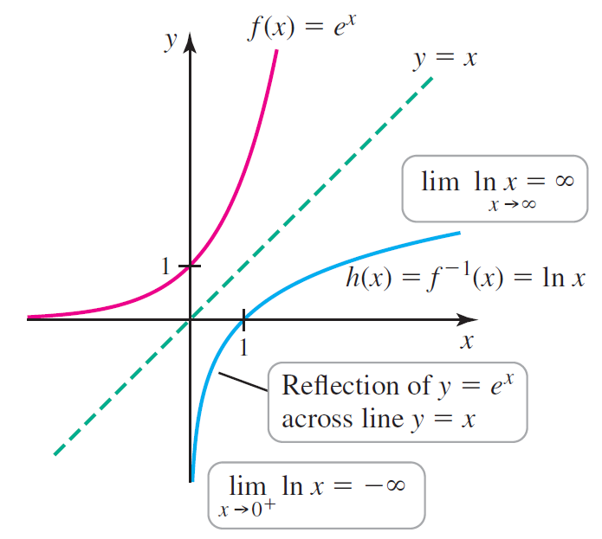

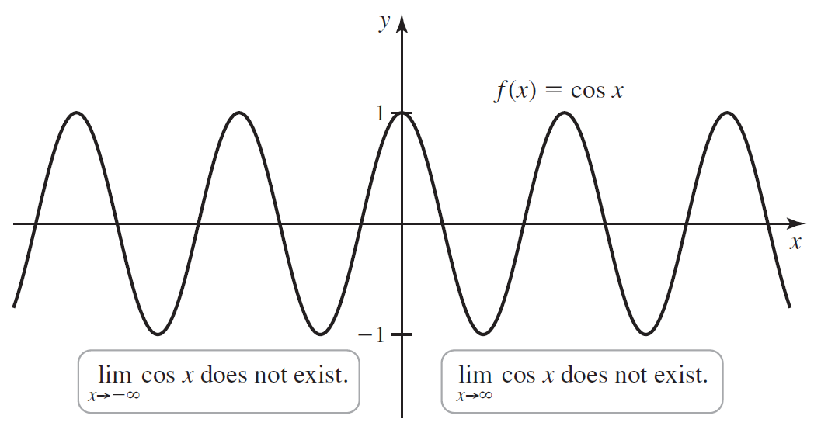

# Topic 5: Limits at Infinity and the Squeeze Theorem