Section 2.6 Continuity

# Topic 1: Continuity at a Point

A function *f* is continuous at *a* if . If *f* is not continuous at *a*, then *a* is a point of discontinuity.

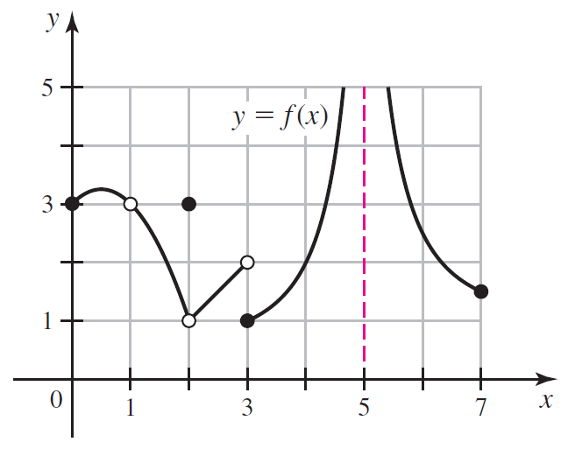

**Continuity Checklist**

In order for *f* to be continuous at *a*, the following three conditions must hold.

1.  is defined (*a* is in the domain of *f*).
2. exists.
3.  (the value of *f* equals the limit of *f* at *a*).

If a function is continuous at *a*, then direct substitution can be used to evaluate  because .

# Topic 2: Classifying Discontinuities

The discontinuities in graphs (a) and (b) below are called **removable discontinuities** because the function can be made continuous at *a* by defining or redefining  so that . These can also be called **point discontinuities**.

Jump discontinuities and infinite discontinuities shown in graphs (c) and (d) below are called **non-removable discontinuities** because the function cannot be made continuous at $a$ by defining or redefining .

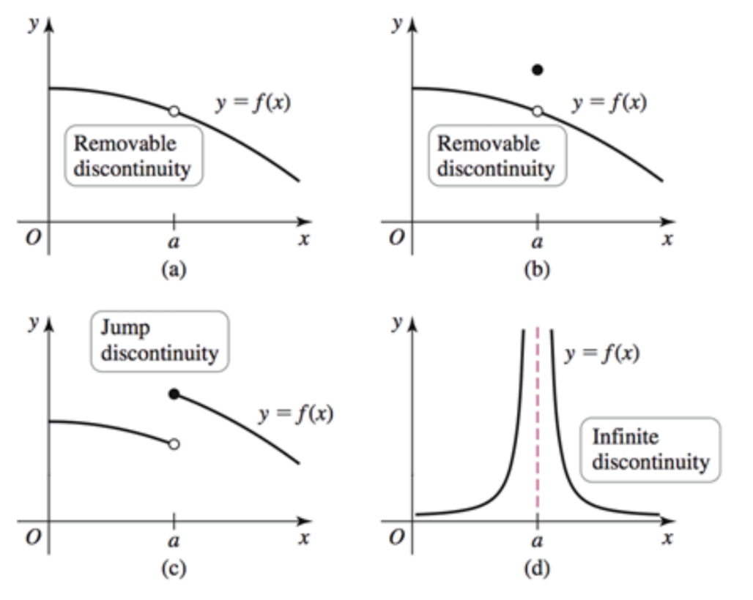

# Topic 3: Continuity on an Interval

**Continuity at Endpoints**

A function *f* is continuous from the right at *a* if . A function *g* is continuous from the left at *b* if .

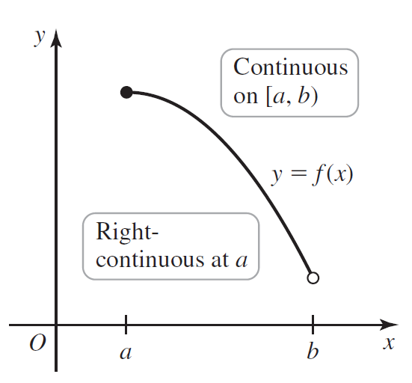 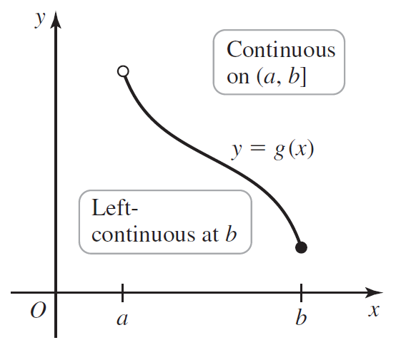

**Continuity on an Interval**

A function *f* is continuous on an interval *I* if it is continuous at all points of *I*. If *I* contains endpoints, continuity on *I* means continuous from the right or left at the endpoints.

# Topic 4: Continuity of Trigonometric Functions

The six trigonometric functions are continuous for all *x* in their domains.

*  and  are continuous for all *x*.
*  and  are continuous for all *x* such that  where *n* is an integer.
*  and  are continuous for all *x* such that  where *n* is an odd integer.

# Topic 5: Limits Involving Transcendental Functions

# Topic 6: The Intermediate Value Theorem

**The Intermediate Value Theorem:** Suppose *f* is continuous on the interval  and *L* is a number strictly between  and . Then there exists at least one number *c* in  such that  .

