Section 3.1 Introducing the Derivative

# Topic 1: Tangent Lines and Rates of Change

**Rate of Change and the Slope of the Tangent Line**

The **average rate of change** of *f* on the interval  is the slope of the corresponding secant line.



The **instantaneous rate of change** of *f* at *a* is the slope of the line tangent to the graph of *f* at the point  , provided the limit exists.



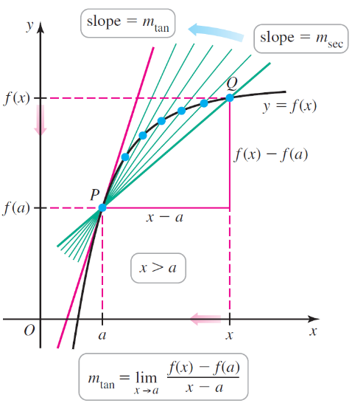

**Alternate Definition for Rate of Change and the Slope of the Tangent Line**

The **average rate of change** of *f* on the interval  is the slope of the

corresponding secant line.



The **instantaneous rate of change** of *f* at *a* is the slope of the line tangent to the graph of *f* at

the point , provided the limit exists.



# Topic 2: The Derivative

The slope of a line tangent to the graph of a function *f* at a given *x*-value *a* gives us the instantaneous rate of change of *f* at *a*. This information about the behavior of the function is so important that it has its own name and notation. For convenience, we will let *h* represent .

**The Derivative of a Function at a Point**

The derivative of *f* at *a*, denoted , is given by either of the two following limits, provided the limits exist and *a* is in the domain of *f*.

 or 

If  exists, we say that *f* is differentiable at *a*.