Section 3.11 Related Rates

Topic 1: Related Rates
Related rates problems are ones in which two or more variables are related in some known way and are each changing with respect to time.
For example, consider an oil rig that begins to leak. The oil spreads in a roughly circular patch around the rig. The radius of the circular patch is increasing over time and so is the area. The known relationship between the radius and area is .

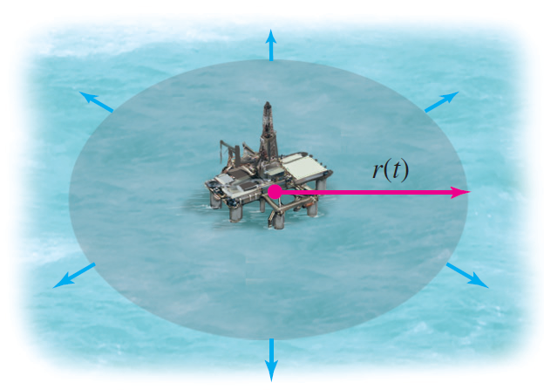

Topic 2: General Procedure for Solving Related Rates Problems

Steps for Solving Related Rates Problems
- Read the problem carefully, making a sketch when appropriate. Identify the rates that are given and the rate that is to be determined.
- Write one or more equations that express the basic relationship(s) among the variables.
- Introduce rates of change by differentiating the appropriate equation(s) with respect to time t.
- Solve for the desired quantity and substitute known values to find the desired quantity.
- Assign correct units and check that the answer is reasonable. (For example, check that the answer has the correct sign.)

