Section 3.2 Working with Derivatives

# Topic 1: The Derivative Function

In the previous section, we computed the derivative of a function at one fixed point. If this point is moved along a curve, the tangent line also moves and often its slope changes. For this reason, the slope of the tangent line for the function *f* is itself a function called the derivative of *f*.

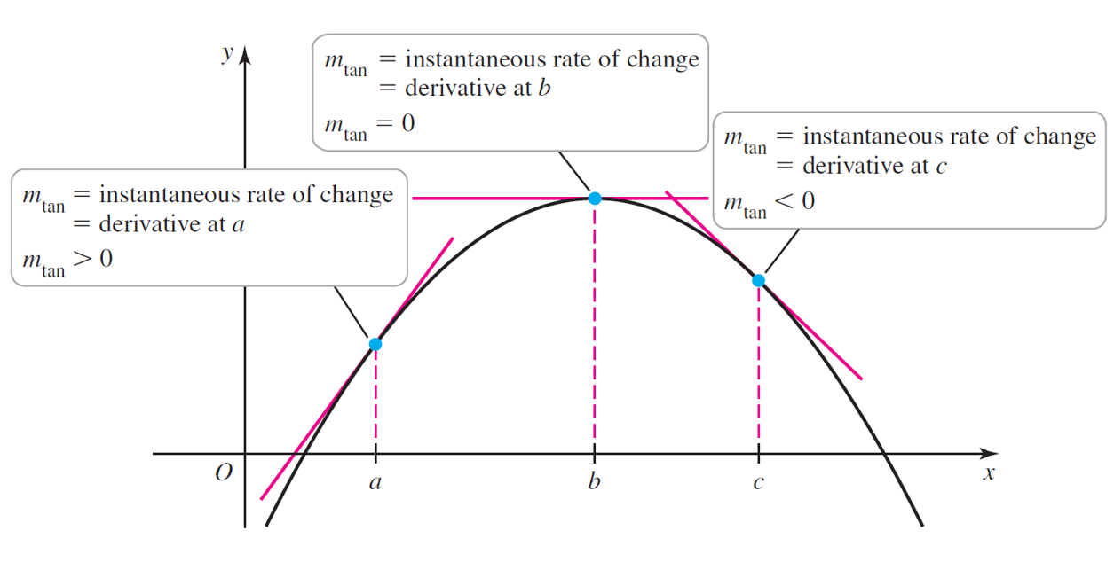

**The Derivative of a Function**

The derivative of *f* is the function  provided the limit exists and *x* is in the domain of *f*. If  exists, we say that *f* is differentiable at *x*. If *f* is differentiable at every point of an open interval *I*, we say that *f* is differentiable on *I*.

# Topic 2: Derivative Notation

For historical and practical reasons, several notations for the derivative are used.









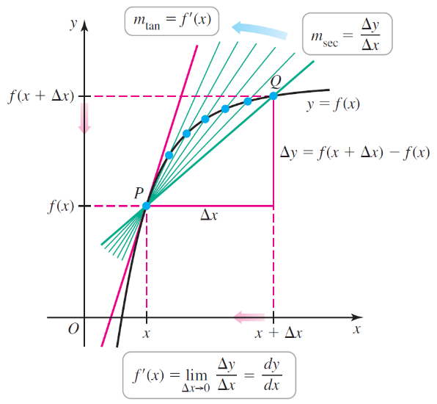

# Topic 3: Graphs of Derivatives

The function  is called the derivative of $f$ because it is derived from $f$. In the following

examples, we will derive the graph of a derivative from the graph of a function.

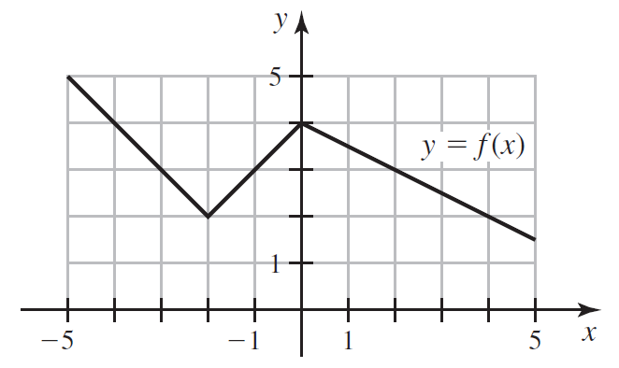

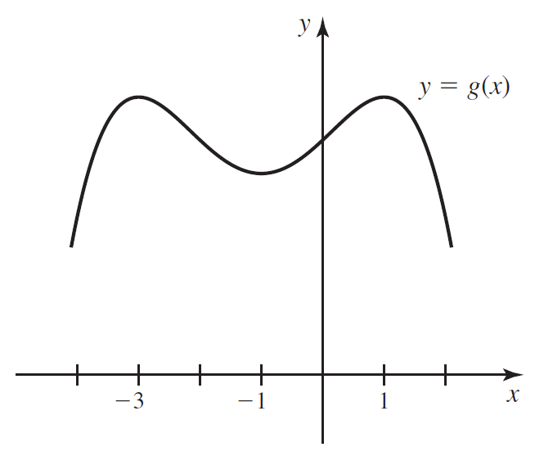

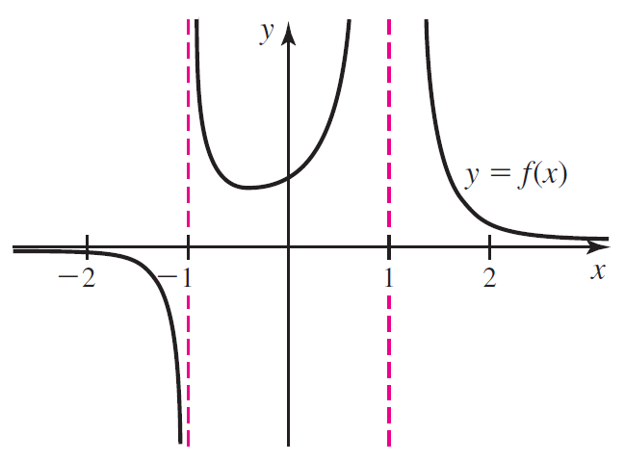

# Topic 4: Differentiability

If  exists, then we say that *f* is differentiable at *a*. If *f* is differentiable at *a*, then *f* is continuous at *a*. If *f* is not continuous at *a*, then *f* is not differentiable at *a*.

**When Is a Function Not Differentiable at a Point?**

A function *f* is not differentiable at *a* if at least one of the following conditions holds.

* The function *f* is not continuous at *a*.
* The graph of *f* makes a sharp turn at *a*.
* The graph of *f* has a vertical tangent line at *a*.