Section 3.5 Derivatives of Trigonometric Functions

# Topic 1: Two Special Limits

In order to determine derivative formulas for sine and cosine, we will need to use two special limits.

**Theorem: Trigonometric Limits**





Note that these limits apply only when the angle $x$ is measured in radians.

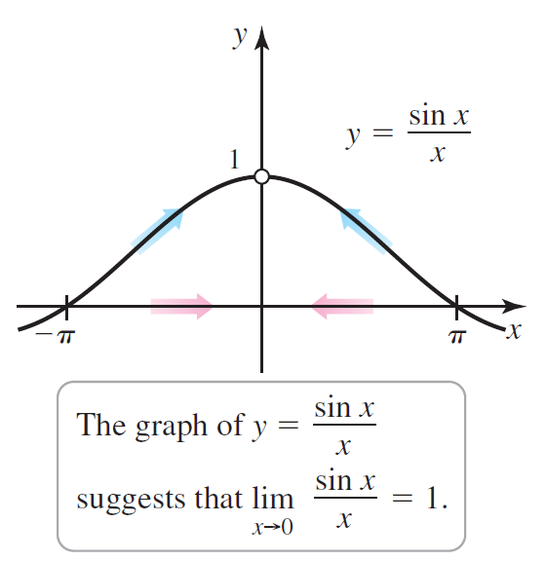

# Topic 2: Derivatives of Sine and Cosine

**Theorem: Derivatives of Sine and Cosine**





# Topic 3: Derivatives of the Other Trigonometric Functions

**Theorem: Derivatives of the Trigonometric Functions**











