Section 3.8 Implicit Differentiation

# Topic 1: Implicit Differentiation

If , then *y* is defined explicitly as a function of *x*.

In an equation such as , the relationship between the variables is expressed implictly.

# Topic 2: Tangent Lines and Normal Lines

Derivatives obtained by implicit differentiation often depend on both *x* and *y*. In these cases, the slope of the curve at a particular point requires both the *x*- and *y*-coordinates of the point.

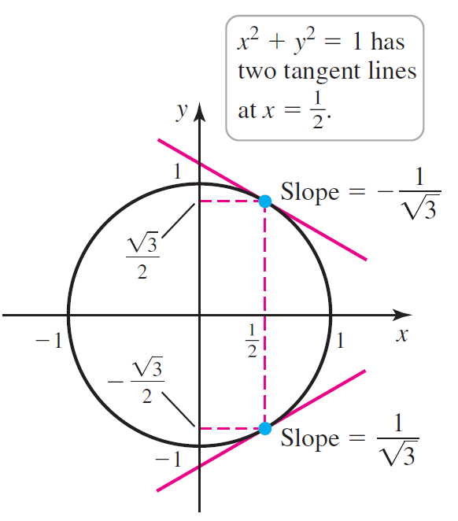

A normal line at a point *P* on a curve passes through *P* and is perpendicular to the line tangent to the curve at *P*.

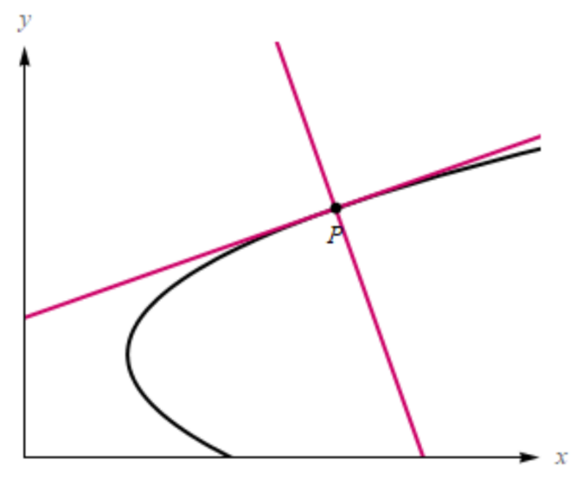

# Topic 3: Higher Order Derivatives

In previous sections, we found higher order derivatives  by first calculating  ,  , …, and . The same approach is used with implicit differentiation.