Section 3.9 Derivatives of Logarithmic and Exponential Functions

# Topic 1: Review of Logarithmic and Exponential Functions

**Inverse Properties for  and **

1.  , for  , and , for all *x*.
2.  if and only if .
3. For all real numbers *x* and , .

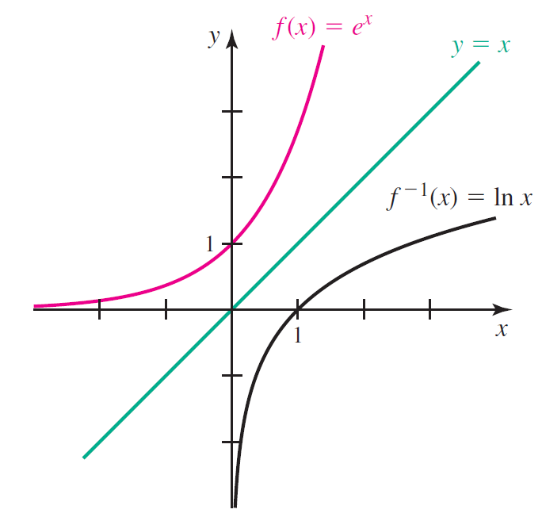

**Properties of Logarithms**

1. , for  and 
2. , for  and 
3. , for 

# Topic 2: Derivatives Involving Natural Logarithm Functions

**Theorem: Derivatives of  and **

, for 

, for 

If *u* is differentiable at *x* and , then



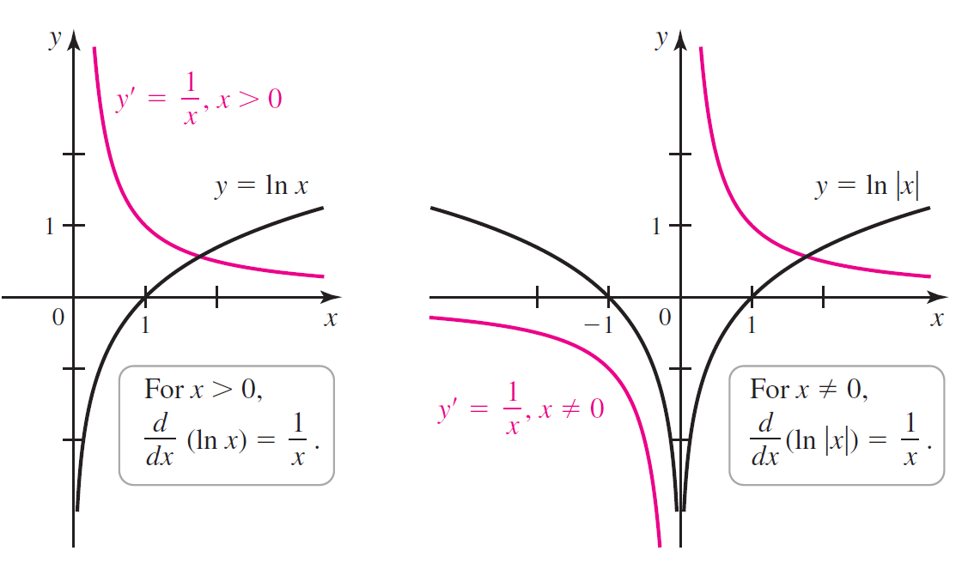

# Topic 3: Derivatives of General Exponential and Logarithmic Functions

**Theorem: Derivative of **

If  and , then , for all *x*.

**Theorem Derivative of $log_{b} x$**

If  and , then  , for  and , for .

# Topic 4: Logarithmic Differentiation

Consider the function .

In order to find the derivative of *f*, we would need to use the quotient rule, product rule, and chain rule and then simplify the result. In cases such as this, the properties of logarithms reviewed at the beginning of this section are useful for differentiating a function.