Section 4.1 Maxima and Minima

# Topic 1: Absolute Maxima and Minima

Let *f* be defined on a set *D* containing *c*.

If  for every *x* in *D*, then  is an **absolute maximum** value of *f* on *D.*

If  for every *x* in *D*, then  is an **absolute minimum** value of *f* on *D*.

An **absolute extreme value** is either an absolute maximum value or an absolute minimum value.

The existence and location of absolute extreme values depend on both the function and the

interval of interest. Several examples are illustrated below.

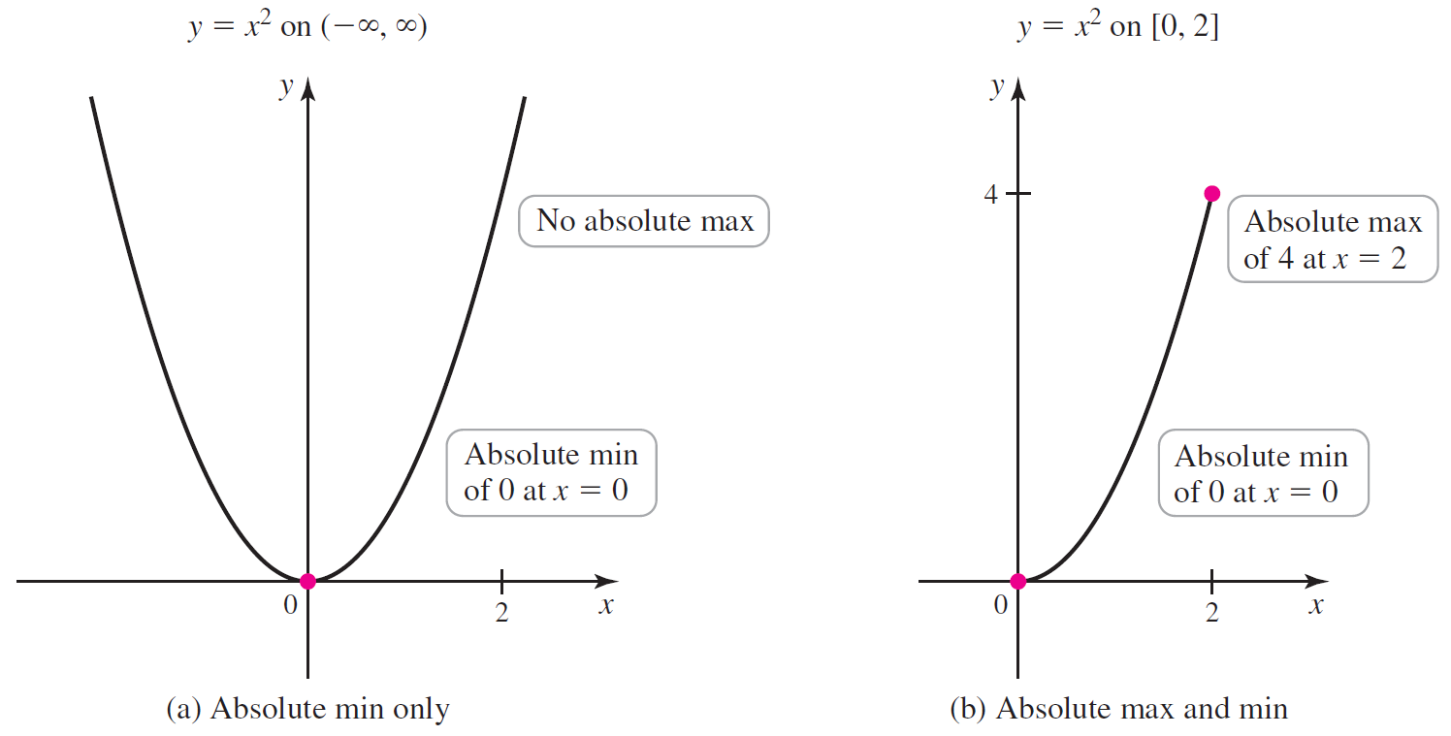

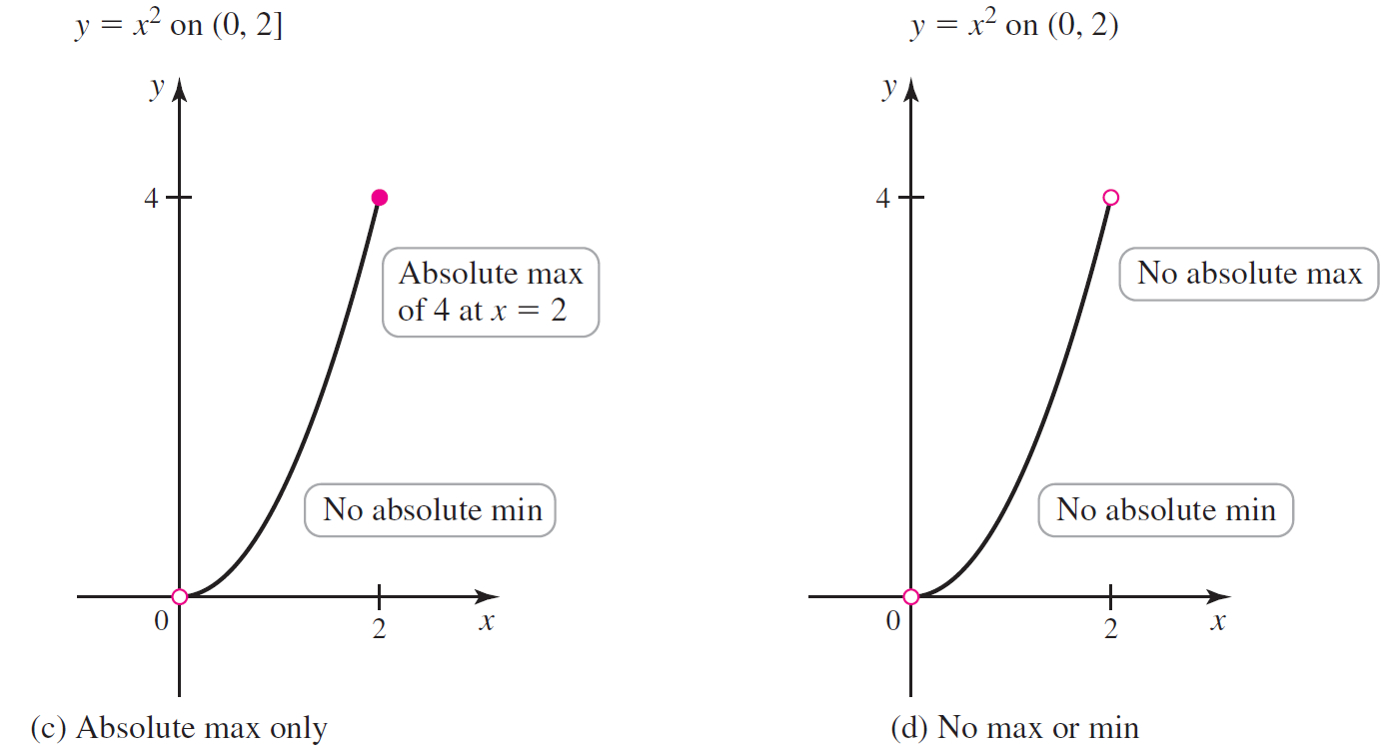

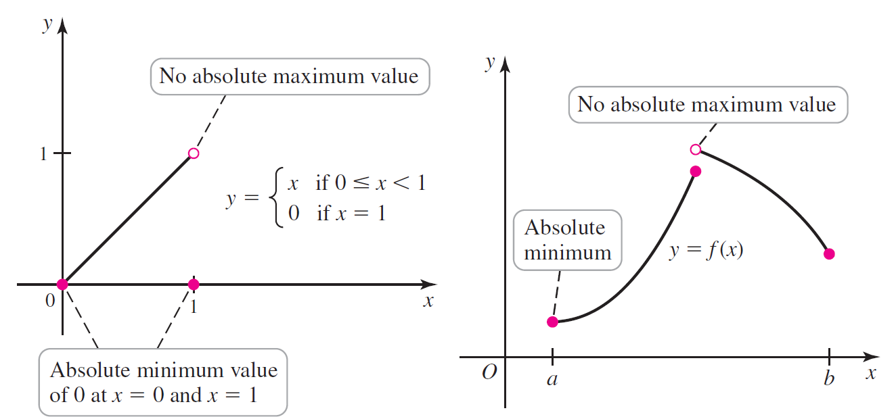

# Topic 2: Extreme Value Theorem

**Extreme Value Theorem:** A function that is continuous on the closed interval  has an absolute maximum value and an absolute minimum value on that interval.

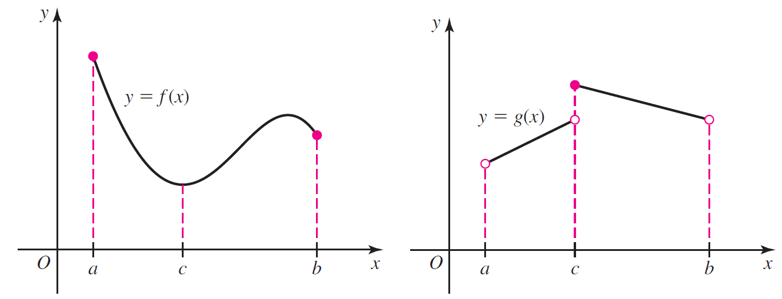

# Topic 3: Local Maxima and Minima

Suppose *c* is contained in some interval *I* on which *f* is defined.

If  for all *x* in *I*, then  is a **local maximum** value of *f*.

If  for all *x* in *I*, then  is a **local minimum** value of *f*.

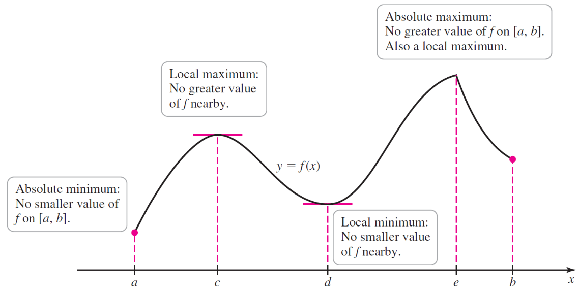

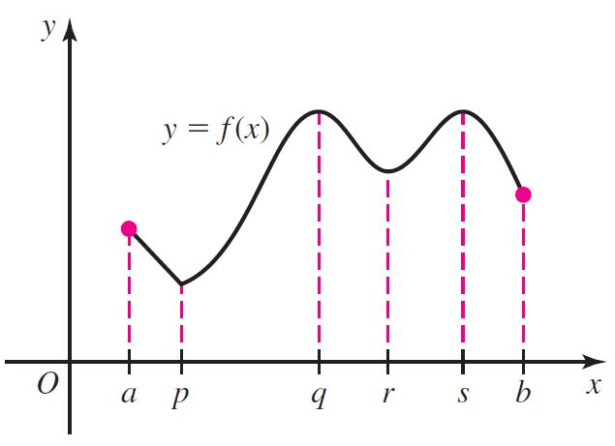

# Topic 4: Critical Points

**Local Extreme Value Theorem:** If *f* has a local maximum or minimum value at *c* and  exists, then .

Local extrema can also occur at points *c* where  does not exist.

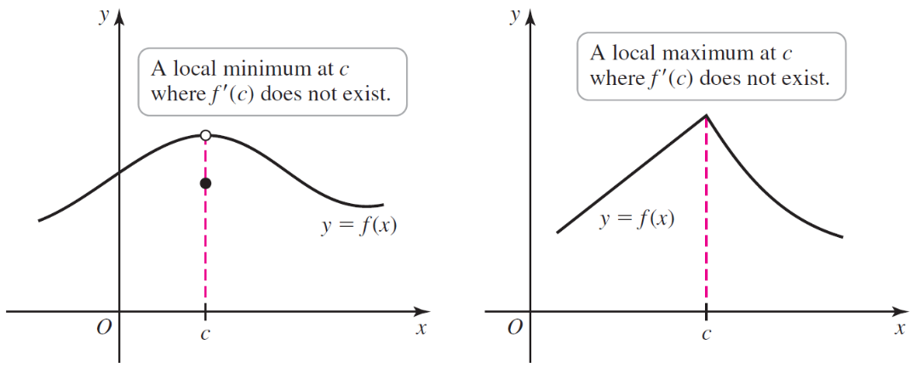

A value *c* of the domain of *f* at which or fails to exist is called a **critical point** of *f.*

It is possible that  or  fails to exist with no local extreme value occurring at *c*.

Therefore, critical points are *candidates* for the location of local extreme values.

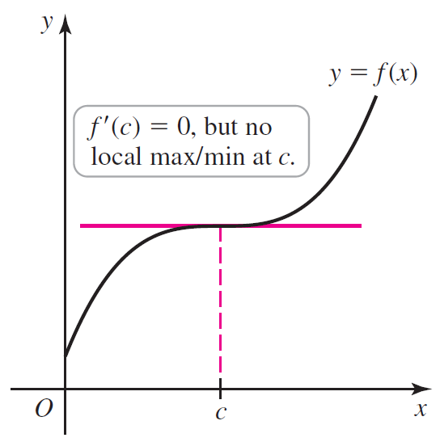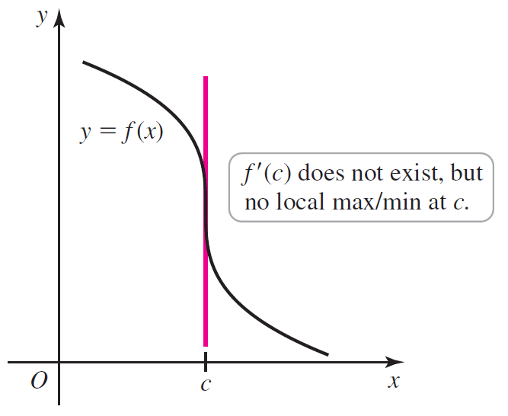

# Topic 5: Locating Absolute Maxima and Minima

The Extreme Value Theorem guarantees the existence of absolute extreme values for a function

that is continuous on the closed interval . Two observations lead to a procedure for finding absolute extreme values.

* An absolute extreme value in the interior of an interval is also a local extreme value, and local extreme values occur at critical points of *f*.
* Absolute extreme values may also occur at the endpoints of the interval of interest.

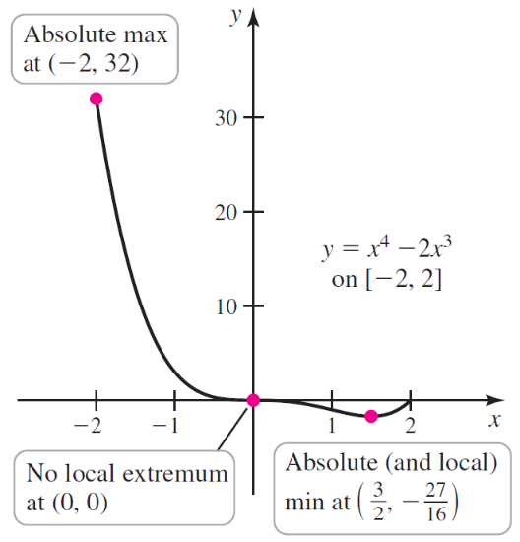

**Steps for Locating Absolute Extreme Values on a Closed Interval**

Assume the function *f* is continuous on the closed interval .

1. Locate the critical points in .
2. Evaluate *f* at the critical points in  and at the endpoints of .
3. Choose the largest and smallest values of *f* from Step 2 for the absolute maximum and minimum values, respectively.