Section 4.2 Mean Value Theorem

# Topic 1: Rolle’s Theorem

**Rolle’s Theorem:** Let *f* be continuous on a closed interval  and differentiable on  with  . There is at least one number *c* in  such that .

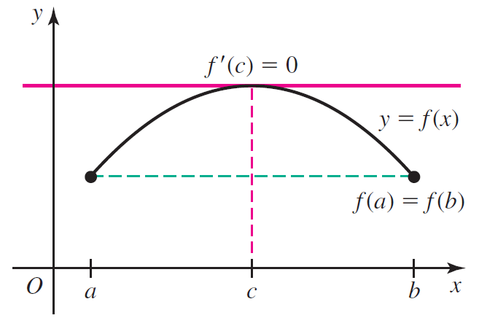

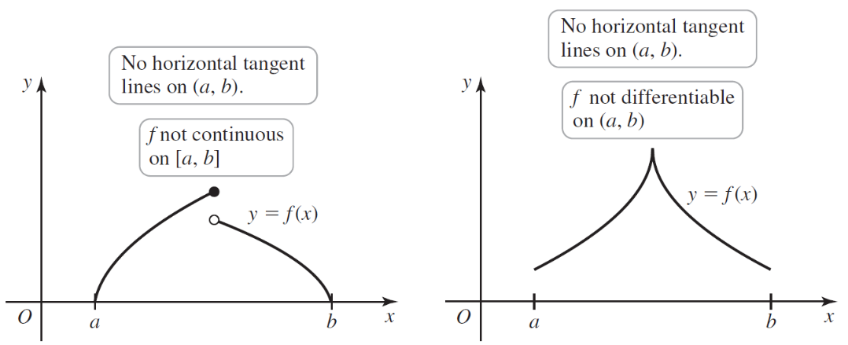

# Topic 2: Mean Value Theorem

**Mean Value Theorem:** Let *f* be continuous on a closed interval  and differentiable on . There is at least one number *c* in  such that .

