Section 4.3 What Derivatives Tell Us

# Topic 1: Increasing and Decreasing Functions

Suppose a function *f* is defined on an interval *I*. We say that *f* is **increasing** on *I* if  whenever  and  are in *I* and . We say that *f* is **decreasing** on *I* if  whenever $x_{1}$ and $x_{2}$ are in *I* and .

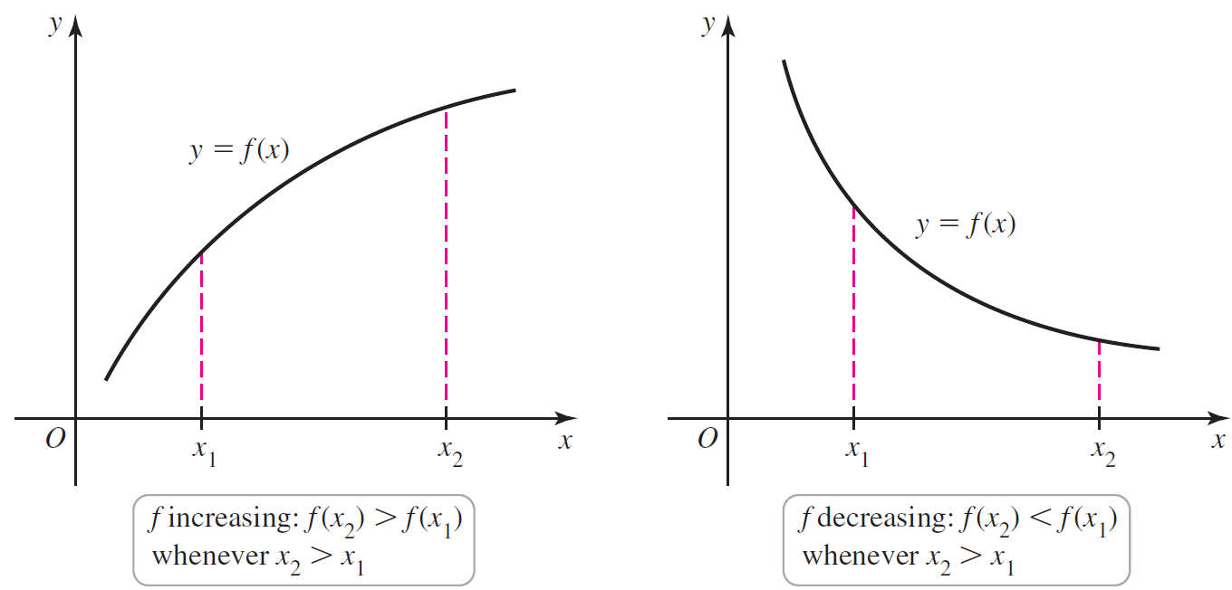

# Topic 2: Intervals of Increase and Decrease

Recall that the derivative of a function gives the slope of the tangent lines. If the derivative is positive on an interval, the tangent lines on that interval have positive slopes, and the function is increasing. If the derivative is negative on an interval, the tangent lines on that interval have negative slopes, and the function is decreasing.

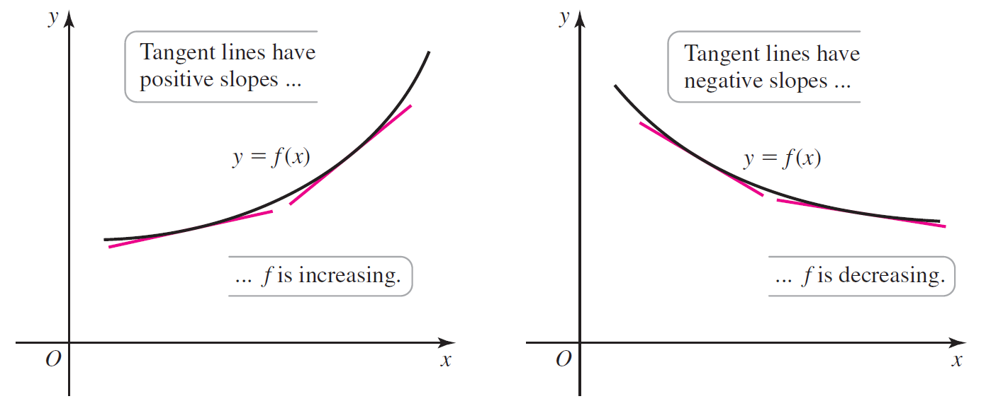

**Theorem: Test for Intervals of Increase and Decrease**

Suppose *f* is continuous on an interval *I* and differentiable at all interior points of *I*. If  at all interior points of *I*, then *f* is increasing on *I*. If  at all interior points of *I*, then *f* is decreasing on *I*.

# Topic 3: Identifying Local Maxima and Minima

Suppose  is a critical point of *f*, where .

Suppose also that  changes signs at *c* with  on an interval  to the left of *c* and  on an interval  to the right of *c*. In this case, *f* is decreasing to the left of *c* and increasing to the right of *c*. Thus, *f* has a local minimum at *c*.

Similarly, suppose that  changes signs at *c* with  on an interval to the left of *c* and  on an interval  to the right of *c*. In this case, *f* is increasing to the left of *c* and decreasing to the right of *c*. Thus, *f* has a local maximum at *c*.

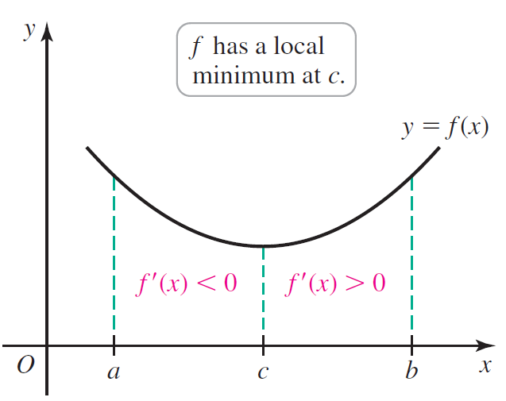 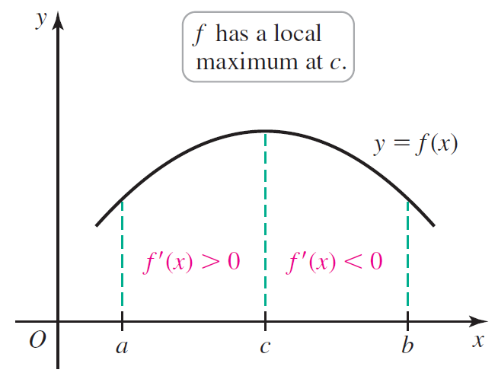

**Theorem: First Derivative Test**

Suppose that *f* is continuous on an interval that contains a critical point *c* and assume *f* is differentiable on an interval containing *c*, except perhaps at *c* itself.

* If  changes sign from positive to negative as *x* increases through *c*, then *f* has a **local maximum** at *c*.
* If  changes sign from negative to positive as *x* increases through *c*, then *f* has a **local minimum** at *c*.
* If  is positive on both sides near *c* or negative on both sides near *c*, then *f* has no local extreme value at *c*.

# Topic 4: Concavity and Inflection Points

Consider the function . Its graph bends upward for , reflecting the fact that the tangent lines get steeper as *x* increases. It follows that the first derivative is increasing for . A function with the property that  is increasing on an interval is concave up on that interval.

Similarly, the graph of  bends downward for  because it has a decreasing first derivative on that interval. A function with the property that  is decreasing on an interval is concave down on that interval.

If a function is concave up at a point, then the tangent line will lie below the graph of the function. If a function is concave down at a point, then the tangent line will lie above the graph of the function.

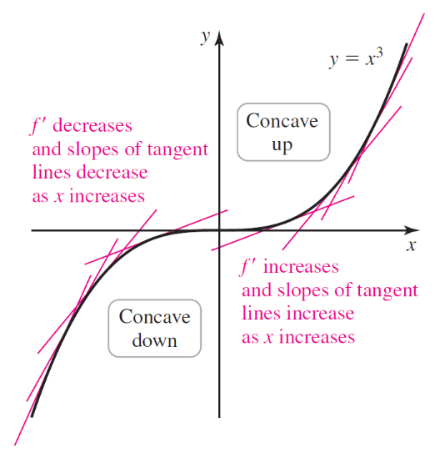

**Concavity and Inflection Points**

Let *f* be differentiable on an open interval *I*. If  is increasing on *I*, then *f* is **concave up** on *I*. If  is decreasing on $I$, then *f* is **concave down** on *I*. If *f*  is continuous at *c* and *f* changes concavity at *c* (from up to down or down to up), then *f* has an **inflection point** at *c*.

If  is positive on an interval *I*, then  is increasing on *I*, and *f* is concave up on I. If  is negative on an interval *I*, then  is decreasing on *I*, and *f* is concave down on *I*. If the values of  change signs at a point *c*, then the concavity of *f* changes at *c*, and *f* has an inflection point at *c*.

**Theorem: Test for Concavity**

Suppose that  exists on an open interval *I*.

* If  is positive on *I*, then *f* is concave up on *I*.
* If  is negative on *I*, then *f* is concave down on *I*.
* If *c* is a point of *I* and  changes sign at *c*, then *f* has an inflection point at *c*.

If  or  does not exist, then  is a *candidate* for an inflection point. To determine whether or not an inflection point occurs at *c*, it is necessary to determine if the concavity of *f* changes at *c*.

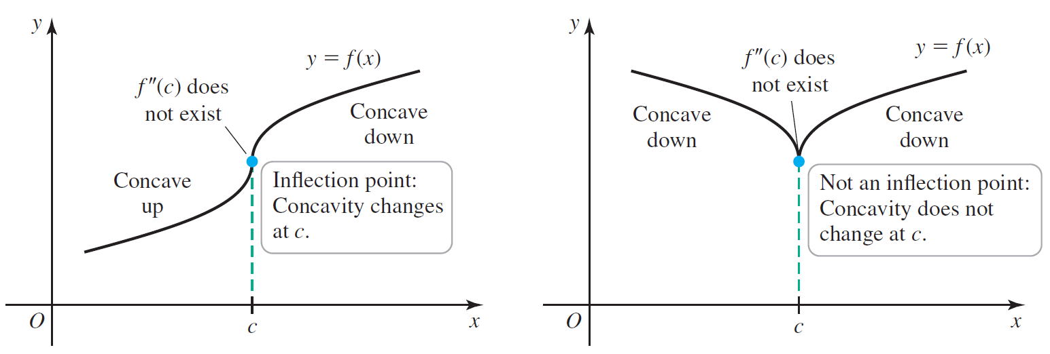

# Topic 5: Second Derivative Test

**Theorem: Second Derivative Test for Local Extrema**

Suppose that  is continuous on an open interval containing *c* with .

* If , then *f* has a local minimum at *c*.
* If , then *f* has a local maximum at *c*.
* If , then the test is inconclusive; *f* may have a local maximum, local minimum, or neither at *c*.

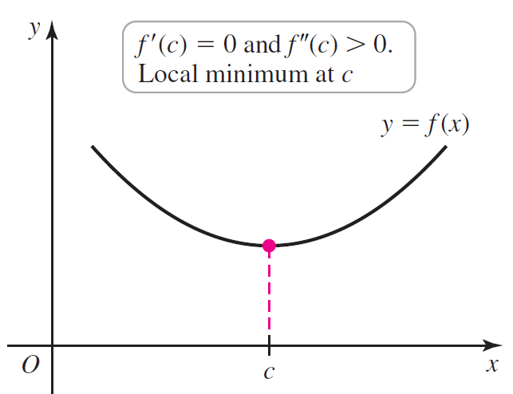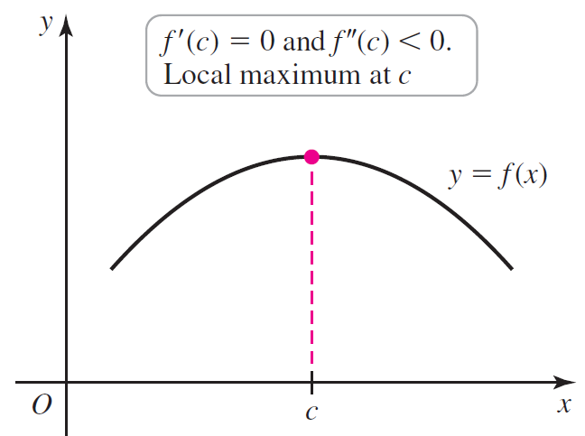

# Topic 6: A Summary of Derivative Properties

The figures below illustrate the following derivative properties:

1. If f is differentiable on an interval, then the graph of f is a smooth curve. The example graph is a smooth curve with three local maximum points and two local minimum points.
2. If , then *f* is increasing. The example graph rises from left to right but not always at the same rate.
3. If , then *f* is decreasing. The example graph falls from left to right but not always at the same rate.
4. If  changes sign at an *x*-value, then *f* has a local maximum or a local minimum at that *x*-value. When changes from positive to negative, there is a local maximum, and the example graph is a parabola opening downward. When  changes from negative to positive, there is a local minimum, and the example graph is a parabola opening upward.
5. If  and  at an *x*-value, then *f* has a local maximum at that *x*-value. The example graph is a parabola opening downward.
6. If  and  at an *x*-value, then *f* has a local minimum at that *x-*value. The example graph is a parabola opening upward.
7. If , then the graph of *f* is concave up. The example graphs show a portion of a graph opening upward and increasing and a portion of a graph opening upward and decreasing.
8. If , then the graph of *f* is concave down. The example graphs show a portion of a graph opening downward and increasing and a portion of a graph opening downward and decreasing.
9. If  changes sign at an *x*-value, then *f* has an inflection point at that *x*-value. The example graph shows a portion of a graph that changes from concave up to concave down at a point of inflection.  is positive on the left side of the point of inflection and negative on the right side of the point of inflection.

