Section 4.6 Linear Approximations and Differentials

# Topic 1: Linear Approximation

The figure shown below suggests that if we zoom in on the graph of a smooth function at a point *P*, the curve approaches its tangent line at *P*. This fact is the key to understanding linear approximations. The idea is to use the line tangent to the curve at *P* to approximate the value of the function at points near *P*.

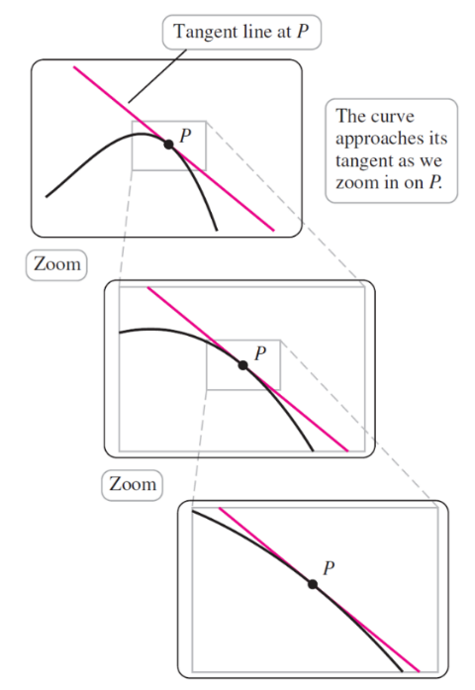

Assume *f* is differentiable on an interval containing the point *a*. The slope of the line tangent to *f* at  is . Therefore, an equation of the tangent line is or.

This tangent line represents a new function *L* that we call the linear approximation to *f* at the point . For values near *a*, .

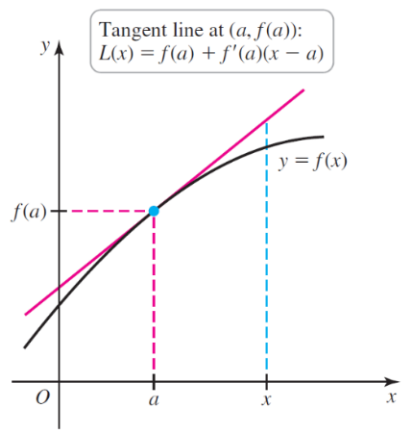

Suppose *f* is differentiable on an interval *I* containing *a*. The **linear approximation** to *f* at *a* is the linear function , for *x* in *I*.

# Topic 2: Linear Approximation and Concavity

If *f* isconcave up at , then the graph of *L* lies below the graph of *f* near *a.*

*L* underestimates the values of *f* near *a.*

If *f* isconcave down at , then the graph of *L* lies above the graph of *f* near *a.*

*L* overestimates the values of *f* near *a.*

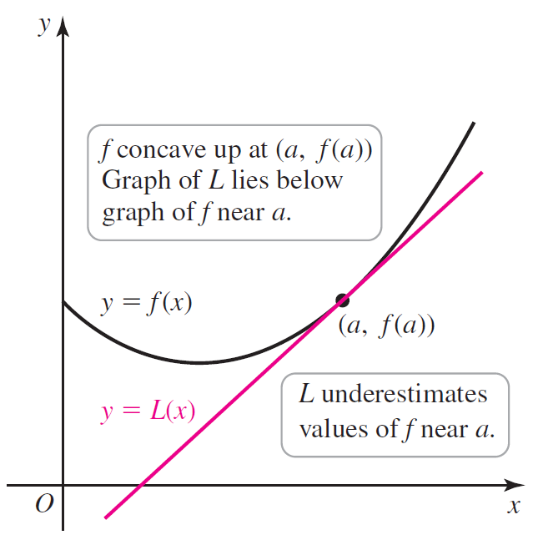 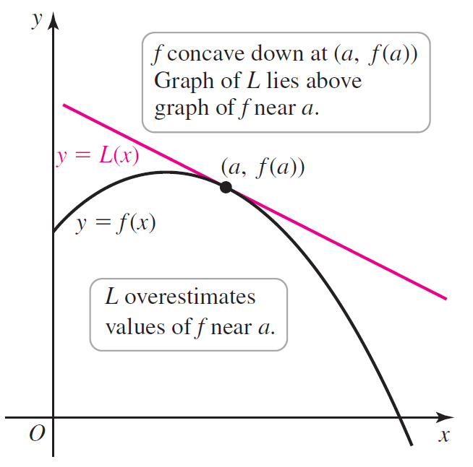

# Topic 3: A Variation on Linear Approximation

**Relationship Between  and **

Suppose *f* is differentiable on an open interval *I* containing *a*. The change in the value of *f* on the interval  can be approximated as  where  is in *I*.

**Summary: Uses of Linear Approximation**

* To approximate *f* near , use .
* To approximate the change in the dependent variable  when *x* changes from *a* to , use .

# Topic 4: Differentials

Differentials allow us to distinguish between two related quantities:

* the change in the function  as *x* changes from *a* to  (which we call ) and
* the change in the linear approximation  as $x$ changes from *a* to  (which we call the differential , defined below).

Let *f* be differentiable on an open interval containing *x*. A small change in *x* is denoted by the **differential** . The corresponding change in *f* is approximated by the **differential **.

