Section 4.8 Newton’s Method

# Topic 1: Deriving Newton’s Method

Newton’s Method is one of the most effective methods for approximating roots, or zeros, of a function when they cannot be found easily using analytical methods.

Assume *r* is a root of *f* that we wish to approximate. This means that . We also assume that *f* is differentiable on some interval containing *r*. Suppose  is an initial approximation to *r* that is generally obtained by some preliminary analysis. A better approximation to *r* is often obtained by carrying out the following two steps.

* Draw a line tangent to the graph of  at the point .
* Find the point  where the tangent line intersects the *x*-axis, and  becomes the new approximation to *r*.

To improve the approximation of , repeat the two-step process using to determine the next estimate, , and so forth. For the curve shown, each new approximation is a better approximation to the root *r* than the previous one.

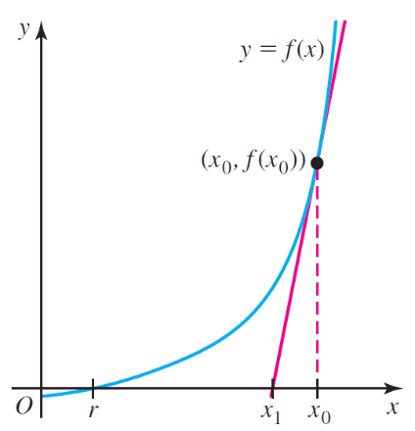 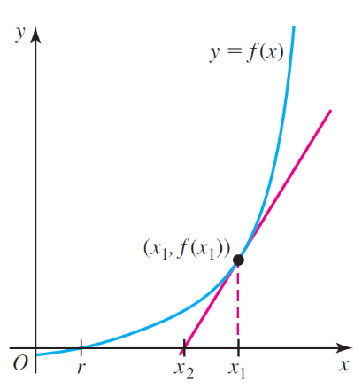 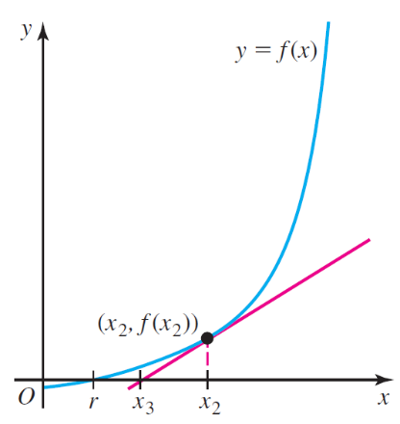

# Topic 2: Newton’s Method

**Procedure: Newton’s Method for Approximating Roots of** 

1. Choose an initial approximation  as close to a root as possible.
2. For *n =* 0, 1, 2, 3, …

, provided .

1. End the calculations when a termination condition is met, depending on the level of accuracy required.