Section 4.9 Antiderivatives

# Topic 1: Antiderivatives

A function is an **antiderivative** of  on an interval *I* provided  , for all *x* in *I*.

**Theorem: The Family of Antiderivatives**

Let  be any antiderivative of on an interval *I*. Then all the antiderivatives of  on *I* have the form  , where *C* is an arbitrary constant.

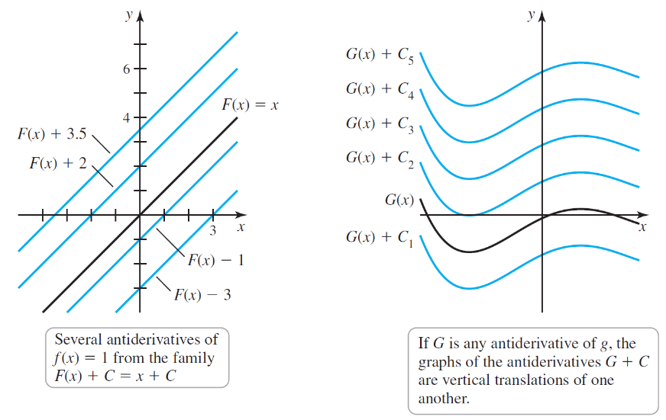

# Topic 2: Indefinite Integrals

The notation  means *take the derivative of* *with respect to x*. We need analogous notation for antiderivatives. For historical reasons, the notation that means *find the antiderivative of* *with respect to x* is the indefinite integral . Every time an indefinite integral sign appears it is followed by a function called the **integrand** and the differential ( when *x* is the independent variable). The notation represents all the antiderivatives of *f*.

**Theorem: Power Rule for Indefinite Integrals**



where  is a real number and *C* is an arbitrary constant.

**Theorem: Constant Multiple and Sum Rules**

Constant Multiple Rule

 for real numbers *c*

Sum Rule



# Topic 3: Indefinite Integrals of Trigonometric Functions

**Indefinite Integrals of Trigonometric Functions**

  

  

  

  

  

  

# Topic 4: Other Indefinite Integrals

**Other Indefinite Integrals**

  

  ,  and

  

  

  

   , 

# Topic 5: Introduction to Differential Equations

An equation involving an unknown function and its derivative is called a **differential equation**. In many cases, the differential equation is accompanied by an **initial condition** that allows us to determine the constant of integration. A differential equation coupled with an initial condition is called an **initial value problem**.

# Topic 6: Motion Problems Revisited

**Initial Value Problems for Velocity and Position**

Suppose an object moves along a line with a (known) velocity , for . Then its position is found by solving the initial value problem

 where  is the initial position.

If the acceleration of the object  is given, then its velocity is found by solving the initial value problem

 where  is the initial velocity.