Section 5.1 Approximating Areas Under Curves

# Topic 1: Area Under a Velocity Curve

Imagine a car traveling at a constant velocity of 60 miles per hour along a straight highway for a two-hour period. The displacement of the car between  and  can be found by using a familiar formula:

displacement 





This product corresponds to the area of the rectangle formed by the velocity curve and the *t*-axis between  and  as shown in the graph below.

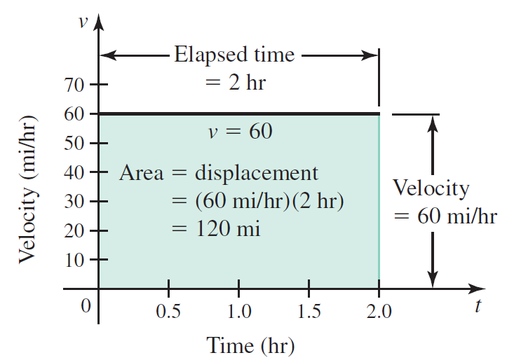

But in most cases, objects do not move at a constant velocity. In these cases, the displacement of an object over time can be approximated by dividing the time interval into subintervals, approximating the displacement on each subinterval (by drawing a rectangle), and then finding the sum of the approximations.

# Topic 2: Approximating Areas by Riemann Sums

Consider a function *f* that is continuous and nonnegative on the interval . The goal is to approximate the area of the region *R* bounded by the graph of *f* and the *x*-axis from  to .

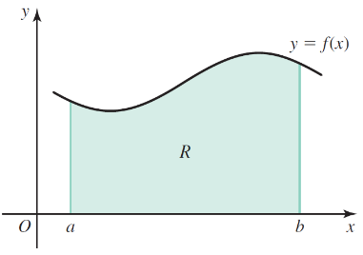

We begin by dividing the interval into *n* subintervals of equal length,



where  and . The length of each subinterval, denoted , is found by dividing the length of the entire interval by *n*.

**Regular Partition:** Suppose  is a closed interval containing *n* subintervals



of equal length  with  and . The endpoints  of the subintervals are called grid points, and they create a **regular partition** of the interval . In general, the *k*th grid point is

, for .

In the *k*th subinterval , we choose any point  and build a rectangle whose height is . The area of the rectangle on the *k*th subinterval is

, where .

Summing the areas of the rectangles gives an approximation to the area which is called a **Riemann sum**:

.

Three notable Riemann sums are the left, right, and midpoint Riemann sums.

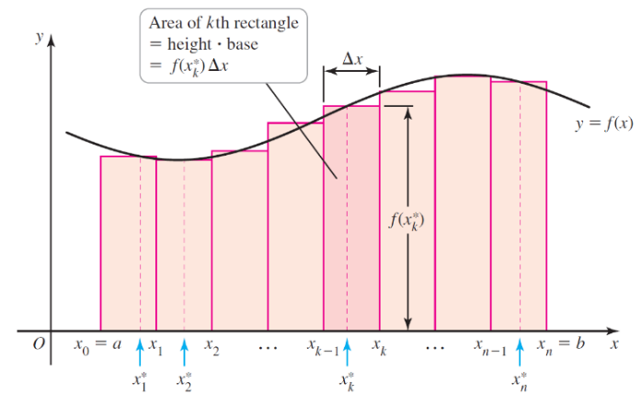

**Riemann Sum**

Suppose *f* is defined on a closed interval , which is divided into *n* subintervals of equal length . If  is any point in the *k*th subinterval , for , then



is called a **Riemann sum** for *f* on . For , this sum is

* a **left Riemann sum** if  is the left endpoint of .
* a **right Riemann sum** if  is the right endpoint of .
* a **midpoint Riemann sum** if  is the midpoint of .

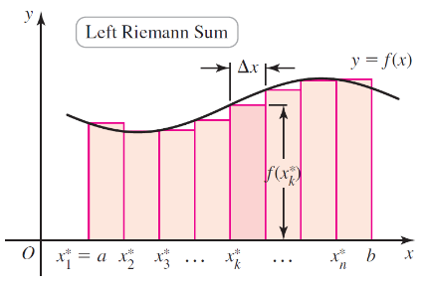 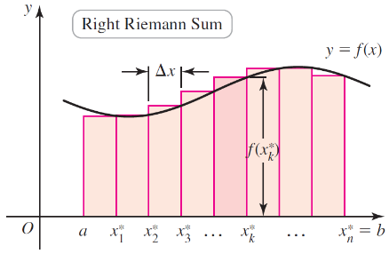 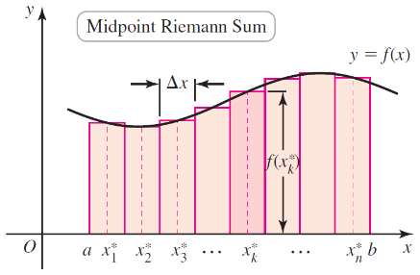

# Topic 3: Sigma (Summation) Notation

**Sigma** (or **summation**) **notation** is used to express sums in a compact way. The symbol  (sigma) stands for sum.

**Theorem: Sums of Powers of Integers**

Let *n* be a positive integer and *c* be a real number.









# Topic 4: Riemann Sums Sigma Notation

**Left, Right, and Midpoint Riemann Sums in Sigma Notation**

Suppose *f* is defined on a closed interval , which is divided into *n* subintervals of equal length . If  is any point in the *k*th subinterval , for , then the **Riemann sum** of *f* on  is

.

Three cases arise in practice.

* **left Riemann sum** if 
* **right Riemann sum** if 
* **midpoint Riemann sum** if 