Section 5.2 Definite Integrals

# Topic 1: Net Area

When the graph of a function lies below the *x*-axis for some interval , the Riemann sum on that interval will be negative. When this is the case, the Riemann sum approximates the negative of the area of the region bounded between the curve and the *x*-axis.

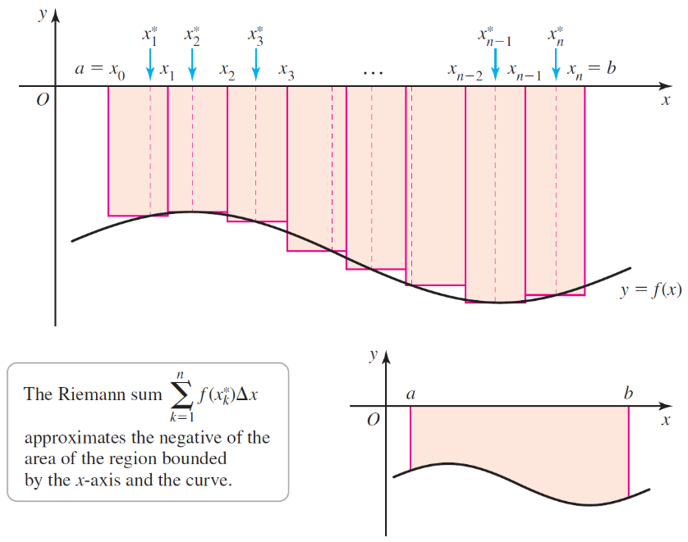

**Net area**

Consider the region *R* bounded by the graph of a continuous function *f* and the *x*-axis between  and . The **net area** of *R* is the sum of the areas of the parts of *R* that lie above the *x*-axis minus the sum of the areas of the parts of *R* that lie below the *x*-axis on .

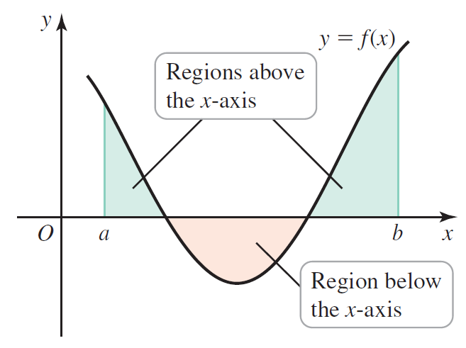

# Topic 2: The Definite Integral

The Riemann sums used so far involve regular partitions in which the subintervals have the same length . We will now look at partitions of  called general partitions in which the lengths of the subintervals are not necessarily equal. The general partition is used to define the general Riemann Sum.

**General Riemann Sum**

Suppose  are subintervals of  with

.

Let  be the length of subinterval  and let  be any point in , for 

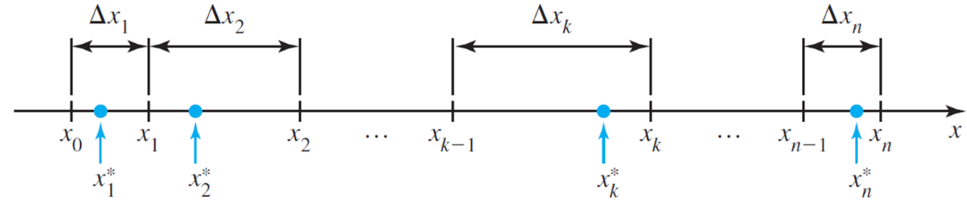

If *f* is defined on , the sum



is called a **general Riemann sum** for *f* on .

We consider the partitions in which we let  denote the largest value of ; that is, . Observe that if , then , for . For



to exist, it must have the same value over all general partitions of  and for all choices of  on a partition.

**Definite Integral**

A function *f* defined on  is integrable on  if



exists. This limit is the **definite integral of *f* from *a* to *b***.



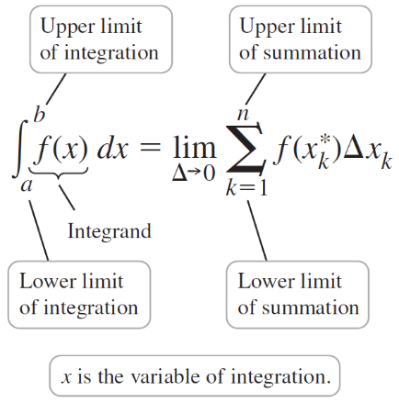

# Topic 3: Evaluating Definite Integrals

**Theorem: Integrable Function**

If *f* is continuous on  or bounded on  with a finite number of discontinuities, then *f* is integrable on .

# Topic 4: Properties of Definite Integrals

**Properties of Definite Integrals**

Let *f* and *g* be integrable functions on an interval that contains *a*, *b*, and *p*.

1.  (definition)
2.  (definition)
3. 
4.  for any constant
5. 

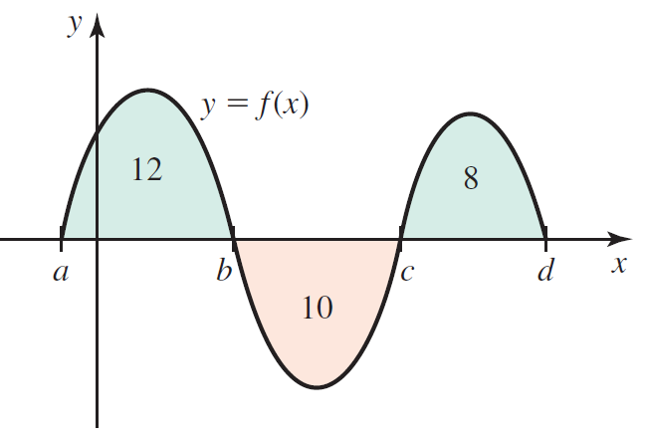

**Topic 5: Evaluating Definite Integrals Using Limits**

If *f* is integrable on , then



for any partition of  and any point . To simplify the calculations, we will use equally spaced grid points and a right Riemann sum to evaluate definite integrals using limits.

