Section 5.3 Fundamental Theorem of Calculus

# Topic 1: Area Functions

Let *f* be a continuous function for . The **area function** for *f* with left endpoint *a* is



where . The area function gives the net area of the region bounded by the graph of *f* and the *t*-axis on the interval .

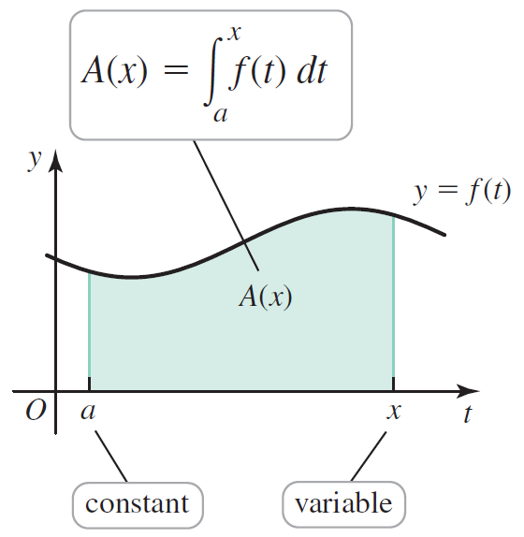

# Topic 2: Fundamental Theorem of Calculus

**Fundamental Theorem of Calculus (Part 1):** If *f* is continuous on , then the area function

, for ,

is continuous on  and differentiable on . The area function satisfies . Equivalently,

.

This means that the area function of *f* is an antiderivative of *f* on .

**Fundamental Theorem of Calculus (Part 2)**

If *f* is continuous on  and  is any antiderivative of *f* on , then

.

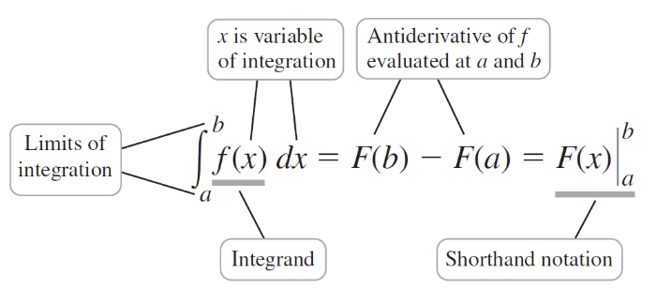

The two parts of the Fundamental Theorem of Calculus express the inverse relationship between differentiation and integration.

* Part 1 of the Fundamental Theorem of Calculus says

.

* Part 2 of the Fundamental Theorem of Calculus says

.