Section 5.4 Working with Integrals

# Topic 1: Integrating Even and Odd Functions

**Theorem: Integrals of Even and Odd Functions**

Let *a* be a positive, real number and let *f* be an integrable function on the interval .

* If *f* is even, then .
* If *f* is odd, then .

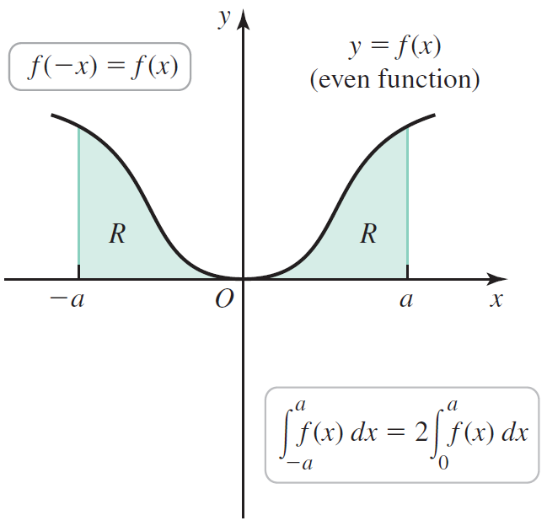 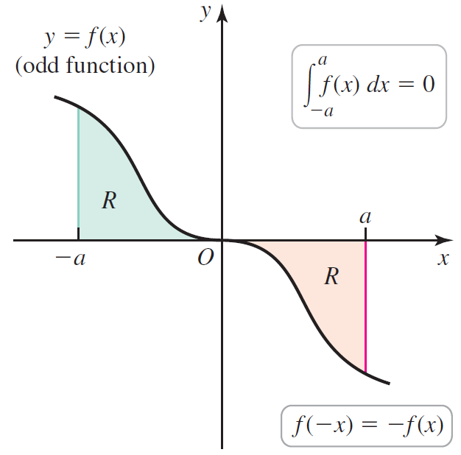

# Topic 2: Average Value of a Function

The **average value of an integrable function** *f* on the interval  is

.

The absolute value of the average value of function *f* on interval , denoted as , is the height of a rectangle with base  that has the same net area as the region bounded by the graph of *f* on the interval .

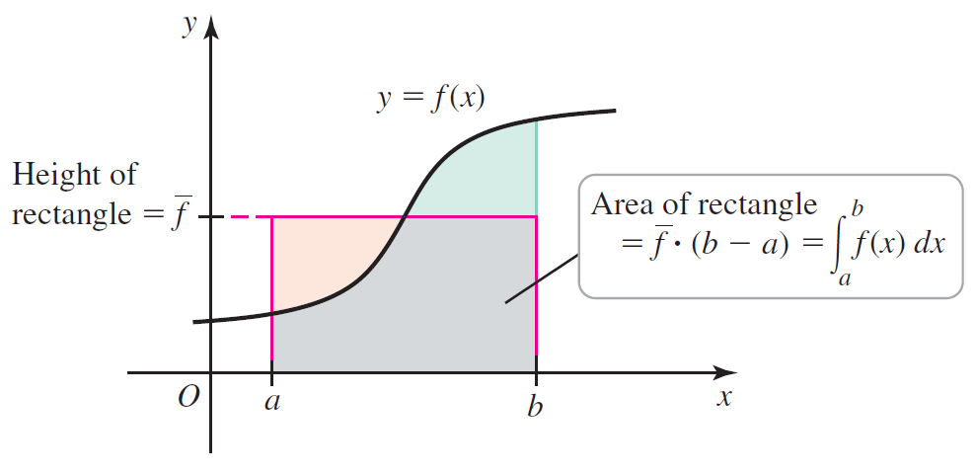

# Topic 3: Mean Value Theorem for Integrals

**Mean Value Theorem for Integrals:** Let *f* be continuous on the interval . There exists a number *c* in  such that

.

