Section 6.1 Velocity and Net Change

# Topic 1: Position, Velocity, Displacement, and Distance

1. The **position** of an object moving along a line at time *t*, denoted , is the location of the object relative to the origin.
2. The **velocity** of an object at time *t* is .
3. The **displacement** of the object between  and  (where ) is

.

1. The **distance traveled** by the object between  and  (where ) is

,

where  is the **speed** of the object at time *t*.

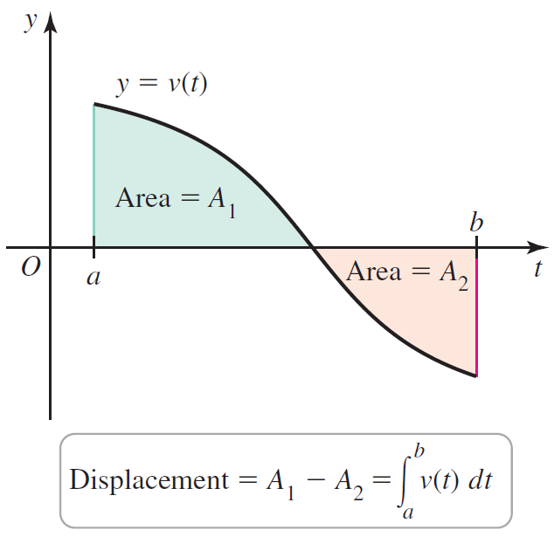 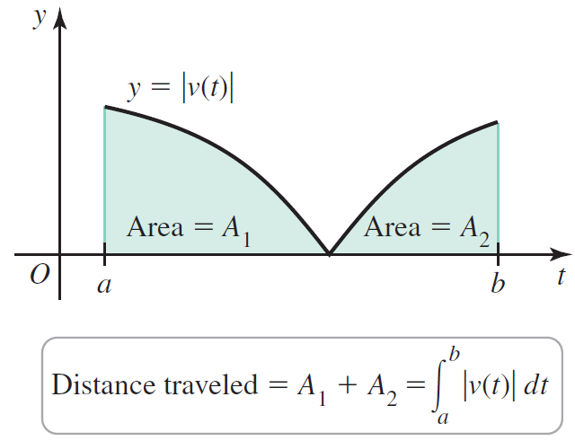

**Theorem: Position from Velocity**

Given the velocity *v* of an object moving along a line and its initial position , the position of the object for time  is

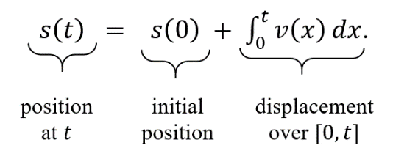

**Theorem: Velocity from Acceleration**

Given the acceleration *a* of an object moving along a line and its initial velocity , the velocity of the object for time is

.

# Topic 2: Net Change and Future Value

**Theorem: Net Change and Future Value**

Suppose a quantity  changes over time at a known rate . The net change in  between  and  (where ) is

.

Given the initial value  , the future value of  at time  is

.