Section 6.2 Applications in Business and Economics

# Topic 1: Continuous Income Stream

**Total Income for a Continuous Income Stream**

If  is the rate of flow of a continuous income stream for time *t*, then the total income produced during the period from  to  is

Total income.

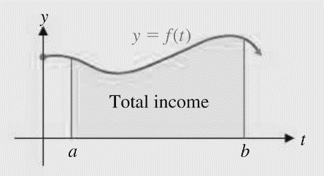

# Topic 2: Future Value of a Continuous Income Stream

**Future Value of a Continuous Income Stream**

If  is the rate of flow of a continuous stream, , and if the income is continuously invested at a rate *r $,$* compounded continuously, then the future value, , at the end of *T* years is given by

.

The future value of a continuous income stream is the total value of all money produced by the continuous income stream (income and interest) at the end of *T* years.

# Topic 3: Consumers’ and Producers’ Surplus

**Consumers’ Surplus**

If  is a point on the graph of the price–demand equation  or a particular product, then the consumers’ surplus, , at a price level of  is



which is the area between  and  from  to  as shown in the figure below. The consumers’ surplus represents the total savings to consumers who are willing to pay more than  for the product but are still able to buy the product for .

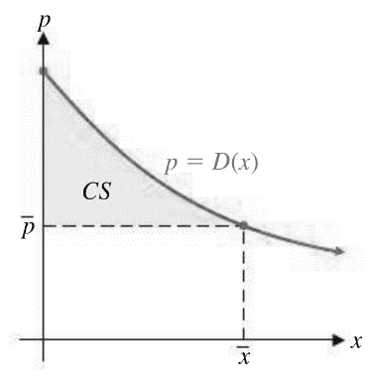

**Producers’ Surplus**

If is a point on the graph of the price–demand equation  for a particular product, then the producers’ surplus, , at a price level of  is



which is the area between  and  from  to  as shown in the figure below. The producers’ surplus represents the total gain to producers who are willing to supply units at a lower price  but are still able to supply units at .

