Section 6.2 Regions Between Curves

# Topic 1: Area of a Region Between Two Curves

Suppose that *f* and *g* are continuous functions with on the interval . The area of the region bounded by the graphs of  and  on  is

.

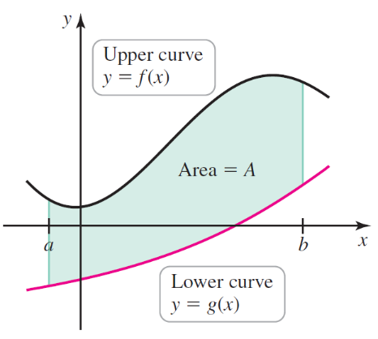 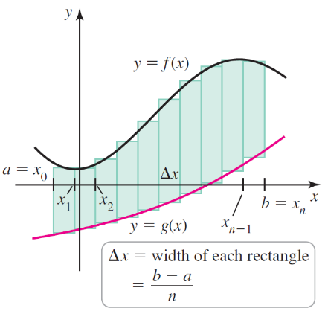 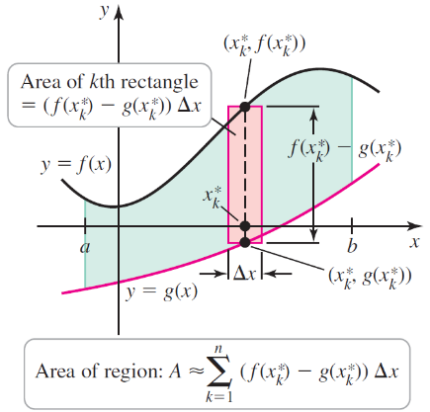

# Topic 2: Integrating with Respect to $y$

**Area of a Region Between Two Curves with Respect to $y$**

Suppose that *f* and *g* are continuous functions with on the interval . The area of the region bounded by the graphs of  and  on  is

.

 