Section 6.4 Volume by Shells

# Topic 1: Cylindrical Shells

The disk/washer method described in the previous section can be used to solve many challenging problems. There are, however, some volume problems that are difficult to solve with this method. We now consider the shell method for computing the volume of solids of revolution.

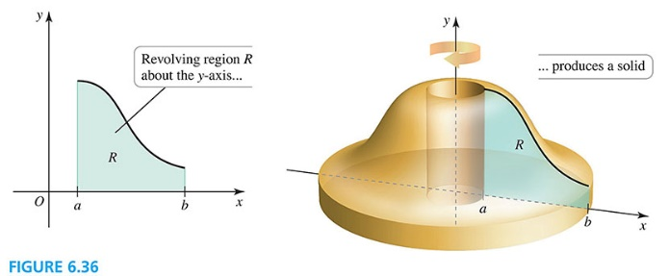

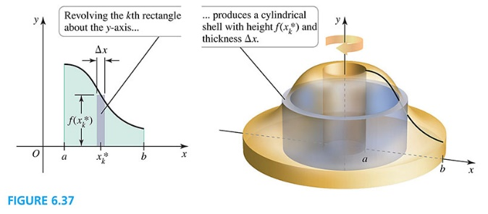

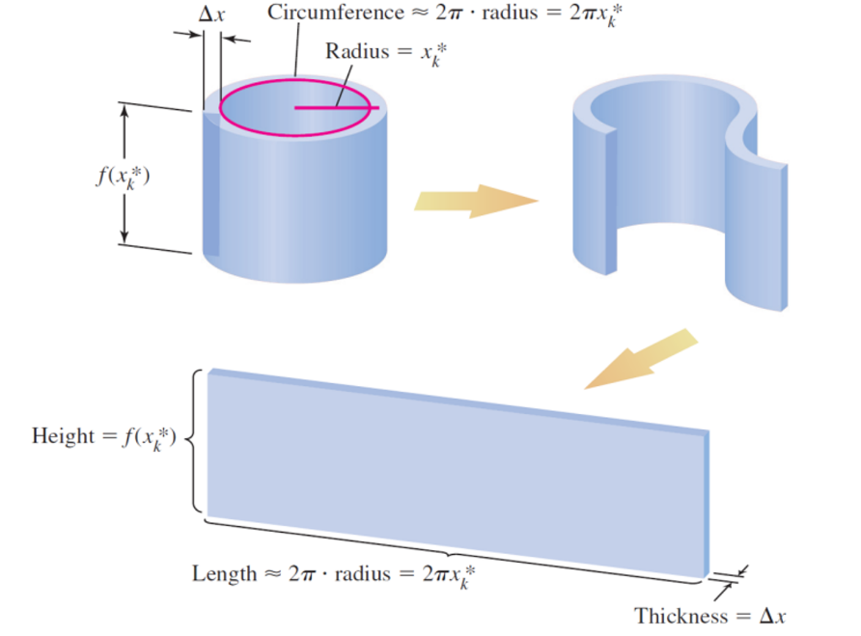

**Volume by the Shell Method**

Let *f* and *g* be continuous functions with  on the interval . If the region *R* bounded by the graphs of *f*, *g*, and the lines  and  is revolved about the *y*-axis, the volume of the resulting solid of revolution is

.

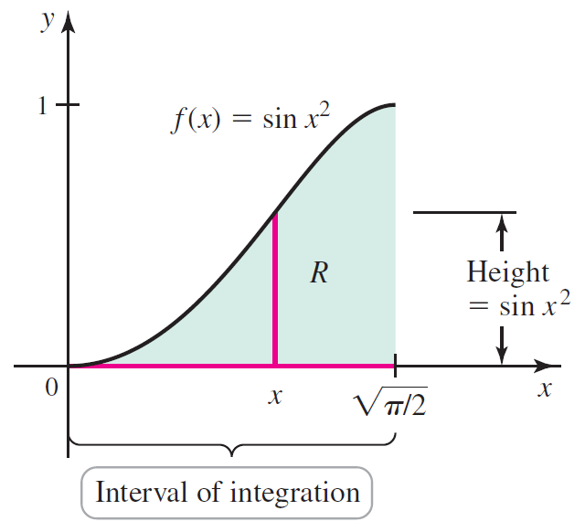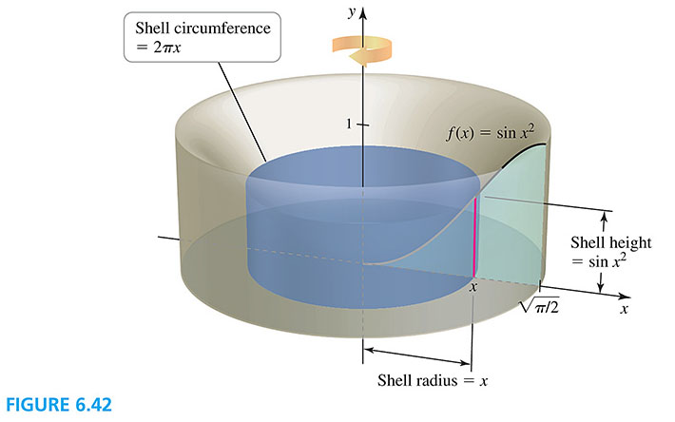

# Topic 2: Shells about the $x$-Axis

The figures below illustrate the shell method when a region *R* is revolved about the *x*-axis.

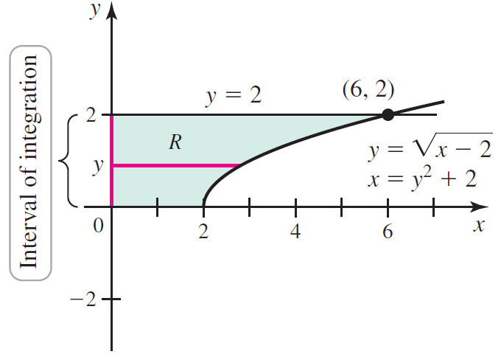 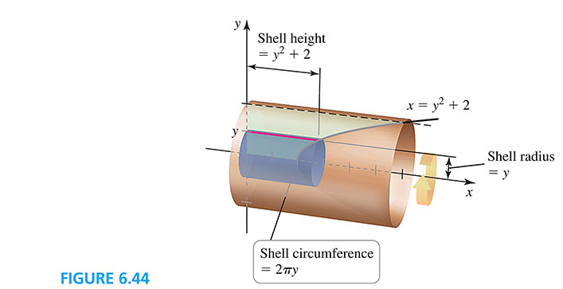

# Topic 3: Revolving about Other Lines

The region *R* shown below is bounded by the line , , and the *y*-axis.

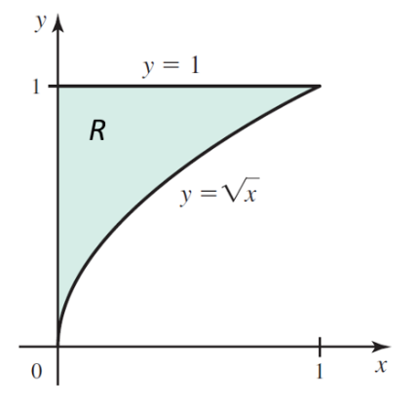

The next pair of figures illustrate the process of revolving *R* around the line  using the shell method.

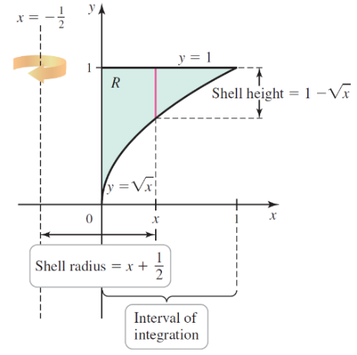 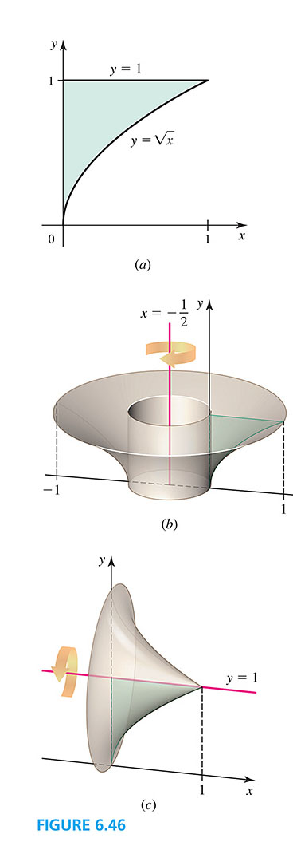

The next pair of figures illustrate the process of revolving *R* around the line  using the shell method.

 