Section 7.1 Graphing and Functions

The **rectangular coordinate system** is also known as the **Cartesian coordinate system,** namedafter Rene’ Descartes.

The Cartesian coordinate system uses two number lines that intersect at right angles at their zero points. The horizontal number line is the **x-axis**. The vertical number line is the **y-axis**. The point of intersection of these axes is their zero points, called the **origin**. Negative numbers are shown to the left and below the origin. The axes divide the plane into four quarters, called **quadrants**. The points located on the axes are not in any quadrant. The quadrants are numbered counterclockwise beginning with quadrant I in the upper right.

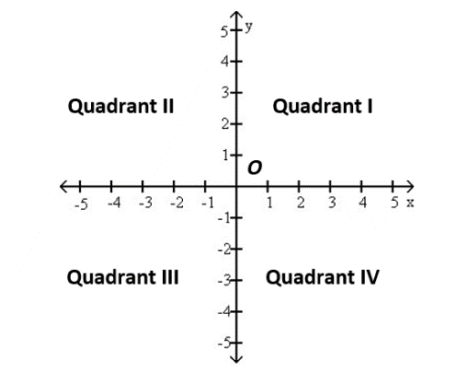

Each point in the rectangular coordinate system corresponds to an **ordered pair** of real numbers . The first number in an ordered pair, called the **x-coordinate**, denotes the distance and direction from the origin along the x-axis. The second number in an ordered pair, called the **y-coordinate**, denotes vertical distance and direction along a line parallel to the y-axis or along the y-axis itself.

# Objective 1: Plotting Ordered Pairs in the Cartesian Plane

To plot the point, go 2 units to the left of the origin on the *x*-axis then move 3 units up parallel to the *y*-axis. The point corresponding to the ordered pair  is located in Quadrant II.

# Objective 2: Graphing Equations by Plotting Points

A **solution of an equation in two variables**, x and y, is an ordered pair of real numbers with the following property: When the x-coordinate is substituted for *x* and the y-coordinate is substituted for *y* in the equation, we obtain a true statement. A solution of an equation is said to **satisfy** the equation.

One way to sketch the graph of an equation is to find several ordered pairs which satisfy the equation, plot those ordered pairs, and then connect the points with a smooth curve. We choose arbitrary values for one of the coordinates then solve the equation for the other coordinate.

The **graph of an equation in two variables** is the set of all points whose coordinates satisfy the equation.