Section 7.4 Linear Inequalities in Two Variables

Recall that a linear equation in two variables is an equation that can be written in the form $Ax+By=C$ where $A$, $B$, and $C$ are real numbers and $A$ and $B$ are not both $0$.

A linear inequality in two variables is an inequality that can be written in one of the following forms:
$Ax+By<C$ $Ax+By>C$
$Ax+By≤C$ $Ax+By≥C$
where $A$, $B$, and $C$ are real numbers and $A$ and $B$ are not both $0$.

An ordered pair is a solution of an inequality in $x$ and $y$ if replacing the variables with the coordinates of the ordered pair results in a true statement.

Objective 1: Graph a linear inequality in two variables

Consider the linear equation $x-y=1$ which is graphed below. Recall that all points on the line defined by $x-y=1$ correspond to ordered pairs that are solutions to the equation.

Notice the line defined by $x-y=1$ divides the coordinate plane into two half-planes. All points on one side of the line are solutions to the inequality $x-y<1$. All points on the other side of the line are solutions to the inequality $x-y>1$. The line that separates these two regions, in this case the line defined by $x-y=1$, is called the boundary line.
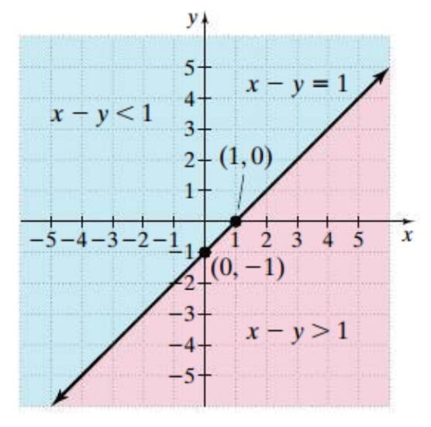

Graphing a linear inequality in two variables can be summarized in the following steps.

Graphing a Linear Inequality in Two Variables

Step 1: Replace the inequality symbol with an equal sign and graph the corresponding linear equation.
- Draw a solid line if the original inequality contains a ≥ or ≤ symbol. The solid line means the points on the line satisfy the inequality.
- Draw a dashed line if the original inequality contains a > or < symbol. The dashed line means the points on the line do not satisfy the inequality.
Step 2: Choose a test point from one of the half-planes. (Do not choose a point on the line.) Substitute the coordinates of the test point into the inequality.
Step 3: If a true statement results, shade the half-plane containing this test point. If a false statement results, shade the half-plane not containing this test point.

Objective 2: Graph a system of linear inequalities

The solution set of a system of linear inequalities is the set of all ordered pairs that satisfy each inequality in the system.

To graph a system of inequalities in two variables, begin by graphing each individual inequality in the same rectangular coordinate system. Then find the region, if there is one, that is common to every graph in the system. The region of intersection gives a picture of the system’s solution set.

