Section 3.7 Coordinate Geometry - Equations of Lines

# Objective 1: Use the Slope-Intercept Form

Recall that the form $y=mx+b$ is called the slope-intercept form of a linear equation because $m$ is the slope of the line and the point $(0,b)$ is the $y$-intercept of the line.

The slope-intercept form can be used to write the equation of a line when its slope and $y$-intercept are known.

a. Find the equation of the line with slope $-\frac{4}{5}$ and $y$-intercept of $(0,7)$.

We can also use the slope-intercept form of the equation of a line to graph a linear equation.

b. Use the slope-intercept form to graph the equation $7x+5y=20$.

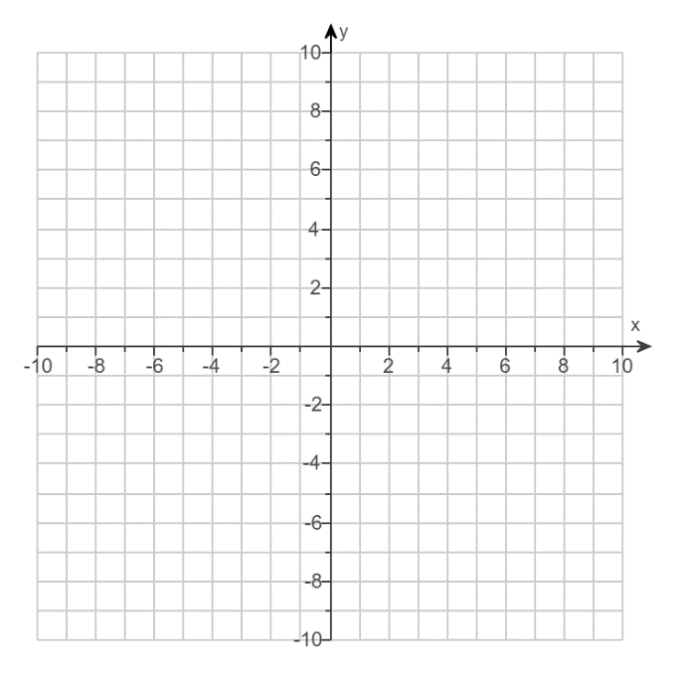

# Objective 2: Use the Point-Slope Form

Given the slope and any point on a line, we can write its equation using the point-slope form of the equation of a line. This form can be derived from the slope formula. Suppose we are given the slope $m$ of a line and a point $(x_{1},y_{1})$ on the line, and $(x,y)$ is any other point on the line.

$$\frac{y-y_{1}}{x-x_{1}}=m$$

$$y-y_{1}=m(x-x_{1})$$

This is the **point-slope form** of the equation of a line.

a. Find the equation of the line that has a slope of $-3$ and passes through the point $(-2,-8)$. Give the equation in standard form.

When given two points on a line, we can find the equation by first finding the slope and then writing the equation in point-slope form.

b. Find the equation of the line that passes through the points $(-4,7)$ and $(-6,-6)$. Give the equation in standard form.

# Objective 3: Writing Equations of Vertical and Horizontal Lines

Recall that vertical lines have equations of the form $x=c$ and horizontal lines have equations of the form $y=c$.

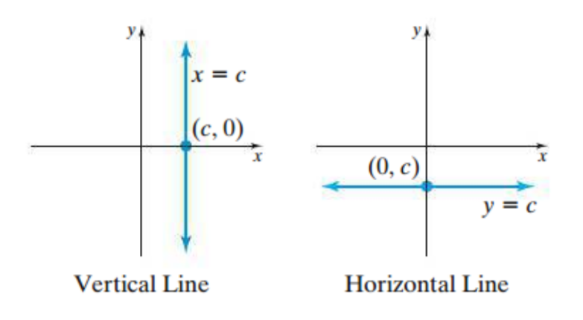

a. Find the equation of the vertical line that passes through the point $\left(-5,8\right).$

b. Find the equation of the horizontal line that passes through the point $\left(-5,8\right).$

# Objective 4: Find the Equations of Parallel and Perpendicular Lines

a. Find the equation of the line, in slope-intercept form, that passes through the point and is parallel to the line .

b. Find the equation of the line, in slope-intercept form, that passes through the point and is perpendicular to the line .

c. Find an equation of the line, in standard form, that passes through the point  and is parallel to the line .

d. Find the equation, in standard form, of the perpendicular bisector of the line segment with endpoints  and.