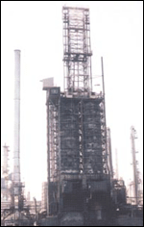
AIMMS User Manual

Table of Contents
Introduction …………………………………………………………………………………………………..4
Vocabulary………………………………………………………………………………………………………5
Opening AIMMS………………………………………………………………………………………………6
Opening the Model--------------------------------------6
Load a Case------------------------------------------------6
Opening the Page Manager---------------------------7
Page Manager Operation------------------------------7

Cost Input………………………………………………………………………………………………………..8
Page Content---------------------------------------------8
Changing Data-------------------------------------------8
Page Output----------------------------------------------9

Cost Summary…………………………………………………………………………………………………10
Page Content--------------------------------------------10
Page Output---------------------------------------------10

Supplier Information……………………………………………………………………………………….11
Page Content-------------------------------------------11
Changing Data------------------------------------------11
Page Output---------------------------------------------12

Supplier Cost……………………………………………………………………………………………………13
Page Content--------------------------------------------13
Changing Data------------------------------------------13
Page Output---------------------------------------------13
Quality Declaration………………………………………………………………………………………….14
Page Content--------------------------------------------14
Changing Data-------------------------------------------14
Page Output----------------------------------------------14

Plant Information……………………………………………………………………………………………..15
Page Content--------------------------------------------15
Page Output---------------------------------------------15

Plant Processing Cost………………………………………………………………………………………..16
Page Content-------------------------------------------16
Changing Data------------------------------------------16
Page Output--------------------------------------------16

Plant Shipping Cost……………………………………………………………………………………………17
Page Content------------------------------------------17
Changing Data-----------------------------------------17
Page Output-------------------------------------------17

Terminal Information…………………………………………………………………………………………18
Page Content-------------------------------------------18
Page Output--------------------------------------------18

Customer Information………………………………………………………………………………………19
Page Content-------------------------------------------19
Changing Data------------------------------------------19
Page Output--------------------------------------------19

Introduction

AIMMS is a computer software program designed for building optimization based operations, research applications, and advanced planning systems. AIMMS includes many advanced modeling concepts and a full graphical interface for the end-user unlike many other optimization software products.
This manual will assist in helping the end-user navigate through AIMMS point-and-click graphical user interface with ease thus allowing Rain CII to be more efficient in Green Coke production. Found in this user manual is a list of vocabulary used by AIMMS and the user manual, how to open AIMMS, and details and instructions about each interface page. This manual and the AIMMS interface developed were customized specifically for the use of Rain CII and affiliates to optimize production and increase company profits.

Vocabulary

- Model Explorer:
Provides user with a simple graphical representation of all the identifiers, procedures, and functions in the model.

- Model:
The mathematical formulas used to execute the objective functions used to produce outputs.

- Cases:
A complete set of data that will enable the end-user to restart a particular modeling application.

- Page Manager:
Organizes all end-user windows associated with AIMMS in a tree-like system to allow for easy end-user navigation.

- Optimize Button:
Button located in the top right-hand corner of the output pages that executes the objective function used to optimize the outputs.

- Green Coke:
The “raw” material Rain CII collects to process and distribute to customers.

Opening AIMMS

Opening the Model

To open AIMMS simply double-click on the link that has been set up on your computer. When AIMMS opens, the model is on the left side of the screen. Next Load a Case.

Load a Case

To load a case, begin by selecting Data from the tool bar at the top of the page (Note: the Data menu option can be accessed from the model page only). From the drop down menu select Load Case. In the next drop down menu, click As Active (see Figure 1.1).

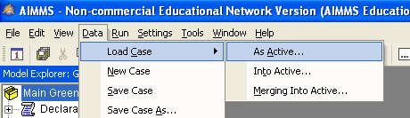
Figure 1.1

A new window will appear with different case names for the end-user to select. Select the name of the set of data, or case, at this time and press Load.

Opening the Page Manager

To open the Page Manager, select the Page Manager icon located on the toolbar (see Figure 1.2 for example).

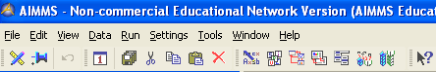
Page Manager Icon
Figure 1.2

After the Page Manager appears on the left side of the screen, the end-user will be able to select which page to see first from the tree-like system (see Figure 1.3).

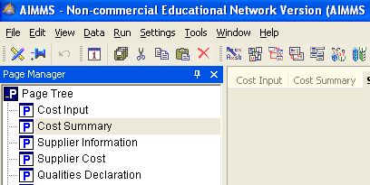
Figure 1.3

Page Manager Operation

The end-user is able to toggle between the Model page and the Page Manager by using the tabs located at the bottom left side of the Page Manager. To open a data page from the Page Manager tree double-click on the desired page to be viewed. When a data page is opened from the Page Manager, a tab containing the name of the page appears at the top of the screen (to the right of the page manager). To switch between pages easily, the end-user simply clicks on the title of the page in which they wish to view.

Cost Input Page

Page Content

The Cost Input page, located on the Page Manager, is where the end-user can access all cost related data that affects the optimization of Rain CII. Located on this page is the Input Supplier Price, Input Processing Cost, Input Shipping Cost from the Supplier to the Plant, and the Input Shipping Cost from the Plant to the Terminal.

Changing Data

All data located on the Cost Input page can be changed by the end-user to produce multiple results. To change data, double-click on the data entry in which you would like to change. The number should highlight and two brackets will appear on each side (See Figure 2.1).

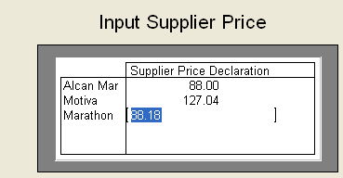
Figure 2.1

Type the new data number to replace the old. When finished adjusting the needed data, click the Optimize button located in the top right corner of the page window. A new Total cost output will be displayed above the Optimize button (see Figure 2.2).

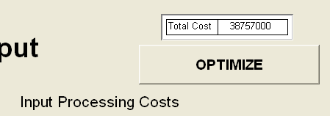
Figure 2.2

Page Output

The Cost Input page outputs the total cost from Supplier Price, Processing Cost, and Shipping Cost from Supplier to Plant and Plant to Terminal. The output can be found above the Optimize button located at the top right-hand corner.

Cost Summary Page

Page Content

The Cost Summary page, located on the Page Manager, shows the summary of all expenses by the company. This page is strictly an output page. No data can be manipulated but multiple outputs can be located here.

Page Output

The Cost Summary page shows the output of Total Product Costs, Shipping
Costs, Processing Cost, and Cost per Customer per Ton. To change any of these outputs the end-user should access the Cost Input page.

Supplier Information Page

Page Content

The Supplier Information page, located on the Page Manager, shows the breakdown of supplier blends. Located on this page are two charts illustrating the Optimum Blend from Supplier to Plant and the Optimum Blend from Supplier to Customer.

Changing Data

Only the graph is adjustable on this page. To adjust the graph, move the cursor to the edge of the bar to be changed so that when the end-user clicks on the bar, the arrow changes to a plus and the edges of the bar become highlighted (see Figure 4.1).

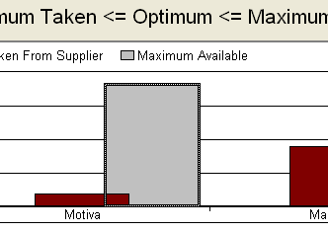
Figure 4.1
(Note: the plus has been slightly exaggerated for display purposes)

When the arrow has changed, the bar can be moved up or down to the desired number on the graph. When the graph is set, press the Optimize button located in the top left corner of the page to produce the output.

Page Output

The Supplier Information page produces an output to show the end-user what is available at each of their suppliers for their customers. Outputs can be found in both charts and above the Optimize button.

Supplier Cost Page

Page Content

The Supplier Cost page, located on the Page Manager, contains all costs that pertain directly to the supplier. Located on this page is Supplier to Plant cost, Shipping cost, and the Total Purchase Price.

Changing Data

Only Cost per Unit and Supplier Purchase Price can be adjusted on this page. To adjust the Cost per Unit, double-click on the desired number so that it is highlighted as earlier demonstrated in Figure 2.1. Once the number is highlighted type in the new number and click the Optimize button at the top right of the page. The data on the Supplier Cost page can be changed on the Cost Input page as well.

Page Output

Outputs located on the Supplier Cost page are all of the costs the supplier will incur. This includes Shipping Costs and Total Supplier Purchase Price in relation to how much product shipped.

Qualities Declaration Page

Page Content

The Qualities Declaration page, located on the Page Manager, displays which qualities each customer would like in their batch of Green Coke. Each data chart is capable of being adjusted to the desired quality amount specified by the costumer. However, only the graph “Supplier Qualities” can be edited on this page.

Changing Data

To edit the data in the charts, double-click on the data point so it becomes highlighted (as shown in Figure 2.1). After the data is highlighted type the desired amount and click the Optimize button located in the top right corner of the display page. To alter the “Supplier Quality” graph move the cursor to the edge of the bar. Click on the edge so that the cursor changes to a plus sign and the bar is highlighted (as shown in Figure 4.1). To recalculate the change, click the Optimize button at the top of the page.

Page Output

The Qualities Declaration page shows the amount of Vanadium and Sulfur contained in each supplier’s batch of Green Coke. Also found on this page is the desired amount each supplier wants in their blend. The amount processed by each plant is located on this page as well.

Plant Information Page

Page Content

The Plant Information page, located on the Page Manager, shows the Supplier Qualities and Plant Pre-process information. This page is strictly an output page. No data can be manipulated but multiple outputs can be located here.

Page Output

The Plant Information page displays the Plants’ Optimal Slack for Customer Demand, Supplier Qualities, and the Plants’ Pre-Processing Qualities. To change Supplier Qualities the end-user should use the Qualities Declaration page.

Plant Processing Cost Page

Page Content

The Plant Processing Cost page, located on the Page Manager, contains data involving the Processing cost and the Supplier to Plant Shipping. Only the “Input Processing Cost” graph and the Processing Restriction can be adjusted on this page.

Changing Data

To change the “Input Processing Cost” graph, move the cursor to the edge of the bar. Click on the edge so that the cursor changes to a plus sign and the bar is highlighted (as shown in Figure 4.1). To recalculate the change, click the Optimize button at the top of the page. To edit the Processing Restriction data in the “Supplier to Plant Shipping” chart, double-click on the data point so it becomes highlighted (as shown in Figure 2.1). After the data is highlighted type the desired amount and click the Optimize button located in the top right corner of the display page.

Page Output

The Plant Processing Cost page displays how much it costs each plant to process the Green Coke. Also located on this page is how much Green Coke is shipped from Supplier to Plant and the processing restriction of the plant.

Plant Shipping Cost Page

Page Content

The Plant Shipping Cost page, located on the Page Manager, displays how much it costs each plant to ship to the specified terminal. Only the Terminal Shipping Cost is able to be adjusted.

Changing Data

To adjust the Terminal Shipping data, double-click on the data point so it becomes highlighted (as shown in Figure 2.1). After the data is highlighted type the desired amount and click the Optimize button located in the top right corner of the display page.

Page Output

The Plant Shipping Cost page produces an output for Plant to Terminal shipping cost. The output can be adjusted for the shipping costs from the four plants to the five different terminals.

Terminal Information Page

Page Content

The Terminal Information page, located on the Page Manager, shows the amount of Green Coke shipped from the Plants to the Terminals and how much it costs. This page is strictly an output page. No data can be manipulated but multiple outputs can be located here.

Page Output

To adjust outputs contained on this page, the end-user can pull up the Cost Input page to change the data. This page displays amount and cost of shipping for the Plants to the Terminals.

Customer Information Page

Page Content

The Customer Information page, located on the Page Manager, displays data involving customer demand and terminal pickup. Only Customer Demand data is adjustable on this page.

Changing Data

To adjust the graph of Customer Demand, move the cursor to the edge of the bar. Click on the edge so that the cursor changes to a plus sign and the bar is highlighted (as shown in Figure 4.1). To recalculate the change, click the Optimize button at the top of the page. To change the Customer Demand data points, double-click on the data so it becomes highlighted (as shown in Figure 2.1). After the data is highlighted type the desired amount and click the Optimize button located in the top right corner of the display page.

Page Output

Outputs found on this page show which terminal each customer can pick up the Green Coke. Each customer will only pick up from one terminal.

