Coreq Support for Section 4.1

Topic 1: Graphing Transformations of the Square Function

(Video: Quadratic Functions and Their Graphs 0:00 – 20:35)
In section 3.4, we graphed transformations of eight basic functions. In this section, we will focus on graphing functions that are transformations of the square function, $y=x^{2}$.

To graph $y=x^{2}$, we can make a table of values and use those points to draw the graph.
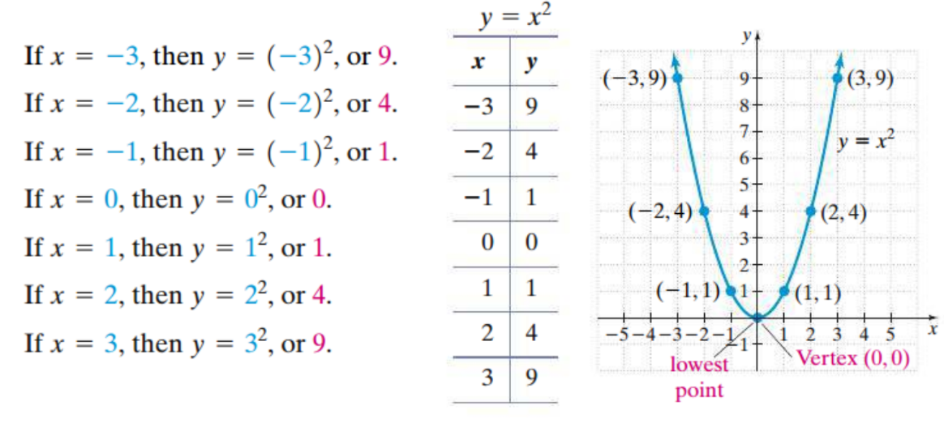
This curve is called a parabola. The lowest point on a parabola opening upward is called the vertex. The graph of a parabola is symmetric about the vertical line that passes through its vertex. The axis of symmetry for the graph of $y=x^{2}$ is the $y$-axis, or the line $x=0$.

Topic 2: Solving Quadratic Equations

Recall that in section 1.4, we learned three methods of solving a quadratic equation: factoring, using the square root property, and using the quadratic formula.

Topic 3: Evaluating Functions for Given Inputs

