Coreq Support for Section 1.6a

Topic 1: Methods of Factoring

(Videos: Greatest Common Factor and Factoring by Grouping; Factoring Trinomials of the Form $x^{2}+bx+c$; Factoring Trinomials of the Form $ax^{2}+bx+c$; Factoring Binomials)

Recall that in previous sections we used several methods of factoring.
- Factoring a greatest common factor
- Factoring by grouping
- Difference of perfect squares
- Factoring trinomials

Topic 2: Solving Quadratic Equations by Factoring and the Zero Product Property

Recall from section 1.4 that some quadratic equations can be solved by factoring and by using the zero product property.

The Zero Product Property: If $AB=0$ then $A=0$ or $B=0$ or both.

Topic 3: Solving Quadratic Equations By Using the Square Root Property

In section 1.4, we also solved quadratic equations by using the square root property.

The Square Root Property: The solution to the quadratic equation $x^{2}-c=0$, or equivalently $x^{2}=c$, is $x=±\sqrt{c}$.

Topic 4: Squaring Binomials

(Video: Special Products 0:00 – 8:20)

Squaring a binomial can be visualized geometrically as the area of a square with side length $(a+b)$ where $a$ and $b$ are both positive, real numbers.
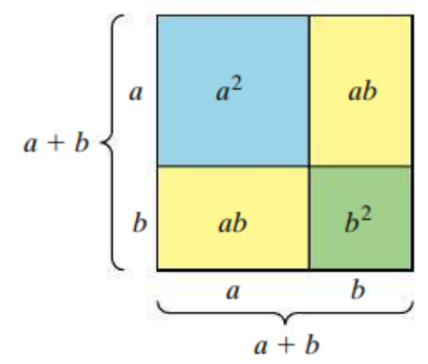
$$Area={\left(a+b\right)}^{2} \\ =(a+b)(a+b) \\ =a^{2}+2ab+b^{2}$$

This leads to two identities that can be used to square a binomial.

$${\left(a+b\right)}^{2}=a^{2}+2ab+b^{2}$$
$${\left(a-b\right)}^{2}=a^{2}-2ab+b^{2}$$

Topic 5: Multiplying the Sum and Difference of Two Terms

(Video: Special Products 8:21 – 13:18)

Another special product is the product of the sum and difference of the same two terms. For products such as this, the linear terms cancels out, leaving the difference of squares. This can be generalized as the following identity.

$$\left(a+b\right)\left(a-b\right)=a^{2}-b^{2}$$

