Coreq Support for Section 1.8

Topic 1: Understanding Absolute Value

The absolute value of a number is its distance from $0$ on the number line. For example, $\left|-5\right|=5$ because the number $-5$ is $5$ units away from $0$ on a number line.

Topic 2: Solving Linear Inequalities

Recall from section 1.7 that the technique to use when solving linear inequalities is to isolate the variable on one side.

We typically describe the solutions to an inequality in one of three ways:
1) Graph the solution on a number line.
2) Write the solution in set builder notation.
3) Write the solution in interval notation.

Topic 3: Compound Inequalities Containing “and”

(Video: Compound Inequalities 0:00 – 10:13)

A value is a solution of a compound inequality containing and if it is a solution of both inequalities. For example, the solution set of the compound inequality $x≤5$ and $x≥3$ contains all values of $x$ that make both statements true. The first graph shown below is the graph of $x≤5$. The second graph is the graph of $x≥3$. The third graph shows the intersection of the two graphs. This graph shows the solution set of the compound inequality $x≤5$ and $x≥3$.
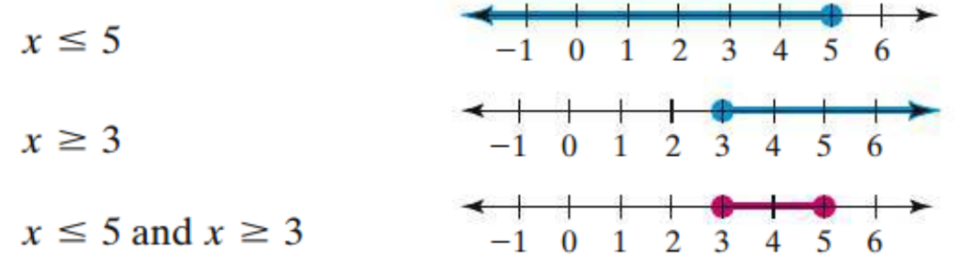

This compound inequality can also be written as $3≤x≤5$.

Topic 4: Compound Inequalities Containing “or”

(Video: Compound Inequalities 10:14 – 18:14)

A value is a solution of a compound inequality containing or if it is a solution of either inequality. For example, the solution set of the compound inequality $x≤1$ or $x≥3$ contains all values of $x$ that make the inequality $x≤1$ a true statement or the inequality $x≥3$ a true statement. The first graph shown below is the graph of $x≤1$. The second graph is the graph of $x≥3$. The third shows the union of the two graphs. This graphs shows the solution set of the compound inequality $x≤1$ or $x≥3$.
