LSU Dual Enrollment Program for Math

COURSE PROFILE with LMS

Content Revised 3-22-2017

COURSE NAME: Geometry
HIGH SCHOOL COURSE CODE: 160323
PRIMARY ONLINE CONTENT SOURCE: Geometry in MyMathLab, Elayn Martin-Gay
COURSE/UNIT CREDIT: 1 Carnegie Unit for full year
GRADE(S): 8, 9, or 10

CHAPTERS
1 – The Beginning of Geometry
2 – Introduction to Reasoning and Proofs
3 – Parallel and Perpendicular Lines
4 – Triangles and Congruence
5 – Special Properties of Triangles
6 – Quadrilaterals
7 – Similarity
8 – Transformations
9 – Right Triangles and Trigonometry
10 – Area
11 – Surface Area and Volume
12 – Circles and Other Conic Sections
13 – Probability

SECTION NAMES (NUMBER OF EXERCISES) AND LEARNING OBJECTIVES | LMS #
CHAPTER 1: The Beginning of Geometry | no data
1.2 Geometry – A Mathematical System (32)
Understand how a mathematical system, like geometry, is formed.
1.3 Points, Lines, and Planes (49)  Learn the basic terms and postulates of geometry | G-CO.A.1
1.4 Segments and Their Measures (35)  Determine where a point is on a line  Understand the measure of segments  Determine whether segments are congruent  Use segment postulates and algebra to find segment lengths | G-CO.A.1
1.5 Angles and Their Measures (35)  Understand the measure of angles  Use algebra and the Angle Addition Postulate to solve applications | G-CO.A.1
1.6 Angle Pairs and Their Relationships (52)  Learn special relationships between pairs of angles  Use algebra to find angle measures | G-CO.A.1  7.G.B.5
1.7 Midpoint and Distance Formulas (39)  Find the midpoint of a segment  Find the endpoint of a segment  Find the distance between two points on the coordinate plane  Find the midpoint and distance of two points | G-GPE.B.6  8.G.B.8
1.8 Basic Geometry Constructions (25)  Make basic constructions using a straight edge and a compass | G-CO.D.12
CHAPTER 2: Introduction to Reasoning and Proofs | no data
2.1 Perimeter, Circumference, and Area (44)  Find the perimeter of circumference of basic shapes  Find the area of basic shapes  Determine whether a situation is discussing area or perimeter  Determine the perimeter and area  Understand the concepts of perimeter and area | G-GPE.B.7
2.6 Properties of Equality and Two-Column Proofs (41)  Use properties of equality to justify reasons for steps  Write a two-column proof | G-CO.C.9
2.7 Proving Theorems About Angles (37)  Prove and uses theorems about angles | G-CO.C.9
CHAPTER 3: Parallel and Perpendicular Lines | no data
3.1 Lines and Angles (61)  Identify relationships between lines and planes  Learn the names of angles formed by lines and a transversal | G-CO.A.1  8.G.A.5
3.2 Proving Lines are Parallel (57)  Use theorems to prove that two lines are parallel  Use algebra to find the measures of angles needed so that lines are parallel.  Understand the concepts of proofs | G-CO.C.9  8.G.A.5
3.3 Parallel Lines and Angles Formed by Transversals (45)  Prove and use theorems about parallel lines cut by a transversal  Use algebra to find measures of angles formed by parallel lines | G-CO.C.9
3.4 Proving Theorems: Parallel and Perpendicular Lines (30)  Use and prove theorems about parallel and perpendicular lines  Use algebra to find measures of angles related to perpendicular lines | G-CO.C.9  G-MG.A.1
3.5 Constructing Parallel an Perpendicular Lines (28)  Construct parallel and perpendicular lines  Construct geometric shapes | G-CO.D.12  7.G.A.2
3.6 Coordinate Geometry – The Slope of a Line (30)  Find the slope of a line  Interpret the slope-intercept form in an application  Compare the slopes of parallel and perpendicular lines | G-GPE.B.5  8.EE.B.6
3.7 Coordinate Geometry – Equations of Lines (21)  Use the slope-intercept form  Use the point-slope form  Write the equations of vertical and horizontal lines  Find the equations of parallel and perpendicular lines  Understand the concepts of parallel and perpendicular lines  Find the equation of the perpendicular bisector of a line segment | G-GPE.B.5
CHAPTER 4: Triangles and Congruence | no data
4.1 Types of Triangles (63)  Learn the vocabulary of triangles  Classify triangles by angles and sides  Find angle measures of triangles | G-CO.C.10  8.G.A.5
4.2 Congruent Figures (40)  Identify corresponding parts in congruent figures  Prove triangles are congruent | G-SRT.B.5
4.3 Congruent Triangles by SSS and SAS (35)  Determine parts of a triangle using a drawing  Prove two triangles are congruent using the SSS and SAS postulates  Use the distance formula to determine if two triangles are congruent  Understand the meaning of the SSS and SAS postulates | G-SRT.B.5
4.4 Congruent Triangles by ASA and AAS (47)  Prove two triangles are congruent using ASA postulates and the AAS theorem  Identify when to use SSS, SAS, ASA, or AAS to prove triangles congruent  Use postulates and theorems of congruence to find missing values in a triangle | G-SRT.B.5
4.5 Proofs Using Congruent Triangles (45)  Identify common parts of overlapping triangles  Use triangle congruence and corresponding parts of congruent triangles  Prove two triangles are congruent using other congruent triangles  Determine the measure of missing angles and sides of congruent triangles | G-SRT.B.5  G-MG.A.1
4.6 Isosceles, Equilateral, and Right Triangles (71)  Determine if triangles are congruent  Use properties of isosceles and equilateral triangles  Use properties of right triangles  Use multiple properties of triangles to solve  Construct triangles | G-CO.C.10  G-SRT.B.5  G-MG.A.1
CHAPTER 5: Special Properties of Triangles | no data
5.1 Perpendicular and Angle Bisectors (42)  Use perpendicular bisectors to solve problems  Use angle bisectors to solve problems | G-CO.C.9  G-CO.D.12  G-SRT.B.5
5.2 Bisectors of a Triangle (44)  Identify the differences between the circumcenter and the incenter of a triangle  Use properties of perpendicular bisectors of sides of a triangle  Use properties of angle bisectors of the angles of a triangle  Use properties of both perpendicular bisectors and angle bisectors | G-C.A.3  G-MG.A.1
5.3 Medians and Altitudes of a Triangle (42)  Identify differences between medians and altitudes of triangles  Use properties of the medians of a triangle  Use properties of the altitudes of a triangle | G-CO.C.10  G-GPE.B.4
5.4 Midsegments of Triangles (35)  Use properties of midsegments of triangles  Use coordinate geometry with midsegments  Solve applications of midsegments | G-CO.C.10  G-CO.D.12  G-GPE.B.4  G-MG.A.1
5.5 Indirect Proofs and Inequalities in One Triangle (47)  Use indirect reasoning to write proofs  Learn the triangle relationship between length of a side and size of its opposite angle  Use the triangle inequality theorem | G-CO.C.10
5.6 Inequalities in Two Triangles (26)  Use the Hinge Theorem and its converse to compare measures of sides and angles | G-CO.C.10  G-MG.A.1
CHAPTER 6: Quadrilaterals | no data
6.2 Parallelograms (51)  Use relationships among sides and angles of parallelograms  Use relationships among consecutive angles and diagonals of parallelograms | G-CO.C.11  G-MG.A.1
6.3 Proving that a Quadrilateral is a Parallelogram (24)  Determine whether quadrilaterals are parallelograms  Use coordinate geometry with parallelograms | G-CO.C.11  G-GPE.B.4  G-MG.A.1
6.4 Rhombuses, Rectangles, and Squares (39)  Define and classify special types of parallelograms  Use properties of diagonals of rhombuses, rectangles, and squares  Use properties of diagonals to form rhombuses, rectangles, and squares | G-CO.C.11
6.5 Trapezoids and Kites (36)  Use properties of trapezoids  Use properties of kites | G-SRT.B.5
CHAPTER 7: Similarity | no data
7.3 Similar Polygons (51)  Identify similar polygons  Use similar polygons to solve applications  Understand the concepts of similar polygons  Make scaled drawings | G-SRT.B.5
7.4 Proving Triangles are Similar (48)  Use the AA~ Postulate and the SAS~ and SSS~ Theorem  Use similarity to find indirect measurements  Find the measurements of similar figures | G-SRT.B.4  G-SRT.B.5
7.5 Geometric Mean and Similarity in Right Triangles (43)  Use altitudes of right triangles to prove similarity  Find the geometric mean of the lengths of segments in a right triangle  Solve applications involving right triangles  Understand the concepts of right triangles | G-SRT.B.4 G-SRT.B.5
7.6 Additional Proportions in Triangles (45)  Use the Side-Splitter Theorem  Use the Triangle-Angle-Bisector Theorem  Understand the properties of parallelograms | G-SRT.B.4  G-SRT.B.5
CHAPTER 8: Transformations | no data
8.1 Rigid Transformations (18)  Identify rigid transformations of isometries  Name images and corresponding parts  Use isometries to determine values of variables | G-SRT.A.2
8.2 Translations (20)  Find translation images of figures  Write ordered-pair translation rules  Solve application problems involving translations  Solve conceptual problems involving translations | G-CO.A.2  G-CO.B.6
8.3 Reflections (26)  Find reflection images of figures  Identify and use line symmetry  Solve application problems involving reflections  Solve conceptual problems involving reflections | G-CO.A.2  G-CO.A.5  G-CO.B.6
8.4 Rotations (27)  Draw and identify rotation images of figures  Find angles of rotation  Identify symmetries | G-CO.A.2  G-CO.B.6
8.5 Dilations (22)  Understand dilation images of figures | G-SRT.A.1  G-CO.A.2
8.6 Compositions of Reflections (21)  Find compositions of reflections, including glide reflections  Classify isometries  Work with kaleidoscope images  Prove properties of transformations | G-CO.A.2  G-CO.A.4  G-CO.A.5  G-CO.B.6
CHAPTER 9: Right Triangles and Trigonometry | no data
9.1 Pythagorean Theorem and its Converse (36)  Use the Pythagorean Theorem  Use the converse of the Pythagorean Theorem  Solve application problems | G-SRT.C.8  G-CO.C.10
9.2 Special Right Triangles (27)  Use the properties of 45°-45°-90° triangles  Use the properties of 30°-60°-90° triangles  Use the properties of special triangles to find the missing parts of figures  Solve application problems | G-SRT.C.6  G-SRT.C.8  G-CO.C.10  G-MG.A.1
9.3 Trigonometric Ratios (47)  Write the ratios for sine, cosine, and tangent given a right triangle  Approximate values for the sine, cosine, and tangent of an angle  Use sine, cosine, and tangent ratios to determine side lengths in right triangles  Approximate angle measures given the sine, cosine, or tangent value  Use the sine, cosine, and tangent ratios to determine angle measure in right triangles  Write the ratios for secant, cosecant, and cotangent given a right triangle  Solve application problems | G-SRT.C.6  G-SRT.C.7  G-SRT.C.8  G-MG.A.1
9.4 Solving Right Triangles (29)  Solve right triangles  Use angle of elevation and depression to solve problems  Solve application problems | G-SRT.C.8
CHAPTER 10: Area | no data
10.1 Angles: Polygons & Regular Polygon Tessellations (38)  Find and use the measures of interior angles of polygons  Find and use the measures of exterior angles of polygons  Solve problems related to the measures of interior and exterior angles of polygons  Determine whether a tessellation of regular polygons is formed  Prove theorems related to the measures of interior and exterior angles of polygons | No LMS correlation
10.2 Areas of Triangles and Quadrilaterals (47)  Find the areas of squares, rectangles, parallelograms, and triangles  Find the areas of trapezoids, rhombuses, and kites  Find the areas of irregular figures | G-GPE.B.7  G-MG.A.1
10.3 Areas of Regular Polygons (36)  Find the measures of angles formed between radii and the apothem in regular polygons  Find areas of regular polygons  Find areas of regular polygons using trigonometric ratios  Solve problems involving geometric constructions or proofs  Understand the relationships among radii, apothems, side lengths, and areas of regular polygons | G-CO.D.13
10.4 Perimeters and Areas of Similar Figures (33)  Find scale factors and ratios of perimeters and areas of similar figures  Find side lengths, perimeters, and areas of similar figures  Solve application problems  Solve problems involving geometric constructions  Complete statements about similar figures | G-SRT.B.5
10.5 Arc Measure, Circumference, and Arc Lengths of Circles (40)  Identify and name semicircles, major arcs, and minor arcs  Find measures of central angles and arcs  Find circumferences and arc lengths | G-CO.A.1  G-C.A.2
10.6 Areas of Circles and Sectors (33)  Find areas of circles, sectors, and segments of circles  Find radii of circles  Solve problems relating regular polygons and circles | G-C.B.5  G-MG.A.1
10.7 Geometric Probability (33)  Use segment models to find the probabilities of events  Use are models to find the probabilities of events | S-CP.A.1
CHAPTER 11: Surface Area and Volume | no data
11.1 Solids and Cross Sections (35)  Recognize polyhedra and their parts  Visualize cross sections of solids  Visualize solids formed by revolving a region about a line | G-GMD.B.4  G-MG.A.1
11.4 Volume of Prisms and Cylinders (32)  Find the volume of a prism  Find the volume of a cylinder  Find the volume of a composite solids | G-GMD.A.3  G-MG.A.1
11.5 Volume of Pyramids and Cones (20)  Find the volume of a pyramid  Find the volume of a cone | G-GMD.A.3  G-MG.A.1
11.6 Volume of Spheres (16)  Find the volume of a sphere | G-GMD.A.3  G-MG.A.1
CHAPTER 12: Circles and Other Conic Sections | no data
12.1 Circle Review and Tangent Lines (33)  Review circles and arcs  Use properties of a tangent line to a circle  Solve problems involving geometric proofs or constructions | G-C.A.2
12.2 Chords and Arcs (18)  Use congruent chords, arcs, and central angles  Use perpendicular bisectors to chords  Solve problems involving geometric proofs or constructions | G-C.A.2
12.3 Inscribed Angles (18)  Find measures of inscribed angles and/or intercepted arcs  Find measures of angles and/or arcs formed by tangent and chords  Solve problems involving geometric proofs or constructions | G-C.A.2  G-C.A.3  G-C.A.4
12.4 Additional Angle Measure and Segment Lengths (17)  Find measures of angles formed by chords, secants, and tangents  Find the lengths of segments associated with circles  Solve application problems  Solve problems involving geometric proofs | G-C.A.2
12.5 Circles in the Coordinate Plane (19)  Write an equation of a circle  Find the center and radius of a circle written in standard form  Complete the square to find the center and radius of a circle  Find quantities related to circles | G-GPE.A.1
CHAPTER 13: Probability | no data
13.1 Fundamentals of Probability (18)  Compute theoretical probability  Compute empirical probability | S-CP.A.1  S-CP.A.4
13.2 Events Involving “Not” and “Or” (16)  Find the probability that an event will not occur  Find the probability of one event or a second event occurring | S-CP.A.1  S-CP.A.4
13.3. Events Involving “And”; Conditional Probability (19)  Find the probability of one event and a second event occurring  Compute conditional probabilities | S-CP.A.2  S-CP.A.3

LMS for Geometry that are not reflected in MyMathLab course exercises:
LMS# | Standard Description
G-CO.A.3 | Given a rectangle, parallelogram, trapezoid, or regular polygon, describe the rotations and reflections that carry it onto itself.
G-CO.B.7 | Use the definition of congruence in terms of rigid motions to show that two triangles are congruent if and only if corresponding pairs of sides and corresponding pairs of angles are congruent.
G-CO.B.8 | Explain how the criteria for triangle congruence (ASA, SAS, and SSS) follow from the definition of congruence in terms of rigid motions.
G-SRT.A.3 | Use the properties of similarity transformations to establish the AA criterion for two triangles to be similar.
G-C.A.1 | Prove that all circles are similar.
G-GMD.A.1 | Give an informal argument for the formulas for the circumference of a circle, area of a circle, volume of a cylinder, pyramid, and cone. Use dissection arguments, Cavalieri’s principle, and informal limit arguments.
G-GMD.B.4 | Identify the shapes of two-dimensional cross-sections of three-dimensional objects, and identify three-dimensional objects generated by rotations of two-dimensional objects.
G-MG.A.2 | Apply concepts of density based on area and volume in modeling situations (e.g., persons per square mile, BTUs per cubic foot).
G-MG.A.3 | Apply geometric methods to solve design problems (e.g., designing an object or structure to satisfy physical constraints or minimize cost; working with typographic grid systems based on ratios).
S-CP.A.5 | Recognize and explain the concepts of conditional probability and independence in everyday language and everyday situations.
S-CP.B.6 | Find the conditional probability of A given B as the fraction of B's outcomes that also belong to A, and interpret the answer in terms of the model.
S-CP.B.7 | Apply the Addition Rule, , and interpret the answer in terms of the model.

LSU College Readiness Program for Math

MML Geometry Supplemental Activities

Standard # and Description | G-CO.A.3  Given a rectangle, parallelogram, trapezoid, or regular polygons, describe the rotations and reflections that carry it onto itself.
Source | Illustrative Mathematics  https://www.illustrativemathematics.org/HSG-CO.A.3

Symmetries of a Quadrilateral I
Suppose ABCD is a quadrilateral for which there is exactly one rotation, through an angle larger than 0 degrees and less than 360 degrees, which maps to itself. Further, no reflections map ABCD to itself. What shape is ABCD?

Symmetries of a Quadrilateral II
There is exactly one reflection and no rotation that sends the convex quadrilateral ABCD onto itself. What shape(s) could quadrilateral ABCD be? Explain.

Standard # and Description | G-CO.B.7  Use the definition of congruence in terms of rigid motions to show that two triangles are congruent if and only if corresponding pairs of sides and corresponding pairs of angles are congruent.
Source | Illustrative Mathematics  https://www.illustrativemathematics.org/content-standards/tasks/1637
Properties of Congruent Triangles
Below is a picture of two triangles:
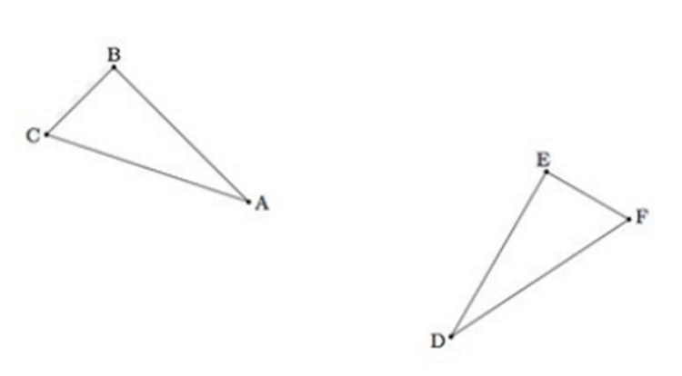
- Suppose there is a sequence of rigid motions which maps ΔABC to ΔDEF. Explain why corresponding sides and angles of these triangles are congruent.
- Suppose instead that corresponding sides and angles of ΔABC and ΔDEF are congruent. Show that there is a sequence of rigid motions which maps ΔABC to ΔDEF.

Standard # and Description | G-CO.B.8  Explain how the criteria for triangle congruence (ASA, SAS, and SSS) follow from the definition of congruence in terms of rigid motions.
Source | Illustrative Mathematics  https://www.illustrativemathematics.org/HSG-CO.B.8
Why Does ASA Work?
In triangles ABC and ABD below, we are given that angle BAC is congruent to angle BAD and angle ABC is congruent to angle ABD. Show that the reflection of the plane about line AB maps triangle ABD to triangle ABC.
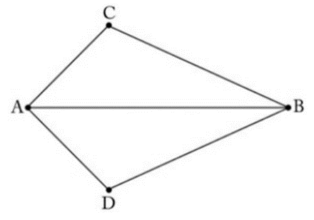
Why Does SAS Work?
In the two triangles below, angle A is congruent to angle D, side AC is congruent to side DF, and side AB is congruent to side DE.
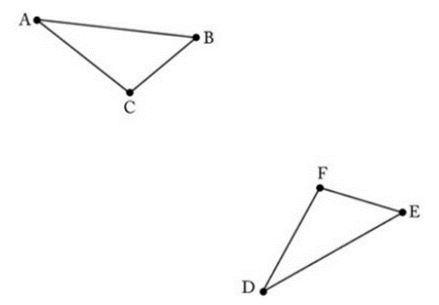
Sally reasons as follows: “If angle A is congruent to angle D, then I can move point A to point D so that side AB lies on top of side DE and side AC lies on top of side DF. Since AB and DE are congruent as are AC and DF, the two triangles match up exactly so they are congruent.”
Explain Sally’s reasoning for why triangle ABC is congruent to triangle DEF using the language of reflections:
- Construct a reflection which maps point A to point D. Call B’ and C’ the images of B and C respectively under this reflection.
- Construct a reflection which does not move D but which sends B’ to E. Call C” the image of C’ under this reflection.
- Construct a reflection which does not move D or E but which sends C” to F.

Why Does SSS Work?
In the two triangles below, segment AB is congruent to segment DE, segment AC is congruent to segment DF, and segment BC is congruent to side EF.
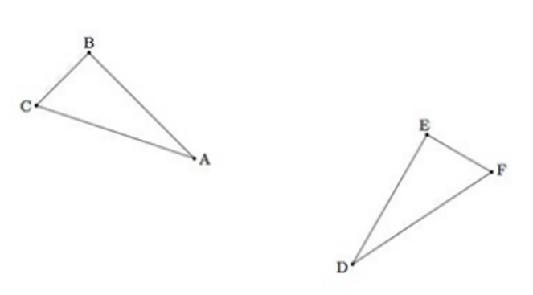
Show that the two triangles ABC and DEF are congruent via the following steps, which produce a rigid transformation of the plane sending triangle ABC to triangle DEF.
- Show that there is a translation of the plane which maps A to D. Call B’ and C’ the images of B and C under this transformation.
- Show that there is a rotation of the plane which does not move D and which maps B’ to E. Call C” the image of C’ under this transformation.
- Show that there is a reflection of the pane which does not move D or E and which maps C” to F.

Standard # and Description | G-SRT.A.3  Use the properties of similarity transformations to establish the AA criterion for two triangles to be similar.
Source | Illustrative Mathematics  https://www.illustrativemathematics.org/content-standards/HSG/SRT/A/3/tasks/1422
Similar triangles
In the two triangles below, and .
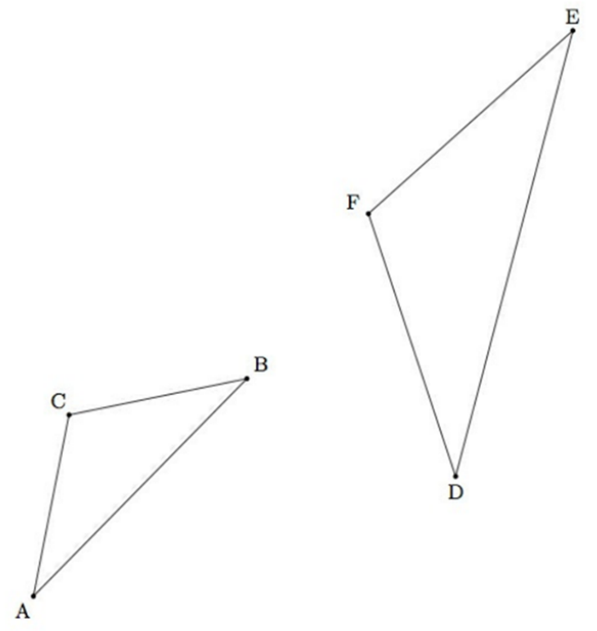
Use a sequence of translations, rotations, reflections, and/or dilations show that ΔABC is similar to ΔDEF.
Standard # and Description | G-C.A.1  Prove that all circles are similar.
Source | Louisiana Student Standards: Companion Document for Teachers (Geometry)  https://www.louisianabelieves.com/resources/library/k-12-math-year-long-planning
Show that the two circles are similar by stating the necessary transformations from C to D.
C: center at $(2, 3)$ with a radius of 5
D: center at $(-1, 4)$ with a radius of 10
Standard # and Description | G-GMD.A.1  Give an informal argument, e.g., dissection arguments, Cavalieri’s principle, or informal limit arguments, for the formulas for the circumference of a circle; area of a circle; volume of a cylinder, pyramid, and cone.
Source | Illustrative Mathematics  https://www.illustrativemathematics.org/content-standards/HSG/GMD/A/1/tasks/1567

Area of a Circle
The goal is to explain why the area enclosed by a circle C of radius r is . Recall that π is the ratio of the circumference of a circle to its diameter and that this ratio is independent of the size of the circle.
- Draw a picture of a regular octagon O inscribed in C. Find a formula for the area of the octagon in terms of its perimeter.
- Reasoning as in part (a), find a formula for the area of a regular n sided polygon, for , inscribed in C. The formula should give the area of the polygon in terms of its perimeter.
- Using your formula from part (b), explain why the area of C is .

Circumference of a Circle
Suppose we define π to be the circumference of a circle whose diameter is 1. Explain why the circumference of a circle with radius is .

Standard # and Description | G-GMD.B.4  Identify the shapes of two-dimensional cross sections of three-dimensional objects, and identify three-dimensional objects generated by rotations of two-dimensional objects.
Source | Mathematics Assessment Project  http://map.mathshell.org/tasks.php?unit=HE16&collection=9&redir=1

Propane Tanks
People who live in isolated or rural areas have their own tanks of natural gas to run appliances like stoves, washers, and water heaters. These tanks are made in the shape of a cylinder with hemispheres on the ends.
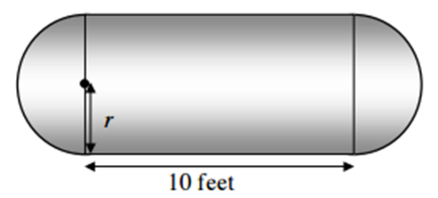
The Insane Propane Tank Company makes tanks with this shape in different sizes. The cylinder part of every tank is exactly 10 feet long, but the radius of the hemispheres, r, will be different depending on the size of the tank. The company wants to double the capacity of their standard tank which is 6 feet in diameter. What should the radius of the new tank be? Explain your thinking and show your calculations.
Standard # and Description | G-MG.A.2  Apply concepts of density based on area and volume in modeling situations (e.g., persons per square mile, BTUs per cubic foot).
Source | Louisiana Student Standards: Companion Document for Teachers (Geometry)  https://www.louisianabelieves.com/resources/library/k-12-math-year-long-planning

- An antique waterbed has the following dimensions 72 in. x 84 in. x 9.5in. It takes 240.7 gallons of water to fill it, which would weigh 2071 pounds. What is the weight of a cubic foot of water?
- Wichita, Kansas has 344,234 people within 165.9 square miles. What is Wichita’s population density?

Standard # and Description | G-MG.A.3  Apply geometric methods to solve design problems (e.g., designing an object or structure to satisfy physical constraints or minimize cost; working with typographic grid systems based on ratios).
Source | Louisiana Student Standards: Companion Document for Teachers (Geometry)  https://www.louisianabelieves.com/resources/library/k-12-math-year-long-planning

- You are the manager of a packing company responsible for manufacturing identical rectangular boxes from rectangular sheet of cardboard, each sheet having the same dimensions (18” X 24”). To save money, you want to manufacture boxes that will have the maximum possible volume. Determine the maximum volume possible.

- The Bolero Chocolate Company makes square prisms to package their famous chocolate almond balls. The package holds 5 of the chocolate almond balls that are 1.5” in diameter. They are considering changing packaging to a triangular prism. What would be the difference in material cost if the cardboard used is currently purchased at $1.25 per square foot? (Consider both the top and bottom of the box.)

Standard # and Description | S-CP.A.5  Recognize and explain the concepts of conditional probability and independence in everyday language and everyday situations. For example, compare the chance of having lung cancer if you are a smoker with the chance of being a smoker if you have lung cancer.  S-CP.B.6  Find the conditional probability of A given B as the fraction of B’s outcomes that also belong to A, and interpret the answer in terms of the model.
Source | Illustrative Mathematics  https://www.illustrativemathematics.org/HSS-CP

The Titanic 1
On April 15, 1912, the Titanic struck an iceberg and rapidly sank with only 710 of her 2,204 passengers and crew surviving. Data on survival of passengers are summarized in the table below. (Data source: www.encyclopedia-titanica.org)
Passenger Type | Survived | Did not survive | Total
First Class | 201 | 123 | 324
Second Class | 118 | 166 | 284
Third Class | 181 | 528 | 709
Total | 500 | 817 | 1317
- Calculate the following probabilities. Round your answers to three decimal places.
- If one of the passengers is randomly selected, what is the probability that this passenger was in first class?
- If one of the passengers is randomly selected, what is the probability that this passenger survived?
- If one of the passengers is randomly selected, what is the probability that this passenger was in first class and survived?
- If one of the passengers is randomly selected from the first class passengers, what is the probability that this passenger survived? (That is, what is the probability that the passenger survived, given that this passenger was in first class?)
- If one of the passengers who survived is randomly selected, what is the probability that this passenger was in first class?
- If one of the passengers who survived is randomly selected, what is the probability that this passenger was in third class?
- Why is the answer to part (a.iv) larger than the answer to part (a.iii)?
- Why is the answer to part (a.v) larger than the answer to part (a.vi)?
- What other questions can you ask and answer using information in the given table? List at least three.

The Titanic 2
On April 15, 1912, the Titanic struck an iceberg and rapidly sank with only 710 of her 2,204 passengers and crew surviving. Some believe that the rescue procedures favored the wealthier first class passengers. Data on survival of passengers are summarized in the table below. We will use this data to investigate the validity of such claims. (Data source: www.encyclopedia-titanica.org)
Passenger Type | Survived | Did not survive | Total
First Class | 201 | 123 | 324
Second Class | 118 | 166 | 284
Third Class | 181 | 528 | 709
Total | 500 | 817 | 1317
- Are the events “passenger survived” and “passenger was in first class” independent events? Support your answer using appropriate probability calculations.
- Are the events “passenger survived” and “passenger was in third class” independent events? Support your answer using appropriate probability calculations.
- Did all passengers aboard the Titanic have the same probability of surviving? Support your answer using appropriate probability calculations.
Standard # and Description | S-CP.B.7  Apply the Addition Rule, P(A or B) = P(A) + P(B) – P(A and B), and interpret the answer in terms of the model.
Source | Illustrative Mathematics  https://www.illustrativemathematics.org/content-standards/HSS/CP/B/7/tasks/1112
Rain and Lightning
- Today there is a 55% chance of rain, a 20% chance of lightning, and a 15% chance of lightning and rain together. Are the two events “rain today” and “lightning today” independent events? Justify your answer.
- Now suppose that today there is a 60% chance of rain, a 15% chance of lightning and a 20% chance of lightning if it is raining. What is the chance of both rain and lightning today?
- Now suppose that today there is a 55% chance of rain, a 20% chance of lightning, and a 15% chance of lightning and rain. What is the chance that we will have rain or lightning today?
- Now suppose that today there is a 50% chance of rain, a 60% chance of rain or lightning, and a 15% chance of rain and lightning. What is the chance that we will have lightning today?

