Pennington Chamber User Manual

The program we have designed for the Pennington Chamber project incorporates raw data from Excel sheets imported by the user and performs calculations to process and statistically correct the data. The resulting processed data can be viewed in the GUI or can be saved to an excel file.

Interface

The interface consists of 4 tabs:

Activity and Behavior: Contains fields for information about whether the infant is asleep, crying, feeding, etc.…. Also contains fields for the start and end times of the desired analysis. Entries for different times may be repeated and entered here, for example if the baby sleeps at two different times in the chamber.
Note: Times must be entered in the format: HH:MM:SS

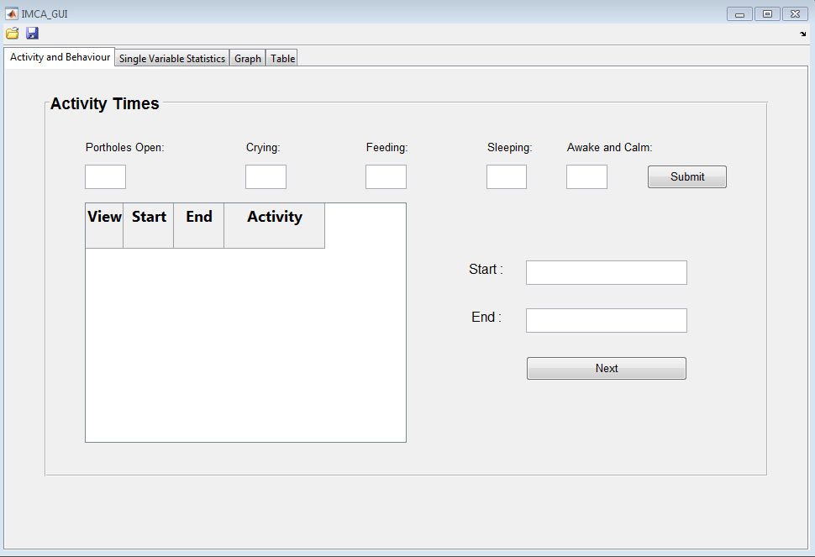

Single Variable Statistics: Once the data has been read by the program, the calibrations, swing out measurements, and averages will be displayed for the desired interval.

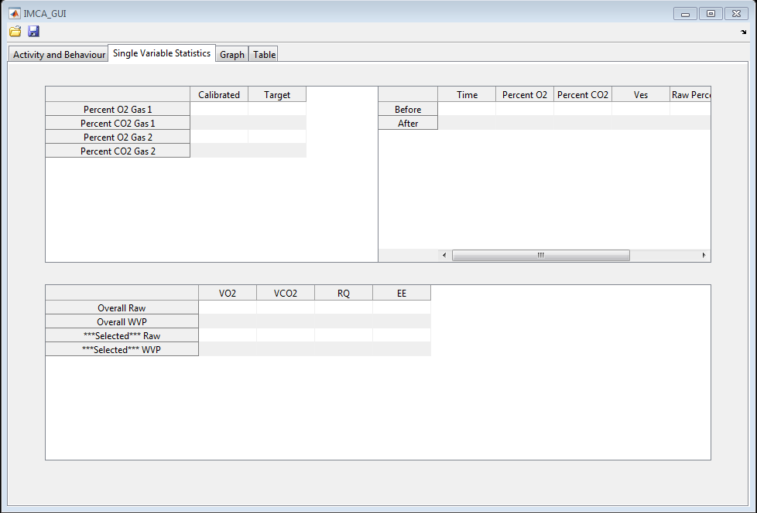

Graph: Contains fields for the various activities of the infant. Allows the user to construct one or two graphs with the y-axes assigned to variable calculations for each side, if desired, and with time as the horizontal axis.

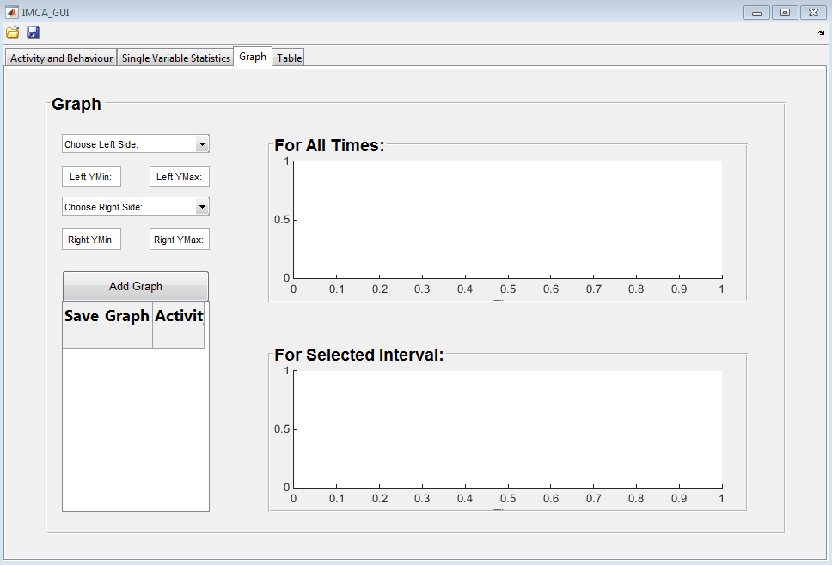

Table: Contains all the calculations and corrected calculations and displays them in a table for the user to reference. There is also an option to save this information in an Excel file, which can be done by clicking the save button in the top left corner.

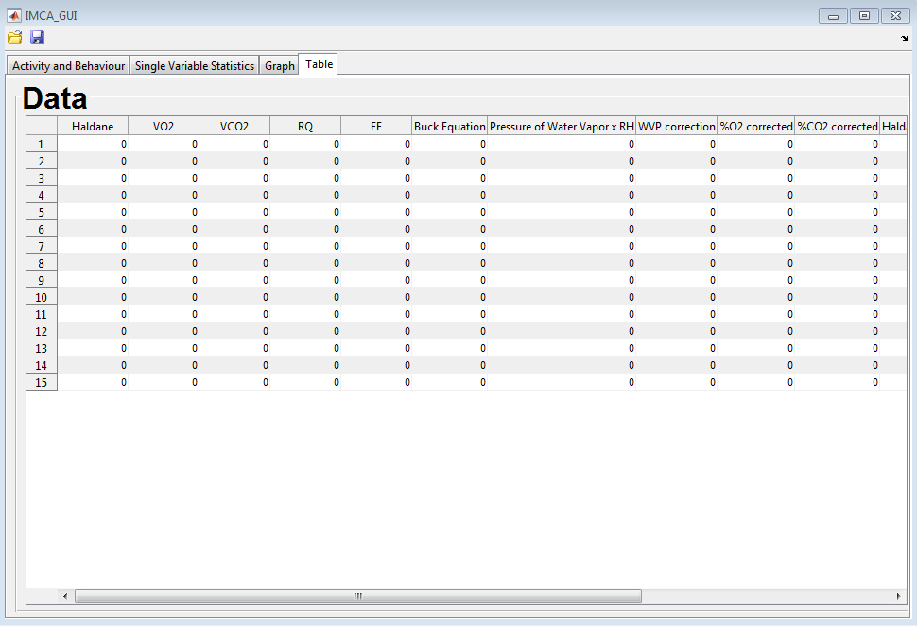

Using the Program

Open the desired data file by using the open icon in the top left corner of the GUI.

The user specifies the number of activities, like sleeping, crying, feeding, etc. For example, if the baby cries twice during the observation, it can be noted here, along with the time interval the activity occurred.

Click the “Submit” button to load the desired activities and then enter the start and end times in the “Start” and “End” time text boxes. Push the “Next” button to load the intervals into the table on the left.
Note: Times must be entered in the format: HH:MM:SS

Check the interval you wish to analyze.

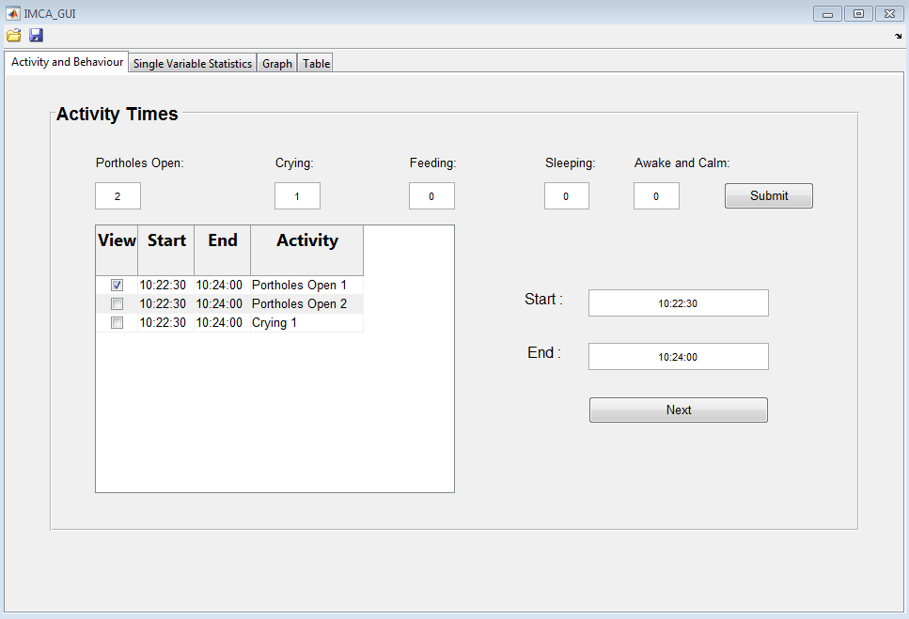

Based on which box you checked on the previous tab, the corresponding data will be analyzed here on the “Single Variable Statistics” tab.

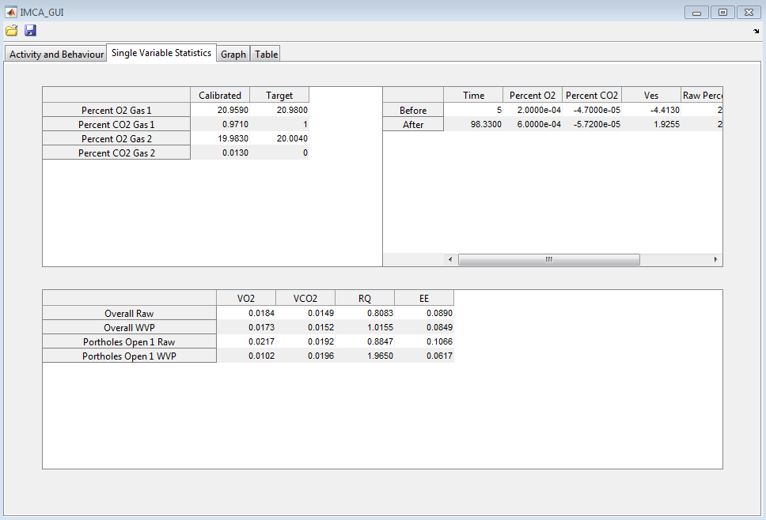

On the “Graph” tab, choose the calculations you wish to compare from the drop-down menus. Choose the desired variable for the graph on the left from the “Choose Left Side” drop-down menu. You may do the same for the graph on the right. These menus plot the specified calculations on the vertical axis with time represented on the horizontal axis. The user may specify the vertical limits as they wish to zoom in on particular intervals. Simply enter the y-axis min and max in the text boxes underneath the drop-down menus.

Corresponding graphs will be plotted across all times in the top window. Graphs are plotted on the specified interval in the bottom window.

Should the user wish to save any of these graphs, this is done by pressing the “Add Graph” button and checking the box underneath the “Save” column in the table to the left. This will export the graph to one of the tabs of the excel file.

All the calculations produced through this program will be displayed in the “Table” tab. If the user wishes to see the data output in a format other than the table on this tab, then save the data by using the “Save” icon in the upper left corner to save the processed data to an excel file. The first tab of the excel file will have the raw data and the second tab will have the raw and processed data. Additional tabs will contain images of the graphs added in the “Graph” tab.

