The Leptin Signaling Pathway
Research Project
Jeremy Braud, Chris Dodd, Chiedu Odita, Cody Wells, Jennifer Williams
1/1/2009

Introduction
Recent reports have shown that a majority of mammalian genes display daily oscillatory behavior in their baseline expression¹. These reports contradict the formally accepted statistic that only 10-15% of gene expression patterns exhibit oscillatory behavior. One of the most important implications of this discovery is related to the way in which biological pathways are modeled, visualized, and understood. If one were to accurately model a genetic pathway that features this behavior, in doing so obtaining a clear comprehension of the cycle, one might be able to use the model as a template for other genetic pathways. The leptin signaling pathway has been chosen as an example to illustrate the concept.
The study of leptin is of importance due to the potential for a greater understanding of appetite and the body’s metabolism. Leptin is an adipose-derived hormone responsible for regulating energy balance and causing the sensation of fullness in the body. After food consumption the liver releases leptin. It then passes through the cell membrane into the cell and proceeds to initiate a self-regulating process. This process, over time, inhibits itself, thus creating the sensation of satiety.
The Process
Once leptin (LEP) is released into the bloodstream, it then enters the cell. An abundance of receptors (LEPR) are ready to bond with the leptin. This new bond forms a complex (LRec). This complex enables the cell mass Janus-Kinase 2 (JAK2) to phosphorylate to form phosphorylated Janus-Kinase 2 (JAK2*). JAK2* then phosphorylates the signal transducer and activation of transcription (STAT3) which forms phosphorylated STAT3 (STAT3*). This STAT3* activates the genetic transcription of the suppressor of cytokine signal (SOCS3). Impeding the cycle in two ways, SOCS3 blocks LEP from bonding with LEPR, and it prevents JAK2 from phosphorylating. Now that the process has been stated we can move forward with the mathematics.
The goal of this project is build a system of differential equations in hopes of generating a feedback system which will allow one to compare the periodicities of the system with the periodicities observed in data. We begin by stating the following variables:
R= Abundance of free leptin receptors
C= Abundance of leptin receptor complexes
J= Abundance of JAK2 available to phosphorylate to STAT3
T= Abundance of STAT3 available for activating transcription of SOCS3
S= Abundance of SOCS3 available to bond to leptin receptor or JAK2
Before building a model for the system several assumptions must be made. First, we will assume all bond rates between cell masses are between 0 and 1. Secondly, we let all phosphorylation rates equal 1. This is due to the fact that the speed in which cell masses bond is incredibly slower than that of the chemical process of phosphorylation. Lastly, we assume that all of the SOCS3 that is transcribed will move on to either block the bond of LEP and LEPR or stop the phosphorylation of JAK2. Below is the linear model of the system. This system will not be explained, but rather to serve as a basic guide for the dynamics of the system.
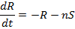

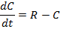

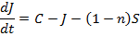

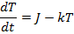

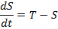

The following nonlinear system was giving to us because it is believed to accurately describe the physical nature of the cell masses:
,

We were able to derive a new set of formulas from the previous equations listed above. For this model we assume that all bond and phosphorylation rates are between 0 and 1. We assumed that all growth decay rates are 0 with the exception of the decay rate of STAT3 which we assumed to be a constant value. We also again assume that all of the available SOCS3 will go on to hinder the system. The initial value of leptin can be any positive value.
The non-linear model that we are actually using is as follows:

Non-linear system:

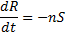
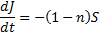
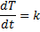
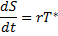
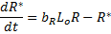
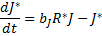
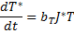

Variables:

R = Abundance of free leptin receptors
J = Abundance of JAK2
T = Abundance of STAT3
S = Abundance of SOCS3
R*= phosphorylated leptin receptors
J*= phosphorylated JAK2
T*= phosphorylated STAT3
Lo = Leptin
k = growth/decay rate
br = bond rate of leptin to leptin receptors
bj =bond rate of phosphorylated leptin to JAK2
bt = bond rate of phophorylated JAK2 to STAT3
r = rate of activation of transcription

It should be noted that our research group had no access to any data. With no known initial conditions analysis of the system becomes difficult. Stability of the system, for example, is hard to determine because the analysis of the Jacobian matrix is too algebraically intensive.
With not being able to move forward with analyzing the mathematics of the system, our new goal is to build a MatLab program that can be compiled into a stand-alone program. A stand-alone program will allow a user to enter research data and then view the graphical output. The graphical user interface our team has created will allow one to change the parameters (i.e. the bond and phosphorylation rates) of the system as they see fit. The user will also have the freedom to set the initial values of all cell masses.
All constants, variables, and parameters used are in the interface are defined as on page 4.
GUI
For building the stand-alone program, we used the MatLab software program to design an interface that would be easy to use for those even with no mathematical background. With the program as listed below on page 7, one only needs to enter in some initial values and a graph will be produced for them. The GUI uses the solver ODE 45 which uses a variable step Runge-Kutta method to solve differential equations numerically. This allowed us to leave the equations in a non-linear state and allows MatLab to solve the equations for us.
Future Work
We are hoping that with the ability to set one’s own initial values, one could get a feel for which initial values give a better representation of a natural oscillatory behavior that would be expected from this process. From the data we were given at the start of this process, we were not able to design a working model of the process that could be confidently accurate. One thing we think may help in creating a more accurate model are adding more solvers to the GUI other than just ODE 45, in order to see more options in the GUI. Another helpful idea would be to analyze the equilibrium point and stability of the Nonlinear model. We hope that if another group is able to work on this project, the foundation we have laid will be a building block and that a solution will be found for this problem.

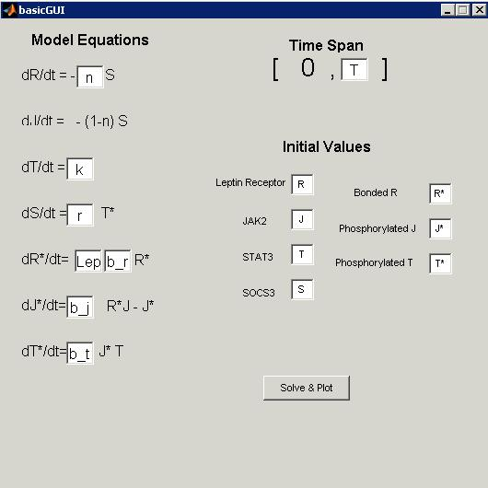

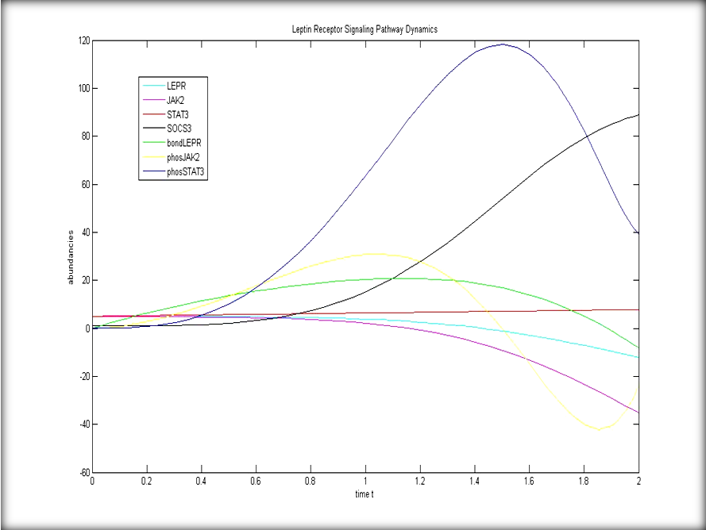

Works Cited

Gimble, Jeffrey; Ptitsyn, Andrey. "Analysis of circadian pattern reveals tissue-specific alternative". BMC Bioimformatics November 1 2007: 1-6.

