Math 1015 – 12.6 Systems of Inequalities

Recall that a linear equation in two variables is an equation that can be written in the form $Ax+By=C$ where $A$, $B$, and $C$ are real numbers and $A$ and $B$ are not both $0$.

A linear inequality in two variables is an inequality that can be written in one of the following forms:
$Ax+By<C$ $Ax+By>C$
$Ax+By≤C$ $Ax+By≥C$
where $A$, $B$, and $C$ are real numbers and $A$ and $B$ are not both $0$.

Objective 1: Determining if an Ordered Pair is a Solution to a Linear Inequality

An ordered pair is a solution of an inequality in $x$ and $y$ if replacing the variables with the coordinates of the ordered pair results in a true statement.

Objective 2: Graphing a Linear Inequality in Two Variables

Consider the linear equation $x-y=1$ which is graphed below. Recall that all points on the line defined by $x-y=1$ correspond to ordered pairs that are solutions to the equation.

Notice the line defined by $x-y=1$ divides the coordinate plane into two half-planes. All points on one side of the line are solutions to the inequality $x-y<1$. All points on the other side of the line are solutions to the inequality $x-y>1$. The line that separates these two regions, in this case the line defined by $x-y=1$, is called the boundary line.

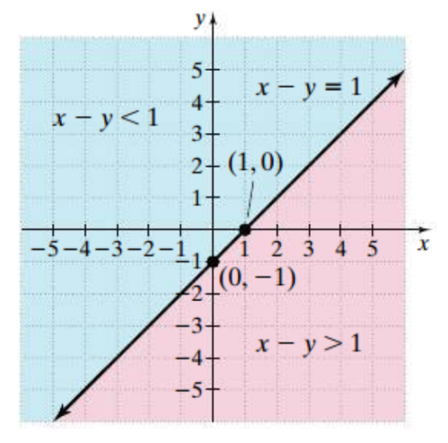
When graphing the solution set of a linear inequality in two variables, if the inequality sign is $>$ or $<$, then the points on the boundary line are not part of the solution set, so the boundary line is dashed. If the inequality sign is $≤$ or $≥$, the points on the boundary line are part of the solution set, so the boundary line is solid.

Objective 4: Determining if an Ordered Pair is a Solution to a System of Linear Inequalities

Just as a system of linear equations is made up of two or more linear equations, a system of linear inequalities is composed of two or more linear inequalities.

A solution of a system of linear inequalities is an ordered pair that satisfies each inequality in the system. The set of all such ordered pairs is the solution set of the system.

Objective 5: Graphing Systems of Linear Inequalities

The solution set of a system of linear inequalities can best be represented with a graph.
Start by graphing each linear inequality in the system, and then determine where the shaded regions overlap. This overlapped (or shared) region represents the set of all solutions to the system of inequalities.

If the shaded regions do not overlap, then there is no solution to the system of inequalities.

