Math 1015 – R.5 Polynomials
Objective 1: Monomials and Polynomials
In this section, we will explore a type of algebraic expression called a polynomial expression.
Polynomial
A polynomial in $x$ is a finite sum of terms of the form $ax^{n}$ where $a$ is a real number and $n$ is a whole number.

For example,
$$x^{3}-2x^{2}+3x+5$$
is a polynomial. Notice that this polynomial is written in descending powers of $x$. When the terms of a polynomial expression are arranged in this way, it is called the standard form of a polynomial expression.

The coefficient is the numerical factor of each term. If a term is a number only, it is called a constant term, or just constant. The polynomial shown above has four terms:
$x^{3}$ which has a coefficient of $1$
$-2x^{2}$ which has a coefficient of $-2$
$3x$ which has a coefficient of $3$
$5$ which is the constant.

The expression ${4x}^{-2}+8x-9$ is not a polynomial because it contains an exponent that is not a whole number.

Each term of a polynomial has a degree. The degree of a term is the sum of the exponents on the variables contained in the term.

The degree of a polynomial is the greatest degree of any term of the polynomial.
A polynomial with exactly one term is called a monomial. A polynomial with exactly two terms is called a binomial. A polynomial with exactly three terms is called a trinomial.

Polynomials can contain more than one variable as long as all exponents on the variables are whole numbers.
Polynomials that contain like terms can be simplified by combining the like terms. Recall that like terms are terms that contain exactly the same variables raised to exactly the same powers. For example, $5a^{2}b$ and $-2a^{2}b$ are like terms, but $5a^{2}b$ and $-2ab^{2}$ are unlike terms.
Objective 2: Adding and Subtracting Polynomials
To add polynomials, combine all like terms.

To subtract one polynomial from another, we add its opposite.

We typically write polynomials in descending order, meaning that we first list the monomial with the highest degree, then the monomial with the next highest degree, and so on. Polynomials that are written in descending order are said to be written in standard form.

Objective 3: Multiplying Polynomials
To find the product of two monomials in one variable, we multiply the coefficients
together and use the product rule of exponents to add any exponents. For example, $\left(8x^{4}\right)\left(-3x^{7}\right)=\left(8\right)\left(-3\right)·x^{4}·x^{7}=-24x^{11}$.
To multiply a monomial by a polynomial with more than one term, we need to use the distributive property multiple times. Thus, if m is a monomial and $p_{1},p_{2},p_{3},{…p}_{n}$are terms of a polynomial, then
$m\left(p_{1}+p_{2}+p_{3}+…+p_{n}\right)=mp_{1}+mp_{2+}mp_{3}+…+mp_{n}$.

The distributive property can also be used to multiply two binomials.
For example, to multiply $(x+1)(x+3)$, we can first distribute the $(x+1)$ to each factor in the second parentheses.
$$\left(x+1\right)\left(x+3\right)=x\left(x+1\right)+3(x+1)$$
We can now apply the distributive property again to clear the parentheses. Then, combine the like terms.
$$\left(x+1\right)\left(x+3\right)=x^{2}+x+3x+3 \\ =x^{2}+4x+3$$

Objective 3: Special Products
Squaring a binomial can be visualized geometrically as the area of a square with side length $(a+b)$ where $a$ and $b$ are both positive, real numbers.
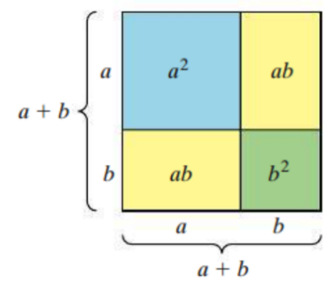
$$Area={\left(a+b\right)}^{2} \\ =(a+b)(a+b) \\ =a^{2}+2ab+b^{2}$$

This leads to two identities that can be used to square a binomial.

$${\left(a+b\right)}^{2}=a^{2}+2ab+b^{2}$$
$${\left(a-b\right)}^{2}=a^{2}-2ab+b^{2}$$

Another special product is the difference of two squares because the resulting binomial is the difference of two perfect squares.
$$\left(a+b\right)\left(a-b\right)=a^{2}-b^{2}$$

The sum and difference of two cubes formulas are shown below:
$${(a+b)}^{3}=a^{3}+3a^{2}b+3ab^{2}+b^{3}$$
and
$${(a-b)}^{3}=a^{3}-3a^{2}b+3ab^{2}-b^{3}$$

