Graphing and “Textbook” Form Calculators NOT Allowed
in the Math Lab or in the Testing Center

Graphing calculators are not allowed in the Math Lab or in the Testing Center. In addition, calculators which can give answers in what can be called “textbook” form are also not allowed. Both of these kinds of calculators can give students answers without the student knowing how to do the work we are assessing. Below are some examples of the current “textbook” form calculators available today that are not acceptable along with the names that specific companies use to identify them.

Casio uses the description Natural Display. HP uses the term SmartCalc.
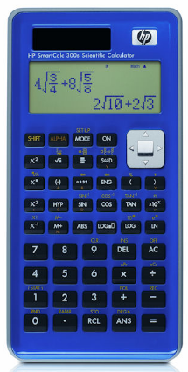
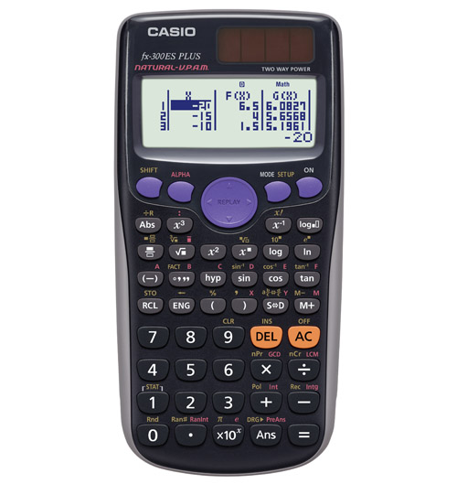
FX-115ESPlus FX-300EX Plus
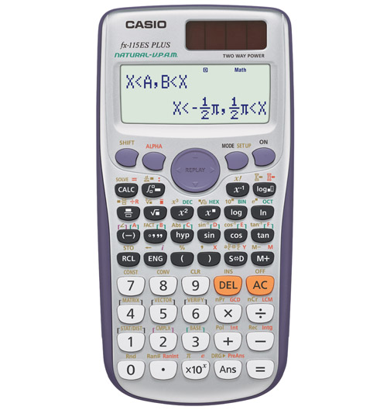

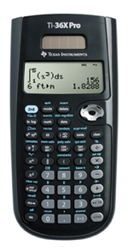
Sharp uses the word WriteView. TI sometimes uses the term MultiView.
