Section 1.2 Geometry—A Mathematical System

The word **geometry** comes from the Greek language and means to *measure the earth*.

To talk about geometry and mathematical systems we will need to use reasoning skills (or **logic**)to recognize patterns, make conjectures, and develop the laws of this system.

# Objective 1: Using Logic to Recognize Patterns

a. Look for a pattern and sketch the next predicted shape.

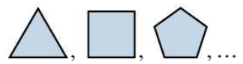

b. Look for a pattern and predict the next two numbers.

1. 64, 32, 16, 8, …
2. -4, -1, 2, 5, …

# -4, 1, 4, 1, -4, …

1. 

# Objective 2: Understand How a Mathematical System, Like Geometry, is Formed

A Mathematical System consists of

* **Undefined terms**—the most basic of terms, not formally defined but with an agreed upon meaning or description.
* **Definitions**—formally defined using undefined terms or already defined terms.
* **Postulates** (or **Axioms**)—statements accepted as true that we do not try to prove.
* **Theorems**—statements we prove using logic, undefined terms, definitions, postulates, and other previously proven theorems.

Note that postulates and axioms are often used interchangeably, but there is a difference: An axiom is thought of as a global, self-evident truth or common notion while a postulate is a truth that is more specific to geometry.

Be careful when assuming anything from a marked or unmarked figure.

a. Can you assume the statement about each figure is true based on the given (labeled) information?

1. This figure is a square.

Shape, square


1. The measures of angles 1 and 2 have a sum of 90°.

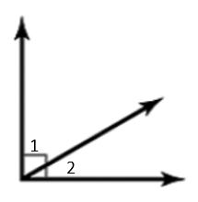

1. These lines are parallel.

