Section 1.3 Points, Lines, and Planes

# Objective 1: Learning Terms and Postulates of Geometry

The following tabledescribes three **undefined terms** of Geometry, how to name these terms, and gives an example of each.

| ***Description*** | ***How to Name It*** | ***Example*** |
| --- | --- | --- |
| A **point** has no dimension (no length, width, or height). It does have a location or position. | Name a point by a single capital letter. | A dot labeled with a capital A which is also read as Point A. |
| A **line** extends in opposite directions without end and has one dimension—length. | Name a line by a single lowercase letter or by any two points on the line. | A line extending infinitely in opposite directions, indicated by arrows, and containing the points A and B.  This line is is named Line l using a lower case l or by writing either A B with an overbar with arrows on both ends or B A with an overbar with arrows on both ends. |
| A **plane** extends in two dimensions without end. The two dimensions are length and width, but no thickness. We represent a plane by a flat surface. | Name a plane by a single capital letter or by any three points on the plane (that do not lie on the same line). | A flat four sided shape containing the points A, B, and C, not all on the same line.  This is named plane P using a capital P or as plane ABC.  (The 3 points A, B, and C can be listed in any order in the name.) |

**Collinear points** are points that lie on the same *line*.

**Coplanar points** are points that lie on the same *plane*.

a. Use the figure shown below to answer the following questions:

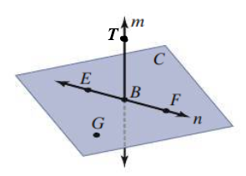

1. Name two other ways to name line .
2. Name two other ways to name plane *C*.
3. Name three collinear points.
4. Name four coplanar points.

**Space** is the set of all points in three dimensions.

A **geometric figure** is any nonempty subset of space.

Another undefined term is **between**. In the figure below, points *A*, *B*, *C*, and *D* all lie on the same line. Point *B* is between points *A* and *C* as well as between points *A* and *D*.

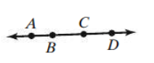

However, in the next figure, point *B* is not between points *A* and *C* because point *B* does not on the same line as points *A* and *C*.

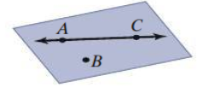

The following table describes some defined terms, how to name them, and gives an example of each.

| ***Definition*** | ***How to Name It*** | ***Example*** |
| --- | --- | --- |
| A **line segment** or simple **segment** is part of a line. It consists of two endpoints and all the points between them. | Name a segment by its end points:  (segment AB) or  (segment BA) | a segment is drawn with endpoints A and B.  It is named segment A B and written A B with an overbar or segment B A written B A with an overbar. |
| A **ray** is part of a line. It consists of an endpoint and all points of the line on one side of the endpoint. | Name a ray by its endpoint and any other point on the ray. The order of the points is important here—list the endpoint first.  (ray AB) is not the same as  (ray BA) | Two figures: first, the ray A B which starts at endpoint A and points to the right in the direction of B written A B with an arrow above both letters pointing from A to B and second, the ray B A which starts at endpoint B and points to the left in the direction of A written B A with an arrow above both letters pointing from B to A. |
| **Opposite rays** are two rays that share the same endpoint and form a line. | Name each opposite ray as you would name a ray. | A line is shown containing the points A, C, and B in that order from left to right.  ray C B and ray C A are opposite rays. |

**Postulate: Two Points Determine a Line**

Through any two points there is exactly one line.

In the figure below, line *t* passes through points A and B. Line *t* is the only line that passes through both points.

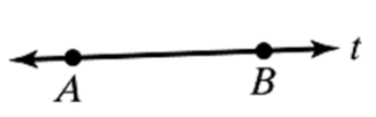

The **intersection** of two or more geometric figures is the set of points that the figures have in common.

**Postulate: Intersection of Lines**

If two distinct lines intersect, then they intersect at exactly one point.

In the figure below, lines *m* and *n* intersect at point *C*.

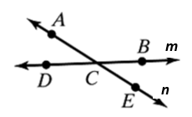

b. Use the figure shown below to answer the following:

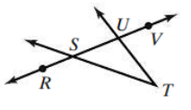

1. Name five points.
2. Name three rays.
3. Name four segments.
4. Name a pair of opposite rays.
5. Are rays  and  opposite rays?

**Postulate: Intersection of Planes**

If two distinct planes intersect, then they intersect in exactly one line.

In the figure below, plane RST and plane WST intersect in line .

two planes R S T and W S T are shown intersecting at the line S T



**Postulate: Three Noncollinear Points Determine a Plane**

Through any three noncollinear points there is exactly one plane.

Points Q, R, and S are noncollinear. Plane P is the only plane that contains them.

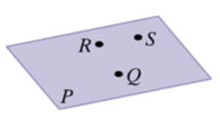

Hint: Do not forget the three points *must* be noncollinear. If the three points are collinear, many planes will pass through the three points!

c. Use the figure below to answer the following questions:

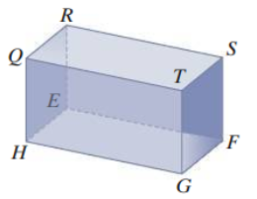

1. Name the intersection of planes QRS and TGF.
2. Name the intersection of planes HEF and SER.
3. Name two planes that intersect in line .
4. Name the intersection of planes TSF and HES.
5. Name a point that is coplanar with Q, T, and G.
6. Name a point that is coplanar with R, S, and G.

d. Plot the points on a coordinate plane and state whether they appear to be collinear or not.

i. (0, 0), (-3, 4), (5, -3)

ii. (-1, -1), (2, 2), (4, 4)

