Section 1.4 Segments and Their Measure

# Objective 1: Understand the Measure of Segments

**Postulate: Ruler Postulate**

Each point on a line can be paired, one-to-one, with a real number. The real number that corresponds to a point is called the **coordinate** of the point.

The distance between points *A* and *B* is the absolute value of the difference of their coordinates. We use the notation *AB* for distance or the length of .

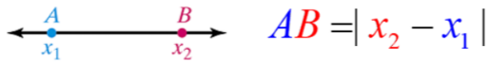

1. Find the lengths of  and  using the figure below.

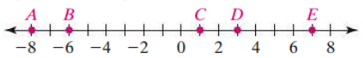

Two segments that have the same length are called congruent segments. The symbol  means congruent.

**Congruent Segments vs. Equal Lengths**

If , then . Also, if , then .

We mark congruent segments in a figure with exactly the same number of tick marks as shown in the figure below. and both have 1 tick mark, so . and both have 2 tick marks, so .

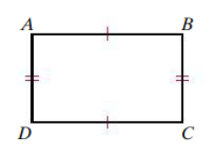

1. In the previous figure, suppose *CD* = 10 inches and *BC* = 7 inches. Find *AB* and *AD*.
2. Use the figure below to determine if  and if .

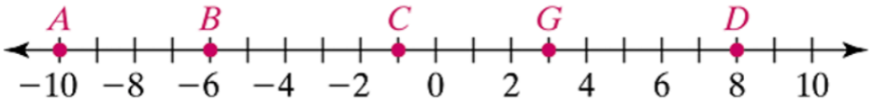

**Postulate: Segment Addition Postulate**

If point *B* is between* points *A* and *C*, then . Also, if , then point *B* is between points *A* and *C*.

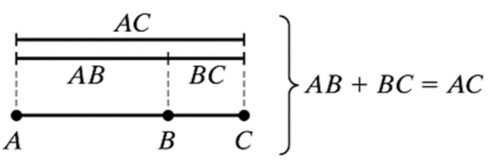

*Recall that for point *B* to be between points *A* and *C*, points *A*, *B*, and *C* must be collinear.

1. If point *S* lies between points *R* and *T*, *RS* = 15, and *ST* = 9, then *RT* = ?
2. If point *S* lies between points *R* and *T*, *ST* = 15, and *RT* = 40, then *RS* = ?

The **midpoint** of a segment is a point that divides, or **bisects**, a segment into two congruent segments.

Consider the figure below.

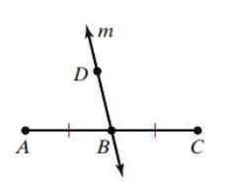

All of the following are true statements:

*B* is the midpoint of .

Line *m* bisects .

 bisects .

Both  and  bisect .





A line, ray, segment, or plane that intersects a segment at its midpoint is called a **segment bisector**.

# Objective 2: Use Segment Postulates and Algebra to Find Segment Lengths

1. If point *S* lies between points *R* and *T*, *RS* = 8*y* + 4, *ST* = 4*y* + 8, and *RT* = 96, find the value of *y* and the lengths of $\overline{RS }$ and $\overline{ST}$.
2. If *T* is the midpoint of , *PT* = 6*x* – 35, and *TQ* = 2*x* – 3, find *PT*, *TQ*, and *PQ*.
3. On a number line, the coordinates of points *X*, *Y*, *Z*, and *W* are -7, -3, 2, and 6, respectively.

Find the lengths of  and . Are they congruent?

1. On a number line, suppose the coordinate of *A* is 0 and *AR* = 12. What are the possible coordinates of the midpoint of ?
2. On Interstate 10 through Louisiana, the exit numbers correspond to the mile markers. Assuming the road is straight, and you drive at an average speed of 65 miles per hour, how long will it take to get from exit 163 in Baton Rouge to exit 33 in Lake Charles?