Section 1.5 Angles and Their Measure

# Objective 1: Understand Angle Measures

An **angle** consists of two different rays with a common endpoint. The rays are the **sides** of the angle. The common endpoint is the **vertex** of the angle.

In the angle shown below, point *A* is the vertex. The sides are  and . The number 1 is inserted between the rays near the vertex. This angle can be named , , , or .

Note that the vertex must be in the middle when naming an angle using three points.

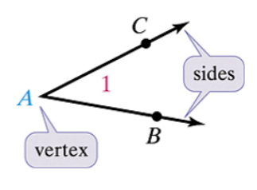

The **interior** of an angle contains all points between the two sides of the angle.

The **exterior** of an angle contains all points that are not in the interior of the angle and are not on the angle.

1. How many different angles are in the figure below?

Name in two other ways.

Why can we not refer to any angle in the diagram as ?

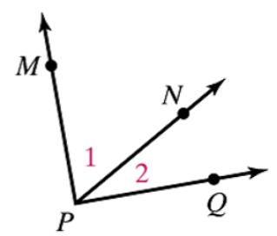

A **protractor** can be used to measure angles in units called **degrees** (°). A circle has 360°. Therefore, 1° is  of the rotation to form a circle.

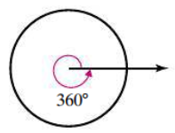

The letter *m* in front of an angle name indicates we are referring to the measure of the angle.

**Postulate: Protractor Postulate**

Suppose we have  as shown and a point *C* on one side of . Every ray with endpoint *A*, for example , can be paired one-to-one with a real number from 0 to 180. The measure of  (in degrees) equals the absolute value of the difference between the real numbers on the protractor for  and for .

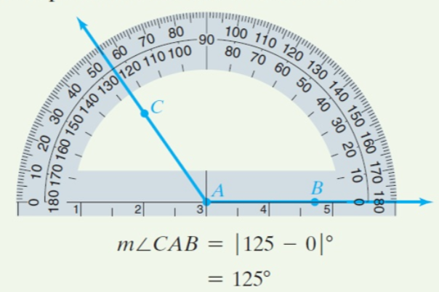

Note that every protractor has two sets of numbering, both from 0 to 180, on the curved portion. Be sure to use either the lower numbering for both rays or the upper numbering for both rays.

**Classifying Angles by Measure**

An **acute angle,** measures between 0° and 90°. If angle *A* is acute, then .

A **right angle** measures exactly 90°. If angle *B* is a right angle, then .

Note that we make a square inside the angle at the vertex to indicate a right angle.

An **obtuse angle** measures between 90° and 180°. If angle *C* is an obtuse angle, then .

A **straight angle** measures exactly 180°. If angle *D* is a straight angle, then .

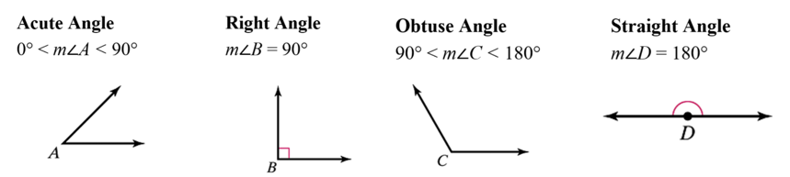

1. Use the protractor shown below to find , , , and . Then classify each angle as acute, right, obtuse, or straight.

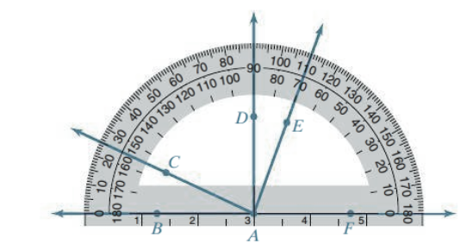

Two angles that have the same measure are called **congruent angles.** We again use the symbol  for congruent.

**Congruent Angles vs. Equal Angle Measures**

If , then . Also, if , then .

We mark congruent angles with exactly the same number of arcs.

In the figure below,  since both are marked with a single arc inside the angles near the vertices. Therefore, if , then . In addition,  since both are marked with two arcs. Therefore, if , then .

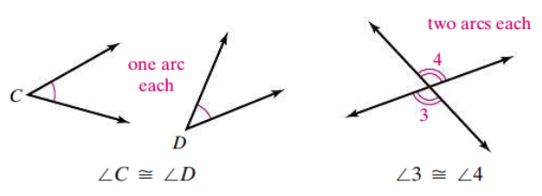

# Objective 2: Use Algebra and the Angle Addition Postulate to Solve Applications

**Postulate: Angle Addition Postulate**

If P is in the interior of , then .

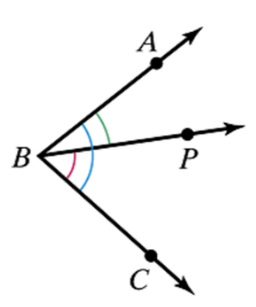

1. If , what are and ?

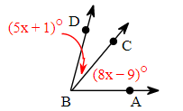

1. Determine the smaller angle measure of the hands of a clock at
2. 11:00
3. 5:00