Section 1.6 Angle Pairs and Their Relationships

# Objective 1: Learn Special Relationships Between Angle Pairs

| **Definition** | **Examples** |
| --- | --- |
| Two angles are called **adjacent angles** if they share a common side and a common vertex but have no interior points in common. | angle 1 and angle 2 are shown sharing a vertex and a common side but no interior points.  Angle 1 and angle 2 are adjacent angles. |
| Two angles are called **vertical angles** if their sides form opposite rays. | Two lines are shown intersecting at one point forming four angles, named angle 1, and then clockwise in order, angle 2, angle 3, and angle 4.  Angles 1 and 3 are vertical angles.  Angles 2 and 4 are also vertical angles.  Angle 1 and angle 3 are vertical angles.  Angle 2 and angle 4 are vertical angles. |
| Two adjacent angles form a **linear pair** if their noncommon sides are opposite rays. | a straignt angle is shown with a ray extending upward and to the left from a point on the straight angle.  angles 5 and 6 have their vertices at this point and share a common side with their other sides being opposite rays forming the straight angle.  Angle 5 and angle 6 form a linear pair. |
| Two angles are **complementary** if their measures have a sum of 90°. Each angle is called the **complement** of the other. | Two sets of complementary angles are shown.  Angle 1 and angle 2 are adjacent angles that form a right angle so the sum of their measures is 90 degrees.  Angle A has a measure of 25 degrees and angle B has a measure of 65 degrees so the sum of their measures is 90 degrees.  Angle 1 and angle 2 are complementary.  Angle A and angle B are complementary. |
| Two angles are **supplementary** if their measures have a sum of 180°. Each angle is called the **supplement** of the other. | Two sets of supplementary angles are shown.  Angle 3 and angle 4 are adjacent angles that form a straight angle so the sum of their measures is 180 degrees.  Angle C has a measure of 63 degrees and angle D has a measure of 17 degrees so the sum of their measures is 180 degrees.  Angle 3 and angle 4 are supplementary.  Angle C and angle D are supplementary. |

1. Use the figure to the right to answer the following questions: 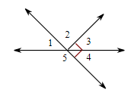

i. Name a pair of adjacent angles.

ii. Name a pair of vertical angles.

iii. Name a pair of angles that form a linear pair.

iv. Name a pair of complementary angles.

v. Name a pair of supplementary angles.

vi. If , find the measures of the remaining numbered angles.

1. Given that , answer the following questions:

i. If  and  are complementary, find .

ii. If  and  are supplementary, find .

iii. If  and  are vertical angles, find .

iv. If  and  form a linear pair, find .

| **Definition** | **Example** |
| --- | --- |
| An **angle bisector** is a ray that divides an angle into two adjacent angles that are congruent. | Angle A P C with ray P B dividing angle A P C into two angles, angle 1 and angle 2, which are marked as congruent. |

1. Use the figure shown to find  and . 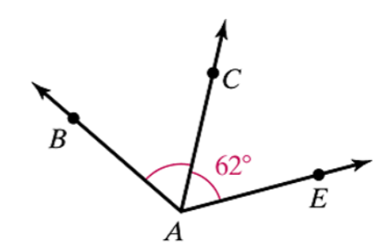
2. Determine whether or not the following conclusions can be made from the information in the diagram.

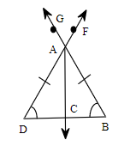

i. 

ii. 

iii. C is the midpoint of segment .

iv.  and  are vertical angles.

# Objective 2: Use Algebra to Find Angle Measures

1. In the figure shown below, ray  bisects . Solve for *x*, and then find the measures of ,  , and .

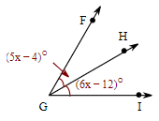

1. Given that ray  bisects  , , and , solve for *x* and find .
2.  and  form a linear pair, and  and . Solve for *x*. Then find  and .
3. Solve for *x* and *y* in the figure shown. Then find the measure of each angle. 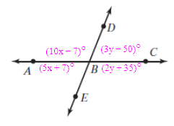
4. The measure of an angle is 36 degrees less than the measure of its complement. Find the measure of each angle. Start by drawing a diagram.