Section 1.6a Other Types of Equations

# Review of Methods of Factoring

***LSU Videos “Greatest Common Factor and Factoring by Grouping”, “Factoring Trinomials of the Form ”, “Factoring Trinomials of the Form ”,*** *and* ***“Factoring Binomials”*** *are found on the course website*.

Recall that in previous sections we used several methods of factoring.

* Factoring a greatest common factor
* Factoring by grouping
* Difference of perfect squares
* Factoring trinomials

# Review of Solving Quadratic Equations by Factoring and the Zero Product Property

Recall from section 1.4 that some quadratic equations can be solved by factoring and by using the zero-product property.

**The Zero Product Property:** If , then  or  or both.

# Review of Multiplying the Sum and Difference of Two Terms

# *LSU Video “Special Products” (8:21 – 13:18) is available on the course website.*

Another special product is the product of the sum and difference of the same two terms. For products such as this, the linear terms cancels out, leaving the **difference of squares**. This can be generalized as the following identity.



# Review of Solving Quadratic Equations by Using the Square Root Property

In section 1.4, we also solved quadratic equations by using the square root property.

**The Square Root Property:** The solution to the quadratic equation, or equivalently, is .

# Objective 1: Solving Higher Order Polynomial Equations

So far in this text we have learned methods for solving linear equations and quadratic equations. Linear equations and quadratic equations are both examples of polynomial equations of first and second degree, respectively. In this section we will first start by looking at certain higher order polynomial equations that can be solved using special factoring techniques.

It is often useful to set one side of the polynomial equation equal to zero. Then, if the polynomial is factored, or if the polynomial can be factored, we can use the **zero-product property** to solve the equation. Be sure to factor the polynomial completely, including **factoring out any common factors**.

 **In an equation of the form** **, do not divide both sides by *x*. This would produce the equation , which has only two solutions. The solution**  **would be “lost.” In addition, because**  **is a solution of the original equation, dividing by *x* would mean dividing by 0, which of course is undefined and produces incorrect results.**

Sometimes polynomials can be solved by grouping terms and factoring (especially when the polynomial has four terms). This is often called “**factoring by grouping**.” Arrange the terms of the polynomial in descending order and group the terms of the polynomial in pairs.

# Review of Squaring Binomials

***LSU Video “Special Products”*** *(0:00 – 8:20) is available on the course website.*

Squaring a binomial can be visualized geometrically as the area of a square with side length $(a+b)$ where $a$ and $b$ are both positive, real numbers.

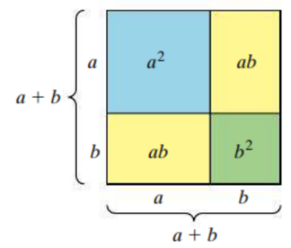



This leads to two identities that can be used to square a binomial.





# Objective 3: Solving Equations Involving Radicals

A radical equation is an equation that involves a variable inside a square root, cube root or any higher root. To solve these equations we must try to isolate the radical, and then raise each side of the equation to the appropriate power to **eliminate the radical**.

 **Because the “squaring operation” can make a false statement true, (, for example), it is essential to always check your answers after solving an equation in which this operation was performed.**

 **Be careful when squaring an expression of the form . Remember,**

**and .**