Section 1.7 Midpoint and Distance Formulas

# Objective 1: Find the Midpoint of a Segment

Recall from section 1.4, the midpoint of a segment is a point that divides, or bisects, a segment into two congruent segments.

In the table below are the midpoint formulas for a segment on a number line and a segment on a coordinate plane.

| **Location of Segment and Description in Words** | **Formula** | **Diagram** |
| --- | --- | --- |
| **On a Number Line**  The coordinate of the midpoint is the *average* or *mean* of the coordinates of the endpoints. | Given segment  on a number line, the coordinate of the midpoint *M* of  is  . | a number line showing points A, M, and B.  The coordinate of point A is lower case a, and the coordinate of point B is lowercase b.  the coordinate of the midpoint M is given by fraction numerator a plus b end numerator over denominator 2. |
| **On the Coordinate Plane**  The coordinates of the midpoint are the average of the *x*-coordinates and the average of the *y*-coordinates of the endpoints. | Given segment  where  and , the coordinates of the midpoint of  are . | a coordinate plane showing points A and B and their midpoint M.  The x coordinate of the midpoint is the average of the x-coordinates of points A and B.  The y coordinate of the midpoint is the average of the y-coordinates of points A and B. |

a. Find the coordinate of the midpoint of the segment on a number line if the coordinates of the endpoints are  and 7.

b. Find the midpoint of the line segment joining points  and .

c. Find the midpoint of the line segment joining points  and .

d. The coordinates of point *T* are . The coordinates of the midpoint of segment  are . Find the coordinates of point *S*.

**Objective 2: Find the Distance Between Two Points on the Coordinate Plane**

**The Distance Formula**

The distance *d* between any two points and is .

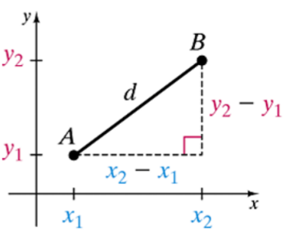

a. Find the distance between the points  and .

b. Find the distance between the points  and . Give an exact, simplified distance and an approximate distance rounded to the nearest tenth.

c. Use the map shown to find the distance between points E and F to the nearest tenth.